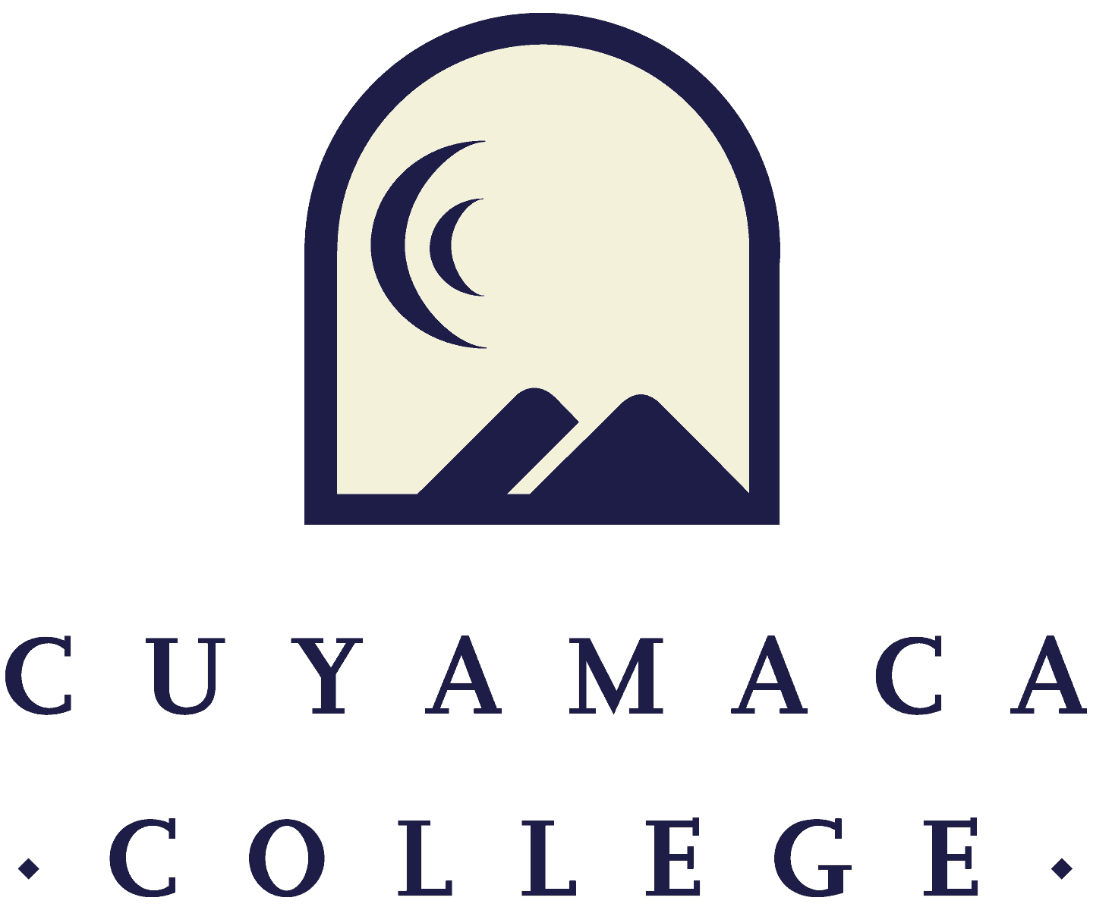

**FALL 2022**

**Student and Instructional (Tutoring & Library) Services Program Review**

**Annual Update Template**

**NOTE THAT ALL PROGRAM REVIEWS MUST BE SUBMITTED ONLINE VIA ONLINE SURVEY FORM.**

**THIS FORM IS PROVIDED FOR RESPONSE DRAFTING AND PLANNING PURPOSES ONLY.**

**EMAILS WITH THE LINK TO EACH SERVICE AREA’S ONLINE MODULE WILL BE PROVIDED IN FALL 2022.**

**IF YOU HAVE QUESTIONS ABOUT THE SURVEYMONKEY PROGRAM REVIEW MODULE, PLEASE CONTACT THE INSTITUTIONAL EFFECTIVENESS, SUCCESS, AND EQUITY OFFICE AT (619) 660-4380 brianna.hays@gcccd.edu.**

**Service Area Overview and Update**

1. Department(s) Reviewed:

2. Lead Author:

3. Collaborator(s):

4. Dean/Manager(s):

5. Initial Collaboration Date with Dean/Manager: Date your program met with your dean or manager to discuss your vision, goals, and resource needs/requests [MM/DD/YYYY]

6. Please summarize the changes, additions, and achievements have occurred in your service area since the last program review. *You can access Fall 2021 program reviews on the program review webpage.*

**Student Learning Outcome/Service Area Outcome Assessment and Student Success**

Please refer to your service area comparison or survey reports provided by the Institutional Effectiveness, Success, and Equity Office as well as any internal data your service area collects to address the following questions. If your service area does not yet have student service access/utilization and demographic data, please contact [Brianna.Hays@gcccd.edu](mailto:Brianna.Hays@gcccd.edu).

**Student Access, Learning, and Achievement**

7. Student services and administrative areas collect data in many different ways. Please discuss the access, success and/or other data that your service area is using to inform its plans for the year and/or to evaluate its progress. This may include student achievement data from comparison reports, service utilization data from SARS or another database, demographic information on the students your area serves, student or employee survey results, reports prepared by external organizations, or other data collected by your service area. How did your service area use the data to improve?

8. What did your service area learn from the transition to remote and then to hybrid (partially online/virtual and partially on campus) operations over the past few years?

9. How will what you learned from this transition continue to help your department improve the student experience and/or improve service area operations?

10. What are your plans to improve equitable student access to services, operations, and/or outcomes (enrollment, matriculation, retention, persistence, graduation, etc.) in the coming year?

*Please upload any supporting documentation related to this section. You can upload PDF, Word, and image files.*

**Service Area Assessment**

**For assistance with SLOs/SAOs, please contact SLO Coordinators Tania Jabour at** [**tania.jabour@gcccd.edu**](mailto:tania.jabour@gcccd.edu) **and Rachel Polakoski at** [**rachel.polakoski@gcccd.edu**](mailto:rachel.polakoski@gcccd.edu)**. For assistance with TracDat, please contact Heyley Aubrey at** [**heyley.aubrey@gcccd.edu**](mailto:heyley.aubrey@gcccd.edu)**.**

**Additional resources are provided on the** [**Learning Outcomes and Assessment webpage**](https://www.cuyamaca.edu/college-info/planning/outcomes-assessment.aspx)

11. Has your department updated its Service Area Outcomes (SAOs) and/or Student Learning Outcomes (SLOs) since 2020?

Yes  No, please describe the department’s plan to update them

12. Does your service area have a current [SLO/SAO assessment plan](https://docs.google.com/document/d/1Nz1zdJAdL_bzQ3z8ACXj5xzznOhYZx0I/edit?usp=sharing&ouid=113087740607092468438&rtpof=true&sd=true)?

Yes  No, please describe your plan to update it

If yes, please upload:

13. Which SLOs/SAOs will you assess this academic year?

14. What are you learning as you engage in SLOs/SAOs assessment in your department?

**Previous Goals: Update**

**For each of your program’s goals (as noted in your Fall 2021 program review annual update), please provide a goal status update and, if applicable, the results of these actions. For a list of active goals as of Fall 2021, visit the program review website to access the Previously Submitted Program Reviews Fall 2021 Program Reviews page.**

Previous Goal 1:

Goal Status

In Progress - will carry this goal forward into next year

Completed

Not Started

Deleted

***If Deleted or Completed:***

Please describe the results or explain the reason for deletion/completion of the goal:

***If Continuing (Not Started or In Progress):***

Link to 2022-2028 College Strategic Goal (Which College Strategic Goals does this department goal most directly support?) (**C*heck only one***)

Increase equitable access (enrollment)

Eliminate equity gaps in course success (passing grade in class)

Increase persistence eliminate equity gaps (re-enrolling the subsequent semester or year)

Increase completion and eliminate equity gaps (graduating with a degree/certificate, or transferring)

Increase hiring and retention of diverse employees to reflect the students and communities we serve

Action Steps for the Next Year: *If you are requesting resources in order to achieve this goal, please list them below as action steps and specify the type of request (e.g., submit technology request for new laptop computers).*

What resources, if any, are needed to achieve this goal? Please select all that apply. Note that links to request forms for each request are included below. All resource requests are due on the program review deadline.

New faculty position [link to request form]

New classified position [link to request form]

Technology [link to request form]

Facilities renovation [link to request form]

Supplies, equipment, and/or furniture [link to request form]

Other, please specify: ____________ [link to request form]

(Repeated as needed)

**New Goals**

If your program is proposing any new goals ***for the remainder of your program review cycle (up to your next Comprehensive Program Review)***, please state the new goal(s), summarize key action steps for the next year, and describe your plan to evaluate the outcomes/results of these actions.

New Goal 1:

Link to 2022-2028 College Strategic Goal: Which College Strategic Goal does this department goal most directly address? (**C*heck only one***)

Increase equitable access (enrollment)

Eliminate equity gaps in course success (passing grade in class)

Increase persistence eliminate equity gaps (re-enrolling the subsequent semester or year)

Increase completion and eliminate equity gaps (graduating with a degree/certificate, or transferring)

Increase hiring and retention of diverse employees to reflect the students and communities we serve

Please describe how this goal advances the college strategic goal identified above.

Please indicate how this goal was informed by SLO assessment results, PLO assessment results, student achievement data, or other data:

Action Steps for this Year:

What resources, if any, are needed to achieve this goal in the next 4 years? Please select all that apply. Note that links to request forms for each request are included below. All resource requests are due on the program review deadline.

New faculty position [link to request form]

New classified position [link to request form]

Technology [link to request form]

Facilities renovation [link to request form]

Supplies, equipment, and/or furniture [link to request form]

Other, please specify: ____________ [link to request form]

**RESOURCES NEEDED TO ACHIEVE PROGRAM GOALS**

**Faculty Resource Needs**

*Contact Person: Alicia Munoz (*[*alicia.munoz@gcccd.edu*](mailto:alicia.munoz@gcccd.edu)*)*

***Link to Faculty Position Request Form- One form must be submitted for each request***

*Please submit an electronic Faculty Position Request Form for each position your department is requesting. A copy of the request form is posted to the* [*Program Review webpage*](https://www.cuyamaca.edu/about-cuyamaca-college/planning/program-review.php) *(under the Staffing Request Information menu) for planning purposes.*

## **Classified Staff Resource Needs**

*Contact Person: Jessica Robinson* ([jessica.robinson@gcccd.edu](mailto:jessica.robinson@gcccd.edu))

***Link to Classified Position Request Form- One form must be submitted for each request***

*Please submit an electronic Classified Position Request Form for each position your department is requesting. A copy of the request form is posted to the* [*Program Review webpage*](https://www.cuyamaca.edu/about-cuyamaca-college/planning/program-review.php) *(under the Staffing Request Information menu) for planning purposes.*

**Technology Resource Needs**

*Contact Person: Jodi Reed (*[*jodi.reed@gcccd.edu*](mailto:jodi.reed@gcccd.edu)*)*

***Link to Technology Request Form- One form must be submitted for each request***

**Supplies, Equipment & Other Resource Needs**

*Contact Person: Nicole Salgado (*[*nicole.salgado@gcccd.edu*](mailto:nicole.salgado@gcccd.edu)*)*

***Link to Supplies, Equipment & Other Resources Request Form-One form must be submitted for each request***

**Facilities Resource Needs**

*Contact Person: Francisco Gonzales (*[*francisco.gonzalez@gcccd.edu*](mailto:francisco.gonzalez@gcccd.edu)*)*

***Link to Facilities Request Form- one form must be submitted for each request***

**Have you completed all of the other sections of this program review?**

☐ Yes ☐ No