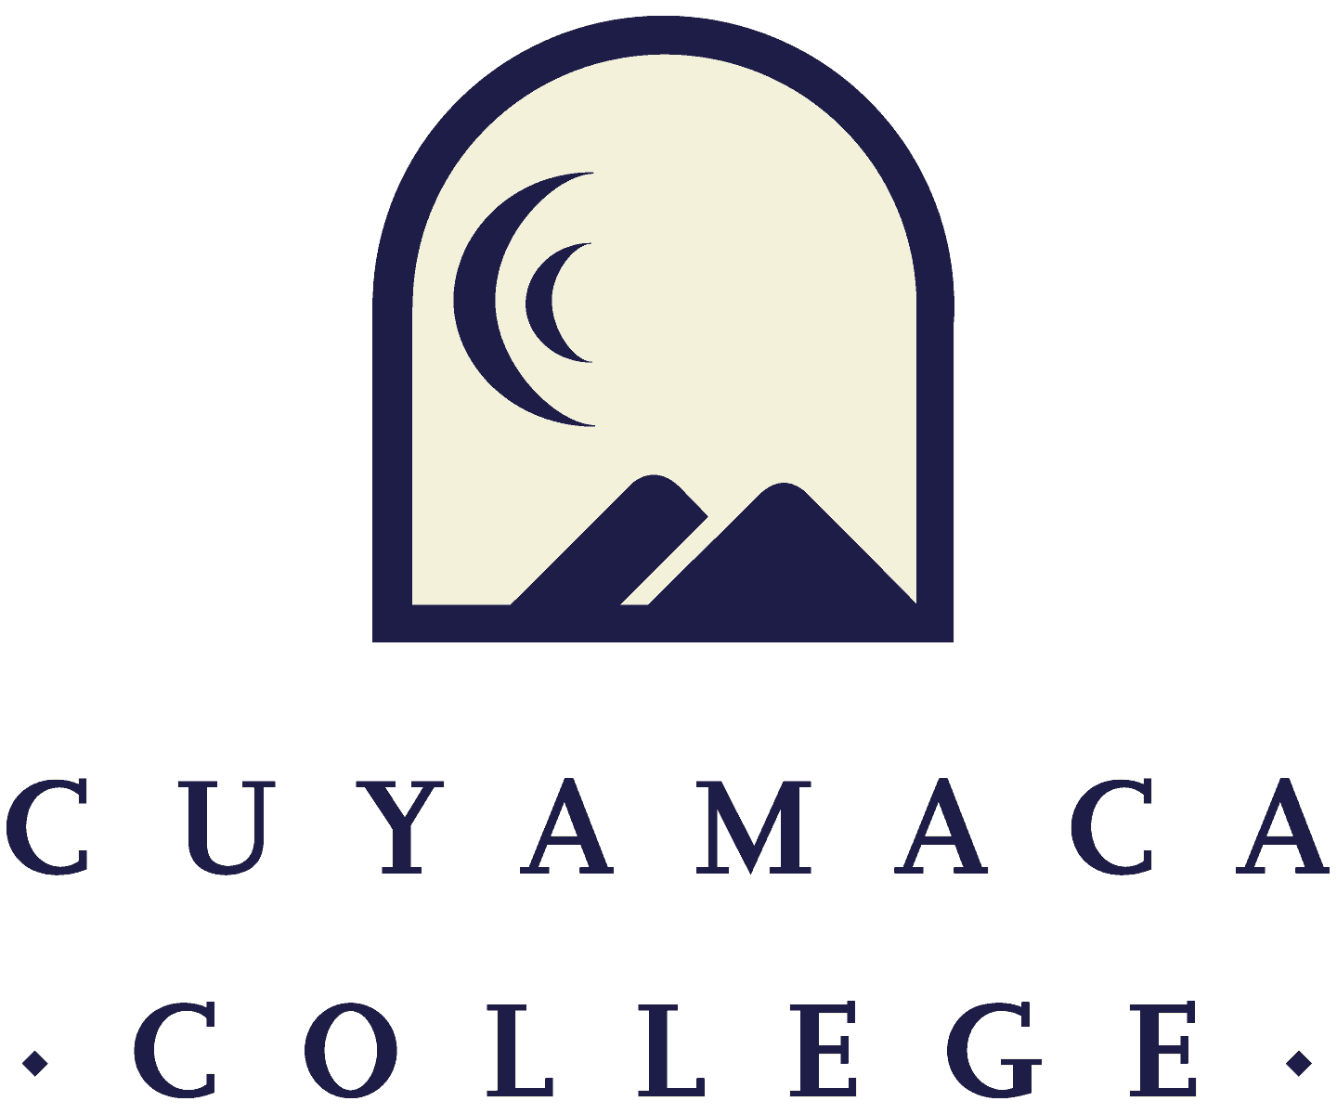

**FALL 2022**

**Instructional Program Review**

**Comprehensive Template**

**NOTE THAT ALL PROGRAM REVIEWS MUST BE SUBMITTED ONLINE VIA ONLINE SURVEY FORM.**

**THIS FORM IS PROVIDED FOR RESPONSE DRAFTING AND PLANNING PURPOSES ONLY.**

**EMAILS WITH THE LINK TO EACH SERVICE AREA’S ONLINE MODULE WILL BE PROVIDED IN FALL 2022.**

**IF YOU HAVE QUESTIONS ABOUT THE SURVEYMONKEY PROGRAM REVIEW MODULE, PLEASE CONTACT THE INSTITUTIONAL EFFECTIVENESS, SUCCESS, AND EQUITY OFFICE AT (619) 660-4380 brianna.hays@gcccd.edu.**

**Program Overview and Update**

1. Department(s) Reviewed:

2. Lead Author:

3. Collaborator(s) {list any person that participated in the preparation of this report}:

4. Dean/Manager(s):

5. Initial Collaboration Date with Dean: Date your program met with your dean to discuss your vision, goals, and resource needs/requests [MM/DD/YYYY]

**Program Reflection and Description**

6. Provide your program’s mission statement. If your program does not have a mission statement, what is your timeline for creating a mission statement?

7. Is the program description in the current [college catalog](https://www.cuyamaca.edu/academics/class-schedules-catalog-and-webadvisor/college-catalog.php) up to date and accurate?

Yes  No: What steps will you take to revise the college catalog description?

8. Describe how your program advances the [College's new vision of equity, excellence, and social justice through education?](https://www.cuyamaca.edu/about-cuyamaca-college/our-vision-mission-and-values/index.php) How does the program reflect the College’s mission and values?

**Course Curriculum, Assessment and Student Success**

**Curriculum Review and Assessment**

***Provide an overview of your program’s Curriculum Review and Development status.***

9. [Access the Five Year Curriculum Review Cycle](https://intra.cuyamaca.edu/in/committees/curriculum/files/Committee%20Documents/21-22-five-year-curriculum-review-cycle.pdf). Have all of your active course outlines been reviewed within the last five years?

Yes  No, please explain:

10. Please list any planned changes **from the current semester forward for curriculum** (courses, degrees, and/or certificates) and the rationale for those changes (e.g., labor market data, advisory committee recommendations, transfer institution changes, industry trends, state-wide transfer model curriculum).

11. How is your program meeting the needs of students, and/or articulation with four year institutions?

***Please provide an overview of your Student Learning Outcomes (SLO) Assessments***

**For assistance with SLOs, please contact SLO Coordinators Tania Jabour at** [**tania.jabour@gcccd.edu**](mailto:tania.jabour@gcccd.edu) **and Rachel Polakoski at rachel.polakoski@gcccd.edu. For assistance with TracDat, please contact Heyley Aubrey at** [**heyley.aubrey@gcccd.edu**](mailto:heyley.aubrey@gcccd.edu)**.**

**Additional resources are provided on the** [**Learning Outcomes and Assessment webpage**](https://www.cuyamaca.edu/about-cuyamaca-college/planning/outcomes-assessment.php)

12. Please upload the most recent version of your program’s course SLO assessment plan. Click [here](https://drive.google.com/file/d/1dFG2fd0MdtPxmpxRGBQS88jnL4kAbYwt/view) for Assessment Plan Template.

13. Please provide a high-level summary and your program’s interpretation of your SLO findings over the past year.

14. Discuss what changes, if any, were made as a result of your SLO findings. Include any student learning-related successes and/or challenges SLO results have revealed for your department.

**DEGREE/CERTIFICATE PROGRAMS**

**Degree and Certificate Programs**

15. Does your program offer any degree/certificate programs?

Yes (continue and then go to 19)

No, and it ***does not*** have program-level outcomes (PLOs; continue and then go to 23)

No, but it ***does*** have PLOs (continue and then go to 19)

16. For each degree and certificate indicate how many awards were conferred in the past five years. Please comment on any trends and provide context to explain any increases or decreases.

[upload excel spreadsheet]

17. Please indicate when each degree and certificate was last reviewed and updated (semester), if this information is available (e.g., via internal program records or Curriculum Committee minutes). If you are unable to locate this information, please state that.

18. Can students complete the degree/certificate requirements within a two-year period?*

Yes  No, Please explain

*requirement of Title 5, California Code of Regulations and Accreditation Standard II.A.

19. Have you updated your program learning outcomes (PLOs) since 2020?

Yes

No, please explain the plan to revise PLO, including which PLOs will be changed and when the changes will occur:

20. Does your program share some PLOs across its Academic and Career Pathway (ACP)?

Yes  No

21. How are you currently assessing your PLOs? If you are not currently assessing PLOs, what is your plan to assess PLOs in the future?

22. How are your PLO assessments informing improvements/changes to your program?

**Student Access and Achievement**

# *Student characteristics and achievement data (both college-wide and by discipline) can be located on the* [*program review data webpage*](https://www.cuyamaca.edu/about-cuyamaca-college/planning/program-review/college-wide-data-and-data-for-instructional-programs.php)*.*

23. Looking at the past 4-5 years of enrollment in your program, what trends do you notice? Has enrollment increased or decreased, and what factors may be contributing to this?

24. What is your department’s overall course success rate? How has it changed over the past 4-5 years? Please note any trends and context for the data.

25. Please review the college-wide and program data sets, which have identified equity gaps based on the following criteria: 3% n=10 students/enrollments. Which groups are experiencing equity gaps in your program for success rate and/or retention rate? Please discuss all equity gaps identified in the data.

26. What department/discipline (or institutional) factors may be contributing to these lower rates of success for these groups of students?

27. What action will the department or discipline take to address these equity gaps over the next four years? If equity gaps have been reduced or eliminated, please share what the program did to achieve this. If equity gaps still exist, consider the specific steps your department will take to address equity gaps.

28. Discuss your program’s plans for diversifying department faculty in alignment with the [GCCCD Board Resolution 20-015](https://www.gcccd.edu/governing-board/documents/resolutions-by-year/2020-resolutions/20-015%20Denunciation%20of%20Violence%20Against%20Black%20Americans%20and%20Commitment%20to%20Anti-Racism.pdf). For assistance with this, please contact Cuyamaca’s EEO site lead, Karen Marrujo at [karen.marrujo@gcccd.edu](mailto:karen.marrujo@gcccd.edu).

29. What other qualitative or quantitative data, if any, is the program using to inform its planning for this comprehensive program review? Please reference additional internal or external data, such as retention and enrollment, student survey results, focus groups, student throughput, or other data, if there are any notable trends.

30. What did your program learn from the transition to remote teaching over the past few years? How can this be used to improve the student experience in the future?

**Distance Education Course Success (If Applicable)**

31. Does your program offer courses via distance education excluding emergency remote teaching 2020-21 (classes that would have been taught in person, if not for the pandemic)

Yes (proceed to next section)  No (proceed to next section)

***For distance education teaching and learning resources, please visit the*** [***Cuyamaca Teaching Online webpage***](https://www.cuyamaca.edu/faculty-staff-resources/teaching-online/index.php)***.***

32. If there are differences in success rates for distance education (online) versus in-person classes, what will the program do to address these disparities? If there are no differences, what did the program do to achieve that?

33. What mechanisms are in place to ensure regular and effective contact [Guide to Best Practices in Online Teaching](https://www.cuyamaca.edu/faculty-staff-resources/teaching-online/index.php) within online courses across the discipline or department?

34. What innovative tools and strategies are you using in your online courses to engage students and support student success?

**Career Exploration and Program Demand**

35. Is your program a career education program (e.g., does it prepare students to directly enter the workforce)?

Yes (Continue to 36)  No (Go to 39)

**Career Education Only**

36. Please share your observations about the employment rate for your program over the past several years.

37. What is the institution-set standard for your program’s employment rate? The institution set standard is what you would consider the lowest acceptable employment rate for your program (or “floor”).

38. What would you like your program’s employment rate to be, ideally (stretch goal)?

**All Programs**

39. What is your program doing to prepare students for successful transition (e.g. transfer and career readiness)? Please include information on how your program is helping students explore careers in your program area.

40. What do the latest labor market data reveal about the careers (including those for transfer students) for which your program prepares students? Consider what career information you would share with students on a career or transfer pathway in your area. Labor market data may be sourced from the [California Employment Development Department](https://www.labormarketinfo.edd.ca.gov/data/lmi-by-subjects.html). You can also contact the Institutional Effectiveness, Success, and Equity Office to access additional labor market information related to your program.

OPTIONAL If your program has labor market data to include in your program review, please use the upload button below to attach the file.

**Strengths, Challenges & External Influences**

Consider your program’s strengths, challenges, areas for improvement, and internal and external factors impacting your program.

41. Please describe your program’s strengths.

42. Please describe your program’s challenges.

43. Please describe external influences that affect your program (both positively and negatively).

44. Given these factors, what opportunities exist for the service area to advance the College’s goals in the next 4 years?

## **Previous Goals:**

**For each of your program’s goals (as noted in your Fall 2021 program review annual update), please provide a goal status update and, if applicable, the results of these actions. For a list of active goals as of Fall 2021, visit the program review website to access the Previously Submitted Program Reviews 🡪** [**Fall 2021-Spring 2022 Program Reviews page**](https://www.cuyamaca.edu/about-cuyamaca-college/planning/program-review/spring-2022-program-review.php)**.**

Previous Goal 1:

Goal Status

Completed

Deleted

In Progress

Not Started

***If Deleted or Completed:***

Please describe the results or explain the reason for deletion/completion of the goal:

(Repeated as needed)

***If Continuing (Not Started or In Progress):***

Link to College Strategic Goal (Which College Strategic Goal does this department goal most directly support? (***Check only one***)

Increase equitable access (enrollment)

Eliminate equity gaps in course success (passing grade in class)

Increase persistence eliminate equity gaps (re-enrolling the subsequent semester or year)

Increase completion and eliminate equity gaps (graduating with a degree/certificate, or transferring)

Increase hiring and retention of diverse employees to reflect the students and communities we serve

Action Steps for the Next Year:

*If you are requesting resources in order to achieve this goal, please list them below as action steps and specify the type of request (e.g., submit technology request for new laptop computers).*

What resources, if any, are needed to achieve this goal in the next 4 years? Please select all that apply. Note that links to request forms for each request are included below. All resource requests are due on the program review deadline.

New faculty position

New classified position

Technology

Facilities renovation

Supplies, equipment, and/or furniture

Other, please specify: ____________

## **New 4-Year Goals**

**Please describe the department’s long-term, overarching goals for this comprehensive program review cycle (the next 4 years). Please state the new goal(s), summarize key action steps for the next academic year, and describe your plan to evaluate the outcomes/results of these actions. You may include previous goals that the program is continuing into this comprehensive program review cycle. PRSC recommends identifying a small number of (1 to 4) broad goals to address over the next four years so that they can help the program focus its efforts.**

New Goal 1:

Link to 2022-2028 College Strategic Goal: Which College Strategic Goal does this department goal most directly address? (**C*heck only one***)

* Increase equitable access (enrollment)
* Eliminate equity gaps in course success (passing grade in class)
* Increase persistence eliminate equity gaps (re-enrolling the subsequent semester or year)
* Increase completion and eliminate equity gaps (graduating with a degree/certificate, or transferring)
* Increase hiring and retention of diverse employees to reflect the students and communities we serve

Please describe how this goal advances the college strategic goal identified above.

Please indicate how this goal was informed by SLO assessment results, PLO assessment results, student achievement data, or other data:

Action Steps for this Year:

What resources, if any, are needed to achieve this goal in the next 4 years? Please select all that apply. Note that links to request forms for each request are included below. All resource requests are due on the program review deadline.

New faculty position

New classified position

Technology

Facilities renovation

Supplies, equipment, and/or furniture

Other, please specify: ____________

How will this goal be evaluated?

[Repeated as needed up to 4 goals]

**RESOURCES NEEDED TO ACHIEVE PROGRAM GOALS**

**Faculty Resource Needs**

*Contact Person: Alicia Munoz (*[*alicia.munoz@gcccd.edu*](mailto:alicia.munoz@gcccd.edu)*)*

***Link to Faculty Staff Request Form- One form must be submitted for each request***

*Please submit an electronic Faculty Position Request Form for each position your department is requesting. A copy of the request form is posted to the* [*Program Review webpage*](https://www.cuyamaca.edu/about-cuyamaca-college/planning/program-review.php) *(under the Staffing Request Information menu) for planning purposes.*

**Classified Staff Resource Needs**

*Contact Person: Jessica Robinson* [*jessica.robinson@gcccd.edu*](mailto:jessica.robinson@gcccd.edu)

***Link to Classified Position Request Form- One form must be submitted for each request***

*Please submit an electronic Classified Position Request Form for each position your department is requesting. A copy of the request form is posted to the* [*Program Review webpage*](https://www.cuyamaca.edu/about-cuyamaca-college/planning/program-review.php) *(under the Staffing Request Information menu) for planning purposes.*

**Technology Resource Needs**

*Contact Person: Jodi Reed (*[*jodi.reed@gcccd.edu*](mailto:jodi.reed@gcccd.edu)*)*

***Link to Technology Request Form- One form must be submitted for each request***

**Supplies, Equipment & Other Resource Needs**

*Contact Person: Nicole Salgado (*[*nicole.salgado@gcccd.edu*](mailto:nicole.salgado@gcccd.edu)*)*

***Link to Supplies, Equipment & Other Resources Request Form-One form must be submitted for each request***

**Facilities Resource Needs**

*Contact Person: Francisco Gonzales (*[*francisco.gonzalez@gcccd.edu*](mailto:francisco.gonzalez@gcccd.edu)*)*

***Link to Facilities Request Form- One form must be submitted for each request***

**Have you completed all of the other sections of this program review?**

☐ Yes ☐ No