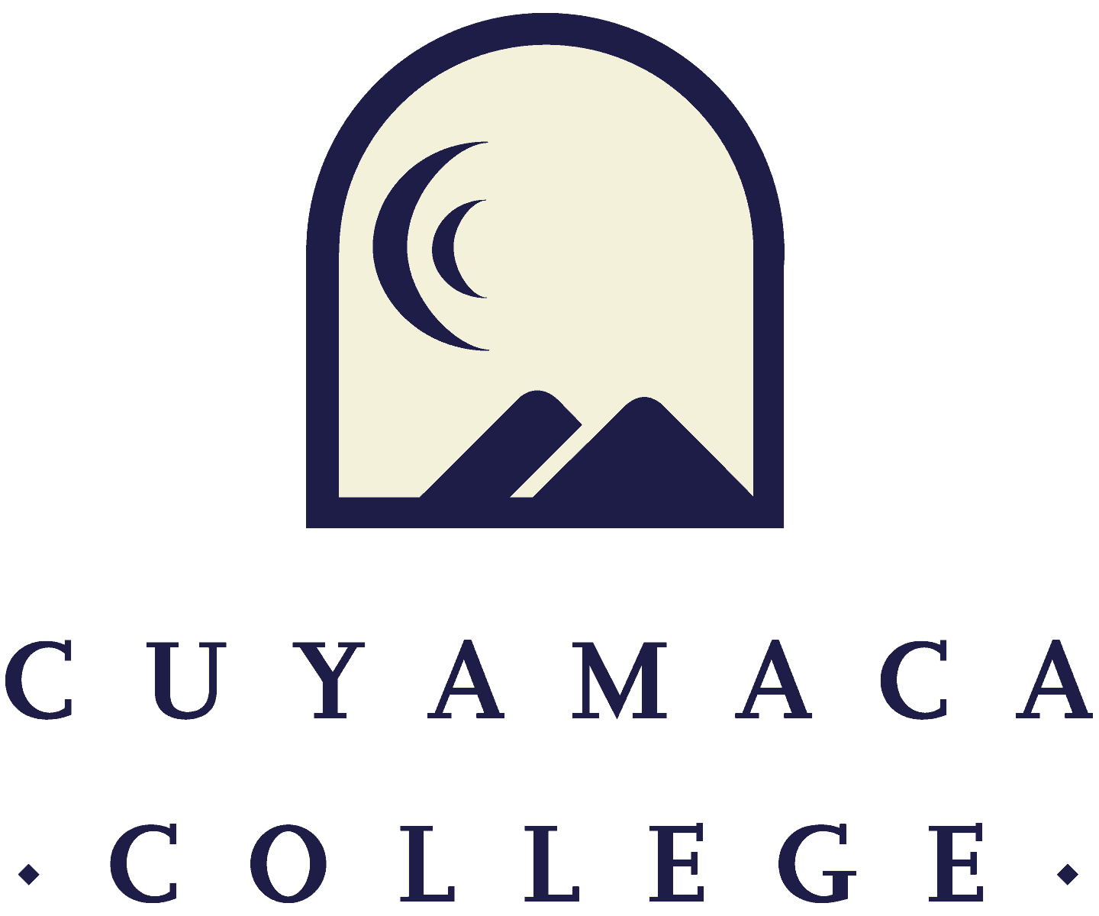

**DRAFT - Instructional Program Review Annual Update18-19**

**NOTE THAT ALL 2018-19 INSTRUCTIONAL PROGRAM REVIEWS MUST BE SUBMITTED ONLINE VIA SURVEYMONKEY.**

**THIS FORM IS PROVIDED FOR RESPONSE DRAFTING AND PLANNING PURPOSES ONLY.**

**EMAILS WITH THE LINK TO EACH PROGRAM’S ONLINE MODULE WILL BE PROVIDED IN OCTOBER 2018. IF YOU HAVE QUESTIONS ABOUT THE SURVEYMONKEY PROGRAM REVIEW MODULE, PLEASE CONTACT THE INSTITUTIONAL EFFECTIVENESS, SUCCESS, AND EQUITY OFFICE AT (619) 660-4380.**

1. **Program Overview and Update**
2. Department(s) Reviewed:
3. Lead Author and Collaborators:
4. Manager:
5. Program Update (Required): Please summarize the changes, additions, and achievements have occurred in your program since the last program review annual update:
6. **Assessment and Student Achievement**
7. **Student and Program Learning Outcome Assessment**
8. Do you have an SLO assessment plan on file with SLOAC?

Yes No

1. Please provide an analysis of your student learning outcomes (SLO) findings and what changes, if any, were made as a result.
2. Do you have an PLO assessment plan on file with SLOAC?

Yes No

1. Please provide an analysis of your program learning outcomes (PLO) findings and what changes, if any were made as a result.
2. **Student Achievement**
3. How has the program’s success rate across all courses changed over the past 5 years?
4. The College has set a 2024 goal of reaching a 77% course success rate (students passing with a grade of A, B, C, or P out of those enrolled at census) for the College as a whole. Consider how your will program help the College reach its long-term goal of increasing the course success rate to 77%. What is your program's one-year (2019/20) goal for success rate across all courses in the program?
5. Which specific groups (by gender and ethnicity) have success rates lower than that of the program overall?
6. What program (or institutional) factors may be contributing to these lower rates of success for these groups of students?
7. What specific steps will the program take to address these equity gaps in the 2019/20 academic year?
8. How do these activities inform the long-term program goals that you are setting in this comprehensive program review?

**Distance Education Course Success (If Applicable)**

1. Are there differences in success rates for distance education (online) versus in-person sections?

Yes No

1. If there are differences in success rates for distance education (online) versus in-person classes, what will the program do to address these disparities?
2. **Previous Goals: Update (If Applicable)**

**If you set goals in your last Comprehensive Program Review, please provide a status update, a summary of key action steps, and the results of these actions (if applicable). List previous goals as needed.**

**Goal 1:**

1. Goal 1:
2. Link to [College Strategic Goal](https://www.cuyamaca.edu/college-info/about/files/strategic-plan/2016-2022-Strategic-Plan-Cuyamaca.pdf)

Basic Skills Acceleration

Guided Student Pathways

Student Validation and Engagement

Organizational Health

1. Goal Status

In Progress - will carry this goal forward into this year's comprehensive program review

Completed

Not Started

Deleted

1. Rationale
2. Action Steps (Previously “Activities”):
3. Evaluation Plan/Results

**Goal 2:**

1. Goal 2:
2. Link to [College Strategic Goal](https://www.cuyamaca.edu/college-info/about/files/strategic-plan/2016-2022-Strategic-Plan-Cuyamaca.pdf)

Basic Skills Acceleration

Guided Student Pathways

Student Validation and Engagement

Organizational Health

1. Goal Status

In Progress - will carry this goal forward into this year's comprehensive program review

Completed

Not Started

Deleted

1. Rationale
2. Action Steps (Previously “Activities”):
3. Evaluation Plan/Results

**Goal 3:**

1. Goal 3:
2. Link to [College Strategic Goal](https://www.cuyamaca.edu/college-info/about/files/strategic-plan/2016-2022-Strategic-Plan-Cuyamaca.pdf)

Basic Skills Acceleration

Guided Student Pathways

Student Validation and Engagement

Organizational Health

1. Goal Status

In Progress - will carry this goal forward into this year's comprehensive program review

Completed

Not Started

Deleted

1. Rationale
2. Action Steps (Previously “Activities”):
3. Evaluation Plan/Results

**Goal 4:**

1. Goal 4:
2. Link to [College Strategic Goal](https://www.cuyamaca.edu/college-info/about/files/strategic-plan/2016-2022-Strategic-Plan-Cuyamaca.pdf)

Basic Skills Acceleration

Guided Student Pathways

Student Validation and Engagement

Organizational Health

1. Goal Status

In Progress - will carry this goal forward into this year's comprehensive program review

Completed

Not Started

Deleted

1. Rationale
2. Action Steps (Previously “Activities”):
3. Evaluation Plan/Results
4. **New Goals**

If your program is proposing any new goals for this program review cycle, please state the new goal(s), summarize key action steps, and describe your plan to evaluate the outcomes/results of these actions.

**New Goal 1:**

1. New Goal 1:
2. Link to [College Strategic Goal](https://www.cuyamaca.edu/college-info/about/files/strategic-plan/2016-2022-Strategic-Plan-Cuyamaca.pdf)

Basic Skills Acceleration

Guided Student Pathways

Student Validation and Engagement

Organizational Health

1. Rationale:
2. Action Steps (Previously “Activities”):
3. Evaluation Plan:

**New Goal 2:**

1. New Goal 2:
2. Link to [College Strategic Goal](https://www.cuyamaca.edu/college-info/about/files/strategic-plan/2016-2022-Strategic-Plan-Cuyamaca.pdf)

Basic Skills Acceleration

Guided Student Pathways

Student Validation and Engagement

Organizational Health

1. Rationale:
2. Action Steps (Previously “Activities”):
3. Evaluation Plan:

**New Goal 3:**

1. New Goal 3:
2. Link to [College Strategic Goal](https://www.cuyamaca.edu/college-info/about/files/strategic-plan/2016-2022-Strategic-Plan-Cuyamaca.pdf)

Basic Skills Acceleration

Guided Student Pathways

Student Validation and Engagement

Organizational Health

1. Rationale:
2. Action Steps (Previously “Activities”):
3. Evaluation Plan:

**New Goal 4:**

1. New Goal 4:
2. Link to [College Strategic Goal](https://www.cuyamaca.edu/college-info/about/files/strategic-plan/2016-2022-Strategic-Plan-Cuyamaca.pdf)

Basic Skills Acceleration

Guided Student Pathways

Student Validation and Engagement

Organizational Health

1. Rationale:
2. Action Steps (Previously “Activities”):
3. Evaluation Plan:
4. **Faculty Resource Needs**
5. Faculty Position Request 1: Please remember to complete and upload (using the upload button below) the Faculty Position Request Form for each position you are requesting.
   1. Description
   2. Related Program Goal(s)
6. Faculty Position Request 2: Please remember to complete and upload (using the upload button below) the Faculty Position Request Form for each position you are requesting.
   1. Description
   2. Related Program Goal(s)
7. **Classified Staff Resource Needs**
8. Classified Staff Position Request 1: Please remember to complete and upload (using the upload button below) the Classified Staff Position Request Form for each position you are requesting.
   1. Description
   2. Related Program Goal(s)
9. Classified Staff Position Request 2: Please remember to complete and upload (using the upload button below) the Classified Staff Position Request Form for each position you are requesting.
   1. Description
   2. Related Program Goal(s)
10. **Technology Resource Needs**
11. Technology Request 1: Please remember to complete and upload (using the upload button below) the Technology Request Form.
    1. Description
    2. One time or On-going
    3. Amount Requested $:
    4. Related Program Review:
12. Technology Request 2: Please remember to complete and upload (using the upload button below) the Technology Request Form.
    1. Description
    2. One time or On-going
    3. Amount Requested $:
    4. Related Program Review:
13. **Perkins and Strong Workforce Resource Needs**
14. Perkins Request and Strong Workforce 1: In the box below please provide. Please remember to complete the Perkins Request Form.
    1. Description
    2. Amount Requested $:
    3. Related Program Review:
15. Perkins Request and Strong Workforce 2: In the box below please provide. Please remember to complete the Perkins Request Form.
    1. Description
    2. Amount Requested $:
    3. Related Program Review:
16. **Supplies/Equipment Resource Needs**
17. Supplies/Equipment Request 1: In the box below please provide. (Supplies/Equipment requests will be considered on a one-time funding basis.)
    1. Description
    2. Amount Requested $:
    3. Related Program Review:
18. Supplies/Equipment Request 2: In the box below please provide. (Supplies/Equipment requests will be considered on a one-time funding basis.)
    1. Description
    2. Amount Requested $:
    3. Related Program Review:

1. **Facilities Resource Needs**
2. Facilities Request 1: In the box below please provide. Please remember to complete and upload (using the upload button below) the Facilities Request Form.
   1. Description
   2. Amount Requested $:
   3. Related Program Review:
3. Facilities Request 2: In the box below please provide. Please remember to complete and upload (using the upload button below) the Facilities Request Form.
   1. Description
   2. Amount Requested $:
   3. Related Program Review:
4. **Professional Development Resource Needs**
5. Professional Development Request 1: In the box below please provide. (Please remember to complete the Professional Development Request Form)
   1. Description
   2. Amount Requested $:
   3. Related Program Review:
6. Professional Development Request 2: In the box below please provide. (Please remember to complete the Professional Development Request Form)
   1. Description
   2. Amount Requested $:
   3. Related Program Review:
7. **Other Resource Needs**
8. Other Resource Request 1: In the box below please provide.

(Other resource requests will be considered on a one-time funding basis. Please fill in the information below.)

* 1. Description
  2. Amount Requested $:
  3. Related Program Review:

1. Other Resource Request 2: In the box below please provide.

(Other resource requests will be considered on a one-time funding basis. Please fill in the information below.)

* 1. Description
  2. Amount Requested $:
  3. Related Program Review: