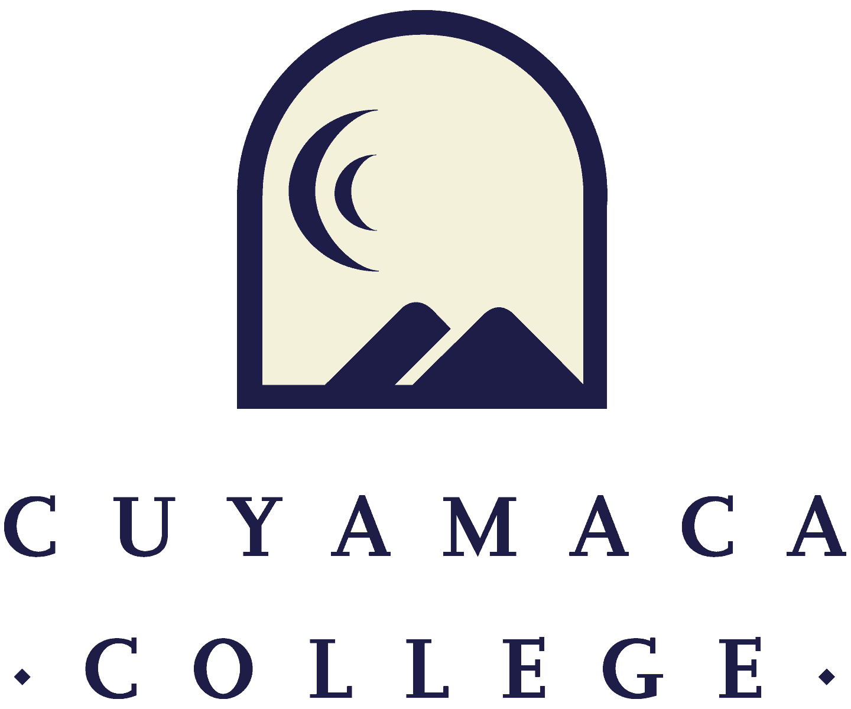

**Instructional Comprehensive Program Review Template 18-19**

**NOTE THAT ALL 2018-19 INSTRUCTIONAL PROGRAM REVIEWS MUST BE SUBMITTED ONLINE VIA SURVEYMONKEY.**

**THIS FORM IS PROVIDED FOR RESPONSE DRAFTING AND PLANNING PURPOSES ONLY.**

**EMAILS WITH THE LINK TO EACH PROGRAM’S ONLINE MODULE WILL BE PROVIDED IN OCTOBER 2018. IF YOU HAVE QUESTIONS ABOUT THE SURVEYMONKEY PROGRAM REVIEW MODULE, PLEASE CONTACT THE INSTITUTIONAL EFFECTIVENESS, SUCCESS, AND EQUITY OFFICE AT (619) 660-4380.**

1. **Program Reflection and Description**
2. Provide a list of the recommendations from your [last program review](https://www.cuyamaca.edu/in/committees/iprpc/reports-2016-2017.aspx) and explain how you have addressed them.
3. Provide a list of tenured/tenure track faculty and support staff in the program as of fall 2016.
4. Provide your program’s mission statement.
5. Describe how your program supports the [mission and goals](https://www.cuyamaca.edu/college-info/about/college-vision-mission.aspx) of the College.
6. Provide the description of your program as it appears in the current college catalog.
7. **Program Degrees and Certificates**

Provide a list of degrees and certificates offered by the program during the past five years (PR Data warehouse}, and industry-standard certificates or licensures supported by the program (CTE only for the latter).

For each degree and certificate, indicate:

1. How many awards were conferred
2. When it was last reviewed and updated
3. How it is meeting the needs of students, industry/workforce (if CTE), and/or articulation with four year institutions (transfer and CTE)
4. Any changes that are planned if it is not meeting these needs
5. Whether students can complete the degree/certificate requirements within a two-year period (sequencing and scheduling of required courses are such that a student could complete them within a two year period or other appropriate timeline per requirements of specialized CTE certificates); this is a requirement of Title 5, California Code of Regulations
   1. Degree/Certificate #1
   2. Degree/Certificate #2
   3. Degree/Certificate #3
   4. Degree/Certificate #4
   5. Please upload the awards data tables for your program.

Choose File

1. **Curriculum Review, Development and Assessment**

**Provide an overview of your program’s Curriculum Review and Development status.**

1. [Access the Five Year Curriculum Review Cycl](https://www.cuyamaca.edu/in/committees/curriculum/default.aspx)e. Have all of your active course outlines been reviewed within the last five years?

Yes No

1. Write a paragraph about any changes planned for the curriculum, both areas of revision and areas of development and growth.

**Provide an overview of your Student and Program Learning Outcomes Assessments**

1. Do you have an assessment plan on file with SLOAC?

Yes No

1. Following that assessment plan, is your program’s data up-to-date and complete in Nuventive/TracDat (including methods of assessment, results, dialogue/actions and follow-up)?

Yes No

1. What student learning-related successes and challenges have SLO results revealed for your department?

*Note: If SLO data are not offering useful feedback regarding student learning, and are not currently informing program improvements, please instead discuss the specific steps you plan to take to make learning outcomes and assessments more meaningful.*

1. Do you have a PLO assessment plan on file with SLOAC?

Yes No

1. Please provide an analysis of your program learning outcomes (PLO) findings and what changes, if any were made as a result.

**CTE Programs Only**

1. If a CTE program, provide a list of the committee members of your Advisory Committee, the chair’s name, and the meeting schedule (i.e., twice yearly)
2. Summarize the recommendations from the Committee.
3. Describe changes that have been made to the program as a result of the committee’s recommendations.
4. If a CTE program, please discuss your [labor market information](http://coeccc.net/Supply-and-Demand.aspx)
5. **Program Data Analysis**

Please refer to your program review data reports provided by the Institutional Effectiveness and Student Equity Office (if you need additional data, contact Brianna.Hays@gcccd.edu) to address the following questions.

**Student Demographics and Access**

1. How has the program’s student population changed over the past 5 years (e.g., student demographics, enrollment, etc.)?
2. How does the program's student population differ from the College's overall student population, if at all?
3. What are the implications for ensuring the program is addressing the needs of its student population?
4. If you would like to attach any charts or additional documentation (aside from the program review report prepared by the IESE Office), please upload it using the button below.

Please upload any supporting documentation related to your student demographics. You do not need to upload the program review data report prepared by the IESE Office, as it will be provided to reviewers. You can upload PDF, Word, and image files.

Choose File

**Student Achievement**

1. How has the program’s success rate across all courses changed over the past 5 years?
2. The College has set a 2024 goal of reaching a 77% course success rate (students passing with a grade of A, B, C, or P out of those enrolled at census) for the College as a whole. Consider how your will program help the College reach its long-term goal of increasing the course success rate to 77%. What is your program's one-year (2019/20) goal for success rate across all courses in the program?
3. Which specific groups (by gender and ethnicity) have success rates lower than that of the program overall?
4. What program (or institutional) factors may be contributing to these lower rates of success for these groups of students?
5. What specific steps will the program take to address these equity gaps in the 2019/20 academic year?
6. How do these activities inform the long-term program goals that you are setting in this comprehensive program review?
7. If you would like to attach any charts or additional documentation (aside from the program review report prepared by the IESE Office), please upload it using the button below.

Please upload any supporting documentation related to your student achievement data. You do not need to upload the program review data report prepared by the IESE Office, as it will be provided to reviewers. You can upload PDF, Word, and image files.

Choose File

**Distance Education Course Success (If Applicable)**

1. Are there differences in success rates for distance education (online) versus in-person sections?

Yes No

1. If there are differences in success rates for distance education (online) versus in-person classes, what will the program do to address these disparities?

**Strengths, Challenges & External Influences**

1. Please describe your program's strengths.
2. Please describe your program's challenges.
3. Please describe external influences that affect your program (both positively and negatively).
4. **Previous Goals: Update (If Applicable)**

**If you set goals in your last Comprehensive Program Review, please provide a status update, a summary of key action steps, and the results of these actions (if applicable). List previous goals as needed.**

**Goal 1:**

1. Goal 1:
2. Link to [College Strategic Goal](https://www.cuyamaca.edu/college-info/about/files/strategic-plan/2016-2022-Strategic-Plan-Cuyamaca.pdf)

Basic Skills Acceleration

Guided Student Pathways

Student Validation and Engagement

Organizational Health

1. Goal Status

In Progress - will carry this goal forward into this year's comprehensive program review

Completed

Not Started

Deleted

1. How was the goal evaluated? If the goal is "in progress," how will it be evaluated?

**PLEASE RESPOND TO THE FOLLOWING QUESTIONS**

**ONLY IF YOU WILL BE CARRYING THIS GOAL FORWARD FOR THIS YEAR'S PROGRAM REVIEW CYCLE.**

1. Please provide the rationale for this goal:
2. Please provide the goal action steps for the year (previously "Activities"):

**Goal 2:**

1. Goal 2:
2. Link to [College Strategic Goal](https://www.cuyamaca.edu/college-info/about/files/strategic-plan/2016-2022-Strategic-Plan-Cuyamaca.pdf)

Basic Skills Acceleration

Guided Student Pathways

Student Validation and Engagement

Organizational Health

1. Goal Status

In Progress - will carry this goal forward into this year's comprehensive program review

Completed

Not Started

Deleted

1. How was the goal evaluated? If the goal is "in progress," how will it be evaluated?

**PLEASE RESPOND TO THE FOLLOWING QUESTIONS**

**ONLY IF YOU WILL BE CARRYING THIS GOAL FORWARD FOR THIS YEAR'S PROGRAM REVIEW CYCLE.**

1. Please provide the rationale for this goal:
2. Please provide the goal action steps for the year (previously "Activities"):

**Goal 3:**

1. Goal 3:
2. Link to [College Strategic Goal](https://www.cuyamaca.edu/college-info/about/files/strategic-plan/2016-2022-Strategic-Plan-Cuyamaca.pdf)

Basic Skills Acceleration

Guided Student Pathways

Student Validation and Engagement

Organizational Health

1. Goal Status

In Progress - will carry this goal forward into this year's comprehensive program review

Completed

Not Started

Deleted

1. How was the goal evaluated? If the goal is "in progress," how will it be evaluated?

**PLEASE RESPOND TO THE FOLLOWING QUESTIONS**

**ONLY IF YOU WILL BE CARRYING THIS GOAL FORWARD FOR THIS YEAR'S PROGRAM REVIEW CYCLE.**

1. Please provide the rationale for this goal:
2. Please provide the goal action steps for the year (previously "Activities"):

**Goal 4:**

1. Goal 4:
2. Link to [College Strategic Goal](https://www.cuyamaca.edu/college-info/about/files/strategic-plan/2016-2022-Strategic-Plan-Cuyamaca.pdf)

Basic Skills Acceleration

Guided Student Pathways

Student Validation and Engagement

Organizational Health

1. Goal Status

In Progress - will carry this goal forward into this year's comprehensive program review

Completed

Not Started

Deleted

1. How was the goal evaluated? If the goal is "in progress," how will it be evaluated?

**PLEASE RESPOND TO THE FOLLOWING QUESTIONS**

**ONLY IF YOU WILL BE CARRYING THIS GOAL FORWARD FOR THIS YEAR'S PROGRAM REVIEW CYCLE.**

1. Please provide the rationale for this goal:
2. Please provide the goal action steps for the year (previously "Activities"):
3. **New Goals**

If your program is proposing any new goals for this program review cycle, please state the new goal(s), summarize key action steps, and describe your plan to evaluate the outcomes/results of these actions.

**New Goal 1:**

1. New Goal 1:
2. Link to [College Strategic Goal](https://www.cuyamaca.edu/college-info/about/files/strategic-plan/2016-2022-Strategic-Plan-Cuyamaca.pdf)

Basic Skills Acceleration

Guided Student Pathways

Student Validation and Engagement

Organizational Health

1. Rationale:
2. Action Steps (Previously “Activities”):
3. Evaluation Plan:

**New Goal 2:**

1. New Goal 2:
2. Link to [College Strategic Goal](https://www.cuyamaca.edu/college-info/about/files/strategic-plan/2016-2022-Strategic-Plan-Cuyamaca.pdf)

Basic Skills Acceleration

Guided Student Pathways

Student Validation and Engagement

Organizational Health

1. Rationale:
2. Action Steps (Previously “Activities”):
3. Evaluation Plan:

**New Goal 3:**

1. New Goal 3:
2. Link to [College Strategic Goal](https://www.cuyamaca.edu/college-info/about/files/strategic-plan/2016-2022-Strategic-Plan-Cuyamaca.pdf)

Basic Skills Acceleration

Guided Student Pathways

Student Validation and Engagement

Organizational Health

1. Rationale:
2. Action Steps (Previously “Activities”):
3. Evaluation Plan:

**New Goal 4:**

1. New Goal 4:
2. Link to [College Strategic Goal](https://www.cuyamaca.edu/college-info/about/files/strategic-plan/2016-2022-Strategic-Plan-Cuyamaca.pdf)

Basic Skills Acceleration

Guided Student Pathways

Student Validation and Engagement

Organizational Health

1. Rationale:
2. Action Steps (Previously “Activities”):
3. Evaluation Plan:
4. **Faculty Resource Needs**
5. Faculty Position Request 1: Please remember to complete and upload (using the upload button below) the Faculty Position Request Form for each position you are requesting.
   1. Description
   2. Related Program Goal(s)
6. Faculty Position Request 2: Please remember to complete and upload (using the upload button below) the Faculty Position Request Form for each position you are requesting.
   1. Description
   2. Related Program Goal(s)
7. **Classified Staff Resource Needs**
8. Classified Staff Position Request 1: Please remember to complete and upload (using the upload button below) the Classified Staff Position Request Form for each position you are requesting.
   1. Description
   2. Related Program Goal(s)
9. Classified Staff Position Request 2: Please remember to complete and upload (using the upload button below) the Classified Staff Position Request Form for each position you are requesting.
   1. Description
   2. Related Program Goal(s)
10. **Technology Resource Needs**
11. Technology Request 1: Please remember to complete and upload (using the upload button below) the Technology Request Form.
    1. Description
    2. One time or On-going
    3. Amount Requested $:
    4. Related Program Review:
12. Technology Request 2: Please remember to complete and upload (using the upload button below) the Technology Request Form.
    1. Description
    2. One time or On-going
    3. Amount Requested $:
    4. Related Program Review:
13. **Perkins and Strong Workforce Resource Needs**
14. Perkins Request and Strong Workforce 1: In the box below please provide. (Please remember to complete the Perkins Request Form)
    1. Description
    2. Amount Requested $:
    3. Related Program Review:
15. Perkins Request and Strong Workforce 2: In the box below please provide. (Please remember to complete the Perkins Request Form)
    1. Description
    2. Amount Requested $:
    3. Related Program Review:
16. **Supplies/Equipment Resource Needs**
17. Supplies/Equipment Request 1: In the box below please provide. (Supplies/Equipment requests will be considered on a one-time funding basis.)
    1. Description
    2. Amount Requested $:
    3. Related Program Review:
18. Supplies/Equipment Request 2: In the box below please provide. (Supplies/Equipment requests will be considered on a one-time funding basis.)
    1. Description
    2. Amount Requested $:
    3. Related Program Review:

1. **Facilities Resource Needs**
2. Facilities Request 1: In the box below please provide. Please remember to complete and upload (using the upload button below) the Facilities Request Form.
   1. Description
   2. Amount Requested $:
   3. Related Program Review:
3. Facilities Request 2: In the box below please provide. Please remember to complete and upload (using the upload button below) the Facilities Request Form.
   1. Description
   2. Amount Requested $:
   3. Related Program Review:
4. **Professional Development Resource Needs**
5. Professional Development Request 1: In the box below please provide. (Please remember to complete the Professional Development Request Form)
   1. Description
   2. Amount Requested $:
   3. Related Program Review:
6. Professional Development Request 2: In the box below please provide. (Please remember to complete the Professional Development Request Form)
   1. Description
   2. Amount Requested $:
   3. Related Program Review:
7. **Other Resource Needs**
8. Other Resource Request 1: In the box below please provide.

(Other resource requests will be considered on a one-time funding basis. Please fill in the information below.)

* 1. Description
  2. Amount Requested $:
  3. Related Program Review:

1. Other Resource Request 2: In the box below please provide.

(Other resource requests will be considered on a one-time funding basis. Please fill in the information below.)

* 1. Description
  2. Amount Requested $:
  3. Related Program Review:

1. **Executive Summary**

Provide a one-page executive summary of the following components of your program review

**(Complete this section after you have completed all of the other sections)**:

1. Program Overview and Description
2. Strengths
3. Challenges
4. External Influences
5. How assessment results have guided your program
6. Future Plans/Goals
   1. Executive Summary:
   2. Have you completed all of the other sections of this program review?

Yes No