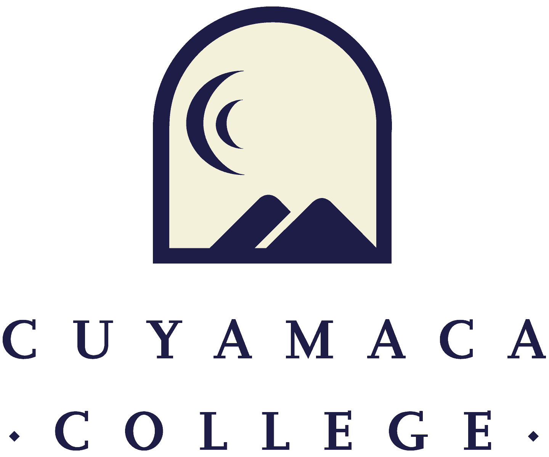

**Student Services Program Review Annual Update18-19**

1. **Program Overview and Update**
2. Department(s) Reviewed:
3. Lead Author and Collaborators:
4. Lead/Dean:
5. Service Area Update (Required): Please summarize the changes, additions, and achievements have occurred in your service area since the last program review annual update:
6. **Student Learning Outcomes/Student Services Outcomes Assessment Reflection**
7. Please provide a summary of your service area’s student learning outcome (SLO) and student services outcome (SSO) assessment efforts and findings from 2017/18.

Please use the button below to upload any supporting documentation for this question.

**Choose File**

1. How did (or will) your service area use its 2017/18 SLO and SSO assessment findings to advance student success and improve services to students?

Please use the button below to upload any supporting documentation for this question.

**Choose File**

1. What are your service area’s assessment plans (i.e., which SLOs and/or SSOs will be assessed) for 2018/19?

Please use the button below to upload any supporting documentation for this question.

**Choose File**

1. **Student Achievement and Institutional Effectiveness**

Cuyamaca College is committed to equity in student access and success, and the College has set goals for equity and improvement in student achievement. Consider how your service area will help the College reach these success and equity goals.

Student Achievement:

For categorical programs, student outcome data will be provided by the Institutional Effectiveness, Success, and Equity (IESE) Office. Please contact the IESE Office for assistance in collecting data to inform your program review.

1. Please review any research data and/or reports for your service area and summarize the findings and implications for practice.

Please use the button below to upload any supporting documentation for this question.

**Choose File**

1. What steps will the service area take to improve services and/or outcomes (e.g., course success, persistence, degree/certificate completion, or transfer) for the College’s disproportionately impacted student groups?

Please use the button below to upload any supporting documentation for this question.

**Choose File**

1. **Previous Goals: Update (If Applicable)**

**If you set goals in your last program review, please provide a status update, a summary of key action steps, and the results of these actions (if applicable). List previous goals as needed.**

**Goal 1:**

1. Goal 1:
2. Link to [College Strategic Goal](https://www.cuyamaca.edu/college-info/about/files/strategic-plan/2016-2022-Strategic-Plan-Cuyamaca.pdf)

Basic Skills Acceleration

Guided Student Pathways

Student Validation and Engagement

Organizational Health

1. Goal Status

In Progress - will carry this goal forward into this year's comprehensive program review

Completed

Not Started

Deleted

1. Rationale
2. Action Steps (Previously “Activities”):
3. Evaluation Plan/Results

**Goal 2:**

1. Goal 2:
2. Link to [College Strategic Goal](https://www.cuyamaca.edu/college-info/about/files/strategic-plan/2016-2022-Strategic-Plan-Cuyamaca.pdf)

Basic Skills Acceleration

Guided Student Pathways

Student Validation and Engagement

Organizational Health

1. Goal Status

In Progress - will carry this goal forward into this year's comprehensive program review

Completed

Not Started

Deleted

1. Rationale
2. Action Steps (Previously “Activities”):
3. Evaluation Plan/Result

**Goal 3:**

1. Goal 3:
2. Link to [College Strategic Goal](https://www.cuyamaca.edu/college-info/about/files/strategic-plan/2016-2022-Strategic-Plan-Cuyamaca.pdf)

Basic Skills Acceleration

Guided Student Pathways

Student Validation and Engagement

Organizational Health

1. Goal Status

In Progress - will carry this goal forward into this year's comprehensive program review

Completed

Not Started

Deleted

1. Rationale
2. Action Steps (Previously “Activities”):
3. Evaluation Plan/Results

**Goal 4:**

1. Goal 4:
2. Link to [College Strategic Goal](https://www.cuyamaca.edu/college-info/about/files/strategic-plan/2016-2022-Strategic-Plan-Cuyamaca.pdf)

Basic Skills Acceleration

Guided Student Pathways

Student Validation and Engagement

Organizational Health

1. Goal Status

In Progress - will carry this goal forward into this year's comprehensive program review

Completed

Not Started

Deleted

1. Rationale
2. Action Steps (Previously “Activities”):
3. Evaluation Plan/Results
4. **New Goals**

If your program is proposing any new goals for this program review cycle, please state the new goal(s), summarize key action steps, and describe your plan to evaluate the outcomes/results of these actions.

**New Goal 1:**

1. New Goal 1:
2. Link to [College Strategic Goal](https://www.cuyamaca.edu/college-info/about/files/strategic-plan/2016-2022-Strategic-Plan-Cuyamaca.pdf)

Basic Skills Acceleration

Guided Student Pathways

Student Validation and Engagement

Organizational Health

1. Rationale:
2. Action Steps (Previously “Activities”):
3. Evaluation Plan:

**New Goal 2:**

1. New Goal 2:
2. Link to [College Strategic Goal](https://www.cuyamaca.edu/college-info/about/files/strategic-plan/2016-2022-Strategic-Plan-Cuyamaca.pdf)

Basic Skills Acceleration

Guided Student Pathways

Student Validation and Engagement

Organizational Health

1. Rationale:
2. Action Steps (Previously “Activities”):
3. Evaluation Plan:

**New Goal 3:**

1. New Goal 3:
2. Link to [College Strategic Goal](https://www.cuyamaca.edu/college-info/about/files/strategic-plan/2016-2022-Strategic-Plan-Cuyamaca.pdf)

Basic Skills Acceleration

Guided Student Pathways

Student Validation and Engagement

Organizational Health

1. Rationale:
2. Action Steps (Previously “Activities”):
3. Evaluation Plan:

**New Goal 4:**

1. New Goal 4:
2. Link to [College Strategic Goal](https://www.cuyamaca.edu/college-info/about/files/strategic-plan/2016-2022-Strategic-Plan-Cuyamaca.pdf)

Basic Skills Acceleration

Guided Student Pathways

Student Validation and Engagement

Organizational Health

1. Rationale:
2. Action Steps (Previously “Activities”):
3. Evaluation Plan:
4. **Faculty Resource Needs**
5. Faculty Position Request 1: Please remember to complete and upload (using the upload button below) the Faculty Position Request Form for each position you are requesting.
   1. Description
   2. Related Program Goal(s)

Faculty Position Request Form 1: Please upload a completed Faculty Position Request Form using the button below. You can access the Faculty Position Request Form [**here**](https://www.cuyamaca.edu/college-info/planning/files/Program-review-files/18-19/request.forms/FacultyPositionRequestForm-2018-19FINAL.docx).

**Choose File**

1. Faculty Position Request 2: Please remember to complete and upload (using the upload button below) the Faculty Position Request Form for each position you are requesting.
   1. Description
   2. Related Program Goal(s)

Faculty Position Request Form 2: Please upload a completed Faculty Position Request Form using the button below. You can access the Faculty Position Request Form [**here**](https://www.cuyamaca.edu/college-info/planning/files/Program-review-files/18-19/request.forms/FacultyPositionRequestForm-2018-19FINAL.docx).

**Choose File**

1. **Classified Staff Resource Needs**
2. Classified Staff Position Request 1: Please remember to complete and upload (using the upload button below) the Classified Staff Position Request Form for each position you are requesting.
   1. Description
   2. Related Program Goal(s)

Classified Position Request Form 1: Please upload a completed Classified Position Request Form using the button below. You can access the Classified Position Request Form [**here**](https://www.cuyamaca.edu/college-info/planning/files/Program-review-files/18-19/request.forms/2018-19%20Classified%20Position%20Request%20Form.docx).

**Choose File**

1. Classified Staff Position Request 2: Please remember to complete and upload (using the upload button below) the Classified Staff Position Request Form for each position you are requesting.
   1. Description
   2. Related Program Goal(s)

Classified Position Request Form 2: Please upload a completed Classified Position Request Form using the button below. You can access the Classified Position Request Form [**here**](https://www.cuyamaca.edu/college-info/planning/files/Program-review-files/18-19/request.forms/2018-19%20Classified%20Position%20Request%20Form.docx).

**Choose File**

1. **Technology Resource Needs**
2. Technology Request 1: Please remember to complete a Technology Request Form, accessible via this link.
   1. Description
   2. One time or On-going
   3. Amount Requested $:
   4. Related Program Review:
3. Technology Request 2: Please remember to complete a Technology Request Form, accessible via this link.
   1. Description
   2. One time or On-going
   3. Amount Requested $:
   4. Related Program Review:
4. **Perkins and Strong Workforce Resource Needs**
5. Perkins Request and Strong Workforce 1: In the box below please provide. (Please remember to complete the Perkins Request Form)
   1. Description
   2. Amount Requested $:
   3. Related Program Review:
6. Perkins Request and Strong Workforce 2: In the box below please provide. (Please remember to complete the Perkins Request Form)
   1. Description
   2. Amount Requested $:
   3. Related Program Review:
7. **Supplies/Equipment Resource Needs**
8. Supplies/Equipment Request 1: In the box below please provide. (Supplies/Equipment requests will be considered on a one-time funding basis.)
   1. Description
   2. Amount Requested $:
   3. Related Program Review:
9. Supplies/Equipment Request 2: In the box below please provide. (Supplies/Equipment requests will be considered on a one-time funding basis.)
   1. Description
   2. Amount Requested $:
   3. Related Program Review:

1. **Facilities Resource Needs**
2. Facilities Request 1: Please remember to complete a Facilities Request Form, accessible via this link.
   1. Description
   2. Amount Requested $:
   3. Related Program Review:
3. Facilities Request 2: Please remember to complete a Facilities Request Form, accessible via this link.
   1. Description
   2. Amount Requested $:
   3. Related Program Review:
4. **Professional Development Resource Needs**
5. Professional Development Request 1: In the box below please provide. (Please remember to complete the Professional Development Request Form)
   1. Description
   2. Amount Requested $:
   3. Related Program Review:
6. Professional Development Request 2: In the box below please provide. (Please remember to complete the Professional Development Request Form)
   1. Description
   2. Amount Requested $:
   3. Related Program Review:
7. **Other Resource Needs**
8. Other Resource Request 1: In the box below please provide.

(Other resource requests will be considered on a one-time funding basis. Please fill in the information below.)

* 1. Description
  2. Amount Requested $:
  3. Related Program Review:

1. Other Resource Request 2: In the box below please provide.

(Other resource requests will be considered on a one-time funding basis. Please fill in the information below.)

* 1. Description
  2. Amount Requested $:
  3. Related Program Review: