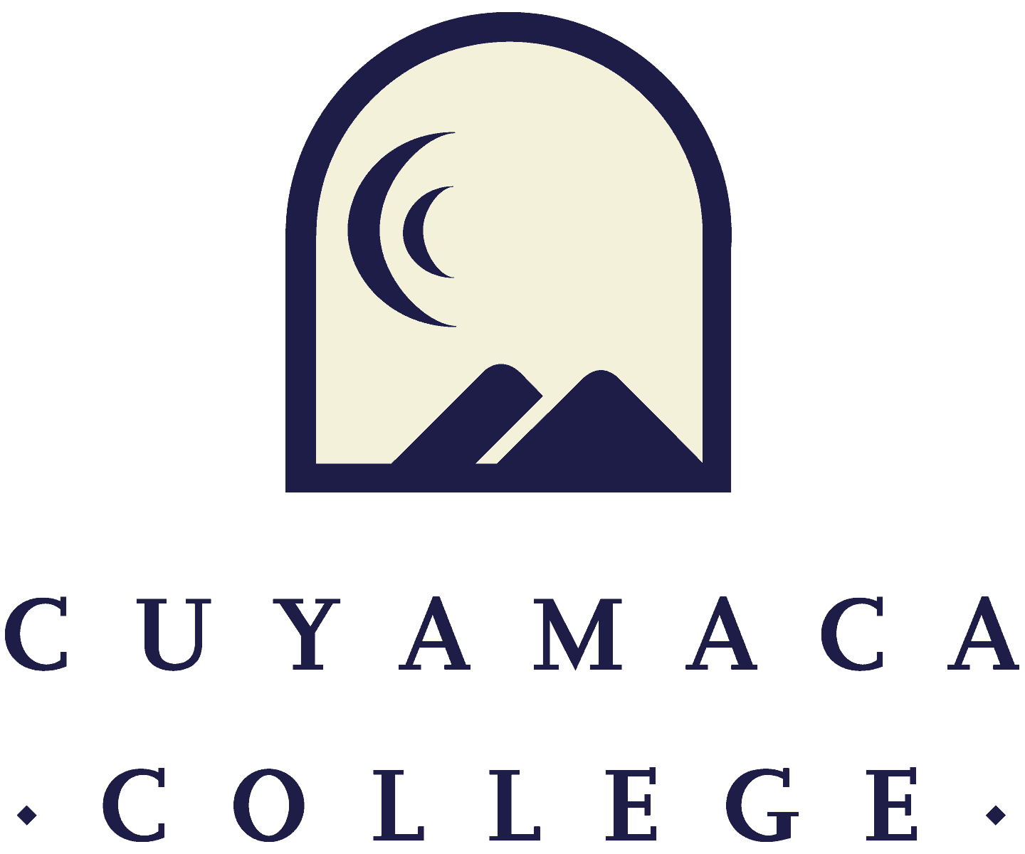

**Student Services and Non-Instructional Comprehensive Program Review Template Spring 2020**

**NOTE THAT ALL STUDENT SERVICES and NON-INSTRUCTIONAL COMPREHENSIVE PROGRAM REVIEWS MUST BE SUBMITTED ONLINE VIA SURVEYMONKEY.**

**THIS FORM IS PROVIDED FOR RESPONSE DRAFTING AND PLANNING PURPOSES ONLY.**

**EMAILS WITH THE LINK TO EACH SERVICE AREA’S ONLINE MODULE WILL BE PROVIDED IN NOVEMBER 2019.**

**IF YOU HAVE QUESTIONS ABOUT THE SURVEYMONKEY PROGRAM REVIEW MODULE, PLEASE CONTACT THE INSTITUTIONAL EFFECTIVENESS, SUCCESS, AND EQUITY OFFICE AT (619) 660-4380 brianna.hays@gcccd.edu.**

1. **Service Area Overview and Update**

I.1. Department(s) Reviewed:

I.2. Lead Author and Collaborators:

I.3. Manager:

1. **Service Area Reflection and Description**

II.1. Provide your service area’s mission statement.

II.2. Describe how your service area supports the [college mission](https://www.cuyamaca.edu/college-info/about/college-vision-mission.aspx).

II.3. Is the service area description in the current [college catalog](https://www.cuyamaca.edu/academics/catalog/files/part07-degree-requirements.pdf) up to date and accurate?  **Yes  No**

If no, what steps will you take to revise the college catalog description?

**III. Course Curriculum, Assessment and Student Success**

III.1. Does your service area offer any credit courses?  Yes  No

**IF YES, complete Section III Below**

**IF No, GO TO Section IV**

**Curriculum Review and Assessment**

***Provide an overview of your program’s Curriculum Review and Development status.***

III.2 [Access the Five Year Curriculum Review Cycl](https://www.cuyamaca.edu/in/committees/curriculum/default.aspx)e. Have all of your active course outlines been reviewed within the last five years?

Yes No (if no, please explain in Section III.3 below)

III.3. What changes are planned for the curriculum, both areas of revision and areas of development and growth?

***Please provide an overview of your Student Learning Outcomes Assessments***

**For assistance with SLOs, please contact SLO Coordinator Tania Jabour at** [**tania.jabour@gcccd.edu**](mailto:tania.jabour@gcccd.edu)**. For assistance with TracDat, please contact Madison Harding at** [**madison.harding@gcccd.edu**](mailto:madison.harding@gcccd.edu)**.**

**Additional resources are provided on the** [**Learning Outcomes and Assessment webpage**](https://www.cuyamaca.edu/college-info/planning/outcomes-assessment.aspx)

III.4. Do you have a course Student Learning Outcomes (SLO) assessment plan on file with Student Learning Outcomes & Assessment Committee (SLOAC) (or the SLO Coordinator)?

Yes  No

III.5. Please provide an analysis of your student learning outcomes (SLO) findings and what changes, if any, were made as a result.

III.6. What student learning-related successes and challenges have SLOs results revealed for your department?

*Note: If SLO data are not offering useful feedback regarding student learning, and are not currently informing program improvements, please instead discuss the specific steps you plan to take to make learning outcomes and assessments more meaningful.*

**Student Achievement**

# *Student characteristics and achievement data (both college-wide and by discipline) can be located on the* [*program review data webpage*](https://www.cuyamaca.edu/college-info/planning/program-review-data.aspx)*. In addition, student demographic and achievement data for categorical and other student services programs can be located on the* [*Completed Reports*](https://www.cuyamaca.edu/college-info/planning/institutional-research-completed-reports.aspx) *page under the Student Services/Categoricals menu.*

III.7. How has the department or discipline’s success rate across all courses changed over the past 5 years?

III.8. The College has set a 2024 goal of reaching a 77% course success rate (students passing with a grade of A, B, C, or P out of those enrolled at census) for the College as a whole. Consider how your department or discipline will help the College reach its long-term goal of increasing the course success rate to 77%.

What is your department or discipline's one-year (2020-21) goal for success rate across all courses in the department or discipline?

III.9. Please describe any equity gaps, in which specific groups (e.g., by gender and ethnicity) have success rates lower than that of the department or discipline overall.

III.10. What department/discipline (or institutional) factors may be contributing to these lower rates of success for these groups of students?

III.11. What specific steps will the department or discipline take to address these equity gaps in the 2020/21 academic year?

III.12. How do these steps inform the long-term department or discipline goals that you are setting in this comprehensive program review?

**Distance Education Course Success (If Applicable)**

Does your service area/program have distance education courses?

**Yes (proceed to III.13)  No (proceed to III.15)**

***For distance education teaching and learning resources, please visit the*** [***Online Teaching and Learning Committee intranet page***](https://www.cuyamaca.edu/in/committees/otlc/default.aspx) ***(note that your GCCCD username and password are required to log in to the intranet).***

III.13. Are there differences in success rates for distance education (online) versus in-person sections?

Yes  No (proceed to III.15)

III.14. If there are differences in success rates for distance education (online) versus in-person classes, what will the program do to address these disparities?

III.15. What mechanisms are in place to ensure regular and effective contact within online courses across the discipline or department?

**DEGREE/CERTIFICATE PROGRAMS**

1. **Degree and Certificate Programs**

IV.1. Does your service area offer any degree/certificate programs?

Yes  No, and it does not have Program-Level Outcomes (PLOs)  No, but it does have PLOs

**(If Yes, complete Sections IV. Below) (If No and it does not have PLOs, GO TO Section IV.10)**

**(If No but it does have PLOs, GO TO IV.7)**

IV.2. For each degree and certificate indicate how many awards were conferred in the past five years {upload excel spreadsheet}

IV.3. Please indicate when each degree and certificate was last reviewed and updated (semester):

IV.4. How are these degree/certificates meeting the needs of students, and/or articulation with four year institutions?

IV.5. Are there any changes planned if the degree/certificates are not meeting these needs?

IV.6. Can students complete the degree/certificate requirements within a two-year period?*

Yes  No, Please explain

*requirement of Title 5, California Code of Regulations

**Note: The college requires assessment of PLOs within a 4-year cycle**

IV.7. How are you currently assessing your PLOs?

IV.8. Are the PLOs in the catalog an accurate reflection of the department or discipline’s current learning objectives?

Yes  No {if no, briefly explain the plan to revise}

IV.9. Are the PLOs mapped to the course SLOs?

Yes  No

**IV.10 Does your service area directly serve students?**

**Yes (complete Section V)  No (go to Section VI)**

**V. Student Service Area Assessment & Data Analysis**

Please refer to your service area comparison reports provided by the Institutional Effectiveness and Student Equity Office to address the following questions. If your service area does not yet have student service access/utilization and demographic data, please contact [Brianna.Hays@gcccd.edu](mailto:Brianna.Hays@gcccd.edu).

**Student Access, Learning, and Achievement**

V.1. How does the service area student population differ from the College's overall student population, if at all?

V.2. How does the service area ensure it is addressing the needs of its student population?

V.3. Service areas are collecting data in many different ways. Please discuss the access, success and/or other data relevant to your service area.

V.4 What steps is your service area taking to advance the college’s student success and equity goals?

*Please upload any supporting documentation related to this section. You can upload PDF, Word, and image files.*

**Service Area Assessment**

**For assistance with SLOs/SSOs, please contact SLO Coordinator Tania Jabour at** [**tania.jabour@gcccd.edu**](mailto:tania.jabour@gcccd.edu)**. For assistance with TracDat, please contact Madison Harding at** [**madison.harding@gcccd.edu**](mailto:madison.harding@gcccd.edu)**.**

**Additional resources are provided on the** [**Learning Outcomes and Assessment webpage**](https://www.cuyamaca.edu/college-info/planning/outcomes-assessment.aspx)

V.5. Does your service area have a (SLO)/Student Services Outcome (SSO) assessment plan on file with SLOAC?

Yes  No

V.6. How are you currently assessing your SLO/SSOs?

**VI. Service Area Assessment and Institutional Effectiveness**

VI.1. In what way does your service area work across the college to advance the college’s student success & equity goals? Please contact the Institutional Effectiveness & Student Equity Office ([brianna.hays@gcccd.edu](mailto:brianna.hays@gcccd.edu) or 619.660.4060) for assistance in collecting data to inform your program review.

VI.2. Please review any research data and/or reports for your service area and summarize the findings and implications for practice. Please use the button below to upload any supporting documentation for this question.

**Strengths, Challenges & External Influences**

Consider your service area’s strengths, challenges, areas for improvement, and internal and external factors impacting services in your department.

VI.3. Please describe your service area strengths.

VI.4. Please describe your service area challenges.

VI.5. Please describe external influences that affect your service area (both positively and negatively).

VI.6. Given these factors, what opportunities exist for the service area to advance student success and institutional effectiveness in the next 4 years?

1. **Previous Goals: Update (If Applicable)**

**If you set goals in your last program review, please provide a status update, a summary of key action steps, and the results of these actions (if applicable). List previous goals as needed.**

**Goal 1:**

1. Goal 1:
2. Link to [College Strategic Goal](https://www.cuyamaca.edu/college-info/about/files/strategic-plan/2016-2022-Strategic-Plan-Cuyamaca.pdf) (Which College Strategic Goal does this department goal most directly support? **C*heck only one***)

Basic Skills Acceleration

Guided Student Pathways

Student Validation and Engagement

Organizational Health

1. Please describe how this goal advances the college strategic goal(s) identified above.
2. Goal Status

In Progress - will carry this goal forward into next year

Completed

Not Started

Deleted

***If Deleted or Completed:***

1. Please describe the results or explain the reason for deletion/completion of the goal:

***If This Goal Is In Progress Or Has Not Yet Been Started:***

1. Action Steps for the Year:
2. How will this goal be evaluated?

(Repeated as needed)

1. **New Goals**

If your program is proposing any new goals for this program review cycle, please state the new goal(s), summarize key action steps, and describe your plan to evaluate the outcomes/results of these actions.

**New Goal 1:**

1. New Goal 1:
2. Link to [College Strategic Goal](https://www.cuyamaca.edu/college-info/about/files/strategic-plan/2016-2022-Strategic-Plan-Cuyamaca.pdf) (Which College Strategic Goal does this department goal most directly support? **C*heck only one***)

Basic Skills Acceleration

Guided Student Pathways

Student Validation and Engagement

Organizational Health

1. Please describe how this goal advances the college strategic goal(s) identified above.
2. Please indicate how this goal was informed by SLO assessment results, PLO assessment results, student achievement data, or other data:
3. Action Steps for this Year:
4. How will this goal be evaluated?

[Repeated as needed]

**Executive Summary**

XVII.1. Provide a one-page executive summary of the following components of your program review

**(Complete this section after you have completed all of the other sections)**:

XVII.2. Program Overview and Description

XVII.3. Strengths

XVII.4. Challenges

XVII.5. External Influences

XVII.6. How assessment results have guided your program

XVII.7. Future Plans/Goals

XVII.8. Executive Summary:

**RESOURCES NEEDED TO ACHIEVE PROGRAM GOALS**

**Faculty Resource Needs**

*Contact Person: Bri Hays (*[*brianna.hays@gcccd.edu*](mailto:brianna.hays@gcccd.edu)*)*

***Link to Faculty Position Request Form- One form must be submitted for each request***

*Please submit an electronic Faculty Position Request Form for each position your department is requesting. A copy of the request form is posted to the* [*Program Review webpage*](https://www.cuyamaca.edu/college-info/planning/program-review.aspx) *(under the Staffing Request Information menu) for planning purposes.*

1. Faculty Position Request 1:
   1. Description
   2. This position is being requested to advance the following Program Goal(s):
2. Faculty Position Request 2:
   1. Description
   2. This position is being requested to advance the following Program Goal(s):

**Classified Staff Resource Needs**

*Contact Person: Bri Hays (*[*brianna.hays@gcccd.edu*](mailto:brianna.hays@gcccd.edu)*)*

***Link to Classified Position Request Form- One form must be submitted for each request***

*Please submit an electronic Classified Position Request Form for each position your department is requesting. A copy of the request form is posted to the* [*Program Review webpage*](https://www.cuyamaca.edu/college-info/planning/program-review.aspx) *(under the Staffing Request Information menu) for planning purposes.*

1. Classified Staff Position Request 1:
   * 1. Description
     2. This position is being requested to advance the following Program Goal(s):
2. Classified Staff Position Request 2:
   * 1. Description
     2. This position is being requested to advance the following Program Goal(s):

**Technology Resource Needs**

*Contact Person: Kerry Kilber Rebman (*[*kerry.kilberrebman@gcccd.edu*](mailto:kerry.kilberrebman@gcccd.ed)*u)*

***Link to Technology Request Form- One form must be submitted for each request***

**Supplies, Equipment & Other Resource Needs**

*Contact Person: Kerry Kilber Rebman (*[*kerry.kilberrebman@gcccd.edu*](mailto:kerry.kilberrebman@gcccd.edu)*)*

***Link to Supplies, Equipment & Other Resources Request Form-One form must be submitted for each request***

**Facilities Resource Needs**

*Contact Person: Francisco Gonzales (*[*francisco.gonzalez@gcccd.edu*](mailto:francisco.gonzalez@gcccd.edu)*)*

***Link to Facilities Request Form- One form must be submitted for each request***

**Have you completed all of the other sections of this program review?**

Yes  No