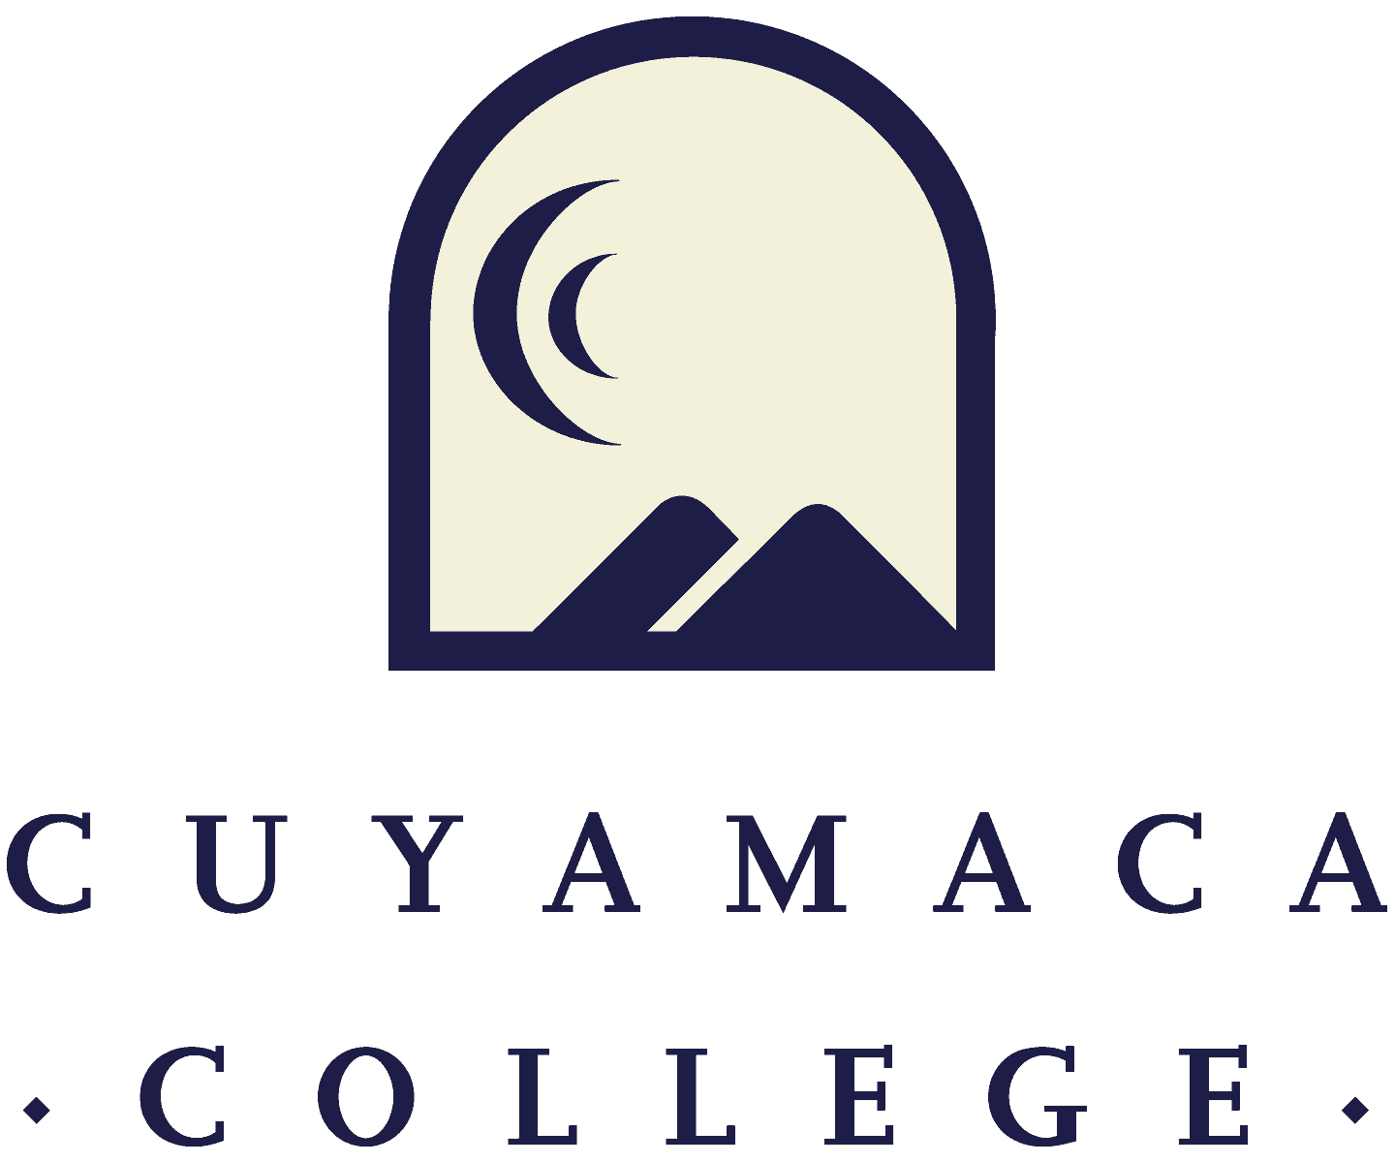

FALL 2023
Student and Instructional (Tutoring & Library) Services Program Review
Annual Update Template
FINAL

NOTE THAT ALL PROGRAM REVIEWS MUST BE SUBMITTED ONLINE VIA ONLINE SURVEY FORM.
THIS FORM IS PROVIDED FOR RESPONSE DRAFTING AND PLANNING PURPOSES ONLY.
EMAILS WITH THE LINK TO EACH SERVICE AREA’S ONLINE MODULE WILL BE PROVIDED IN FALL 2023.
IF YOU HAVE QUESTIONS ABOUT THE SURVEYMONKEY PROGRAM REVIEW MODULE, PLEASE CONTACT THE INSTITUTIONAL EFFECTIVENESS, SUCCESS, AND EQUITY OFFICE AT (619) 660-4380 brianna.hays@gcccd.edu.

Service Area Overview and Update

1. Department(s) Reviewed:
2. Lead Author:
3. Collaborator(s) {list any person that participated in the preparation of this report}:
4. Dean/Manager(s):
5. Initial Collaboration Date with Dean/Manager: Date your program met with your dean or manager to discuss your vision, goals, and resource needs/requests [MM/DD/YYYY]
6. Please summarize the changes, additions, and achievements that have occurred in your service area since the last program review. You can access fall 2022 program reviews on the program review webpage.
Student Learning Outcome/Service Area Outcome Assessment and Student Success
Please refer to your service area comparison or survey reports provided by the Institutional Effectiveness, Success, and Equity Office as well as any internal data your service area collects to address the following questions. If your service area does not yet have student service access/utilization and demographic data, please contact Brianna.Hays@gcccd.edu.

Student Access, Learning, and Achievement

7. Student Services areas collect data in many different ways. This may include the number of students, employees, or community members served, survey results, or other reports prepared by the department and external organizations. Which data was used for your service area?
8. Please discuss any equity gaps in access or success the data revealed.
9. What action will the department or discipline take to address these equity gaps? If equity gaps have been reduced or eliminated, please share what the program did to achieve this. If equity gaps still exist, consider the specific steps your department will take to address equity gaps.
10. How has this data impacted the goals set in your previous comprehensive program review {Data: Instruction/Student Services}?
11. Please describe the most significant or impactful ways your service area worked across the college to advance the college’s vision of equity, excellence and social justice through education over the past year.

12. What challenges is your service area still experiencing due to the disruption of operations caused by the pandemic and the need to offer services in various modalities?

Please upload any supporting documentation related to this section. You can upload PDF, Word, and image files.
Service Area Assessment

For assistance with SLOs/SAOs, please contact SLO Coordinators Tania Jabour at tania.jabour@gcccd.edu and Rachel Polakoski at rachel.polakoski@gcccd.edu. For assistance with TracDat, please contact Heyley Aubrey at heyley.aubrey@gcccd.edu. Additional resources are provided on the Learning Outcomes and Assessment webpage

- Did your program complete and submit SLO/SAO assessment in the last year? If you are unsure, check the most recent updates on your program’s SLO Assessment Updates.
☐ Yes ☐ No, please describe the department’s plan to update them
  - Which SLO/SAOs did you assess in the last year?
  - If you did not assess in the last year, please share why, including whether your program is experiencing barriers to assessment or data submission, and/or if your program would benefit from outcomes and assessment support.

- Please share any outcomes assessment projects your program has worked on in the last year, including SLO/SAOs on Canvas, PLOs by ACP, Equitable Assessment Strategies (innovative collective/common assessments, project-based, work-based learning, student-centered, etc.), or other.

Previous Goals: Update
For each of your program’s goals (as noted in your fall 2022 program review annual update), please provide a goal status update and, if applicable, the results of these actions. For a list of active goals as of fall 2022, visit the program review website to access the Previously Submitted Program Reviews Fall 2022 Program Reviews page.
Previous Goal 1:

Goal Status
☐ In Progress - will carry this goal forward into next year
☐ Completed
☐ Not Started
☐ Deleted

If Deleted or Completed:
Please describe the results or explain the reason for deletion/completion of the goal:

If it is Not Started, please share why - including whether your program is experiencing barriers for starting this goal
If it is In Progress, what actions steps from the last report have been completed and which ones are you still working towards
Link to 2022-2028 College Strategic Goal (Which College Strategic Goals does this department goal most directly support?) (Check only one)
☐ Increase equitable access (enrollment)
☐ Eliminate equity gaps in course success (passing grade in class)
☐ Increase persistence eliminate equity gaps (re-enrolling the subsequent semester or year)
☐ Increase completion and eliminate equity gaps (graduating with a degree/certificate, or transferring)
☐ Increase hiring and retention of diverse employees to reflect the students and communities we serve

Action Steps for the Next Year: If you are requesting resources in order to achieve this goal, please list them below as action steps and specify the type of request (e.g., submit technology request for new laptop computers).

What resources, if any, are needed to achieve this goal? Please select all that apply. Note that links to request forms for each request are included below. All resource requests are due on the program review deadline.
☐New faculty position [link to request form]
☐New classified position [link to request form]
☐Technology [link to request form]
☐Facilities renovation [link to request form]
☐Supplies, equipment, and/or furniture [link to request form]
☐Other, please specify: ____________ [link to request form]

(Repeated as needed)

New Goals
If your program is proposing any new goals for the remainder of your program review cycle (up to your next Comprehensive Program Review), please state the new goal(s), summarize key action steps for the next year, and describe your plan to evaluate the outcomes/results of these actions.

New Goal 1:

Link to 2022-2028 College Strategic Goal: Which College Strategic Goal does this department goal most directly address? (Check only one)
☐Increase equitable access (enrollment)
☐Eliminate equity gaps in course success (passing grade in class)
☐Increase persistence eliminate equity gaps (re-enrolling the subsequent semester or year)
☐Increase completion and eliminate equity gaps (graduating with a degree/certificate, or transferring)
☐Increase hiring and retention of diverse employees to reflect the students and communities we serve

Please describe how this goal advances the college strategic goal identified above.

Please indicate how this goal was informed by SLO assessment results, PLO assessment results, student achievement data, or other data:

Action Steps for this Year:

What resources, if any, are needed to achieve this goal in the next 4 years? Please select all that apply. Note that links to request forms for each request are included below. All resource requests are due on the program review deadline.
☐New faculty position [link to request form]
☐New classified position [link to request form]
☐Technology [link to request form]
☐Facilities renovation [link to request form]
☐Supplies, equipment, and/or furniture [link to request form]
☐Other, please specify: ____________ [link to request form]

RESOURCES NEEDED TO ACHIEVE PROGRAM GOALS
Faculty Resource Needs
Contact Person: TBD
Link to Faculty Position Request Form- One form must be submitted for each request

Please submit an electronic Faculty Position Request Form for each position your department is requesting. A copy of the request form is posted to the Program Review webpage (under the Staffing Request Information menu) for planning purposes.

Classified Staff Resource Needs
Contact Person: Bri Hays (Brianna.hays@gcccd.edu)
Link to Classified Position Request Form- One form must be submitted for each request

Please submit an electronic Classified Position Request Form for each position your department is requesting. A copy of the request form is posted to the Program Review webpage (under the Staffing Request Information menu) for planning purposes.

Technology Resource Needs
Contact Person: Jessica Hurtado Soto (jessica.hurtadosoto@gcccd.edu)
Link to Technology Request Form- One form must be submitted for each request

Supplies, Equipment & Other Resource Needs
Contact Person: Nicole Salgado (nicole.salgado@gcccd.edu)
Link to Supplies, Equipment & Other Resources Request Form-One form must be submitted for each request

Facilities Resource Needs
Contact Person: Francisco Gonzales (francisco.gonzalez@gcccd.edu)
Link to Facilities Request Form- one form must be submitted for each request

Have you completed all of the other sections of this program review?
☐ Yes ☐ No

