Tables for Math Department Annual Update Spring 2024
Table 9.1 Access
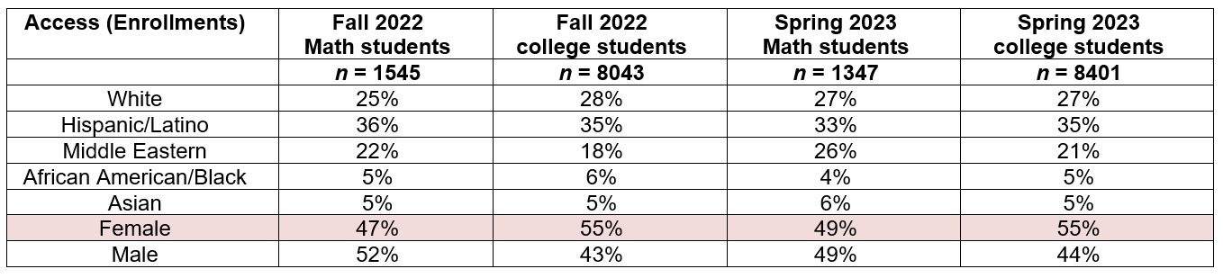

Table 9.2 Success
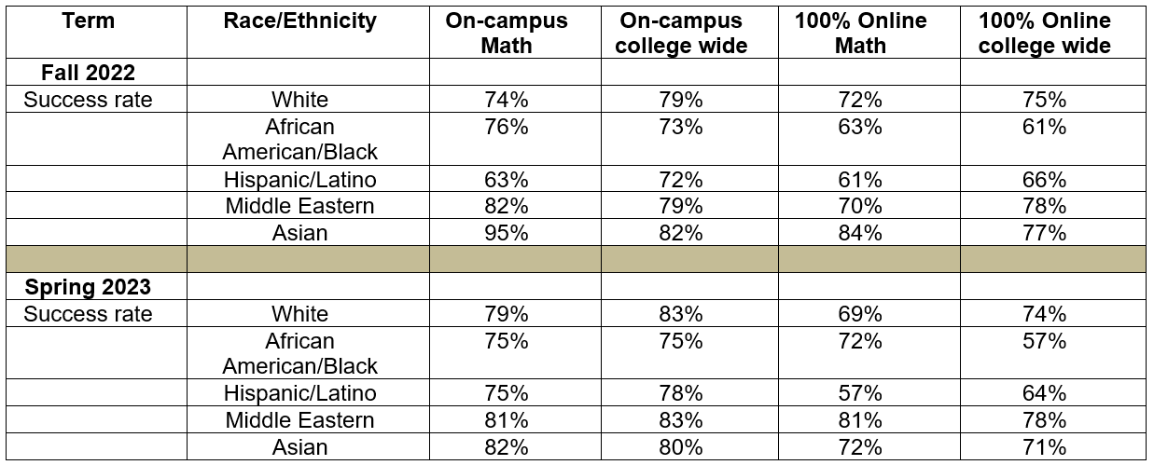

Table 12.1 Online Success
