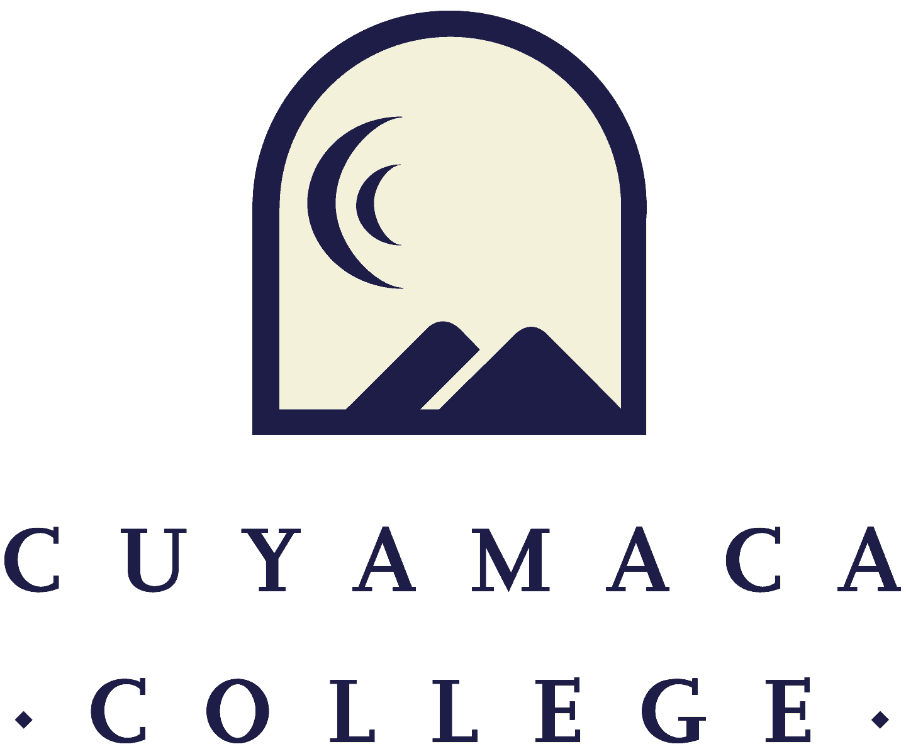

Fall 2023
Student and Instructional (Tutoring and Library) Service Areas
Comprehensive Program Review Template
FINAL

NOTE THAT ALL PROGRAM REVIEWS MUST BE SUBMITTED ONLINE VIA ONLINE SURVEY FORM.
THIS FORM IS PROVIDED FOR RESPONSE DRAFTING AND PLANNING PURPOSES ONLY.
EMAILS WITH THE LINK TO EACH SERVICE AREA’S ONLINE MODULE WILL BE PROVIDED IN FALL 2023.
IF YOU HAVE QUESTIONS ABOUT THE SURVEYMONKEY PROGRAM REVIEW MODULE, PLEASE CONTACT THE INSTITUTIONAL EFFECTIVENESS, SUCCESS, AND EQUITY OFFICE AT (619) 660-4380 brianna.hays@gcccd.edu.

Service Area Overview and Update

- Department(s) Reviewed: Cuyamaca College Health and Wellness Services

- Lead Author: Julia Priscilla Chavez, MSN-Ed, RN, PHN, PCCN

- Collaborators {list any person that participated in the preparation of this report}: Rieko Suto, BSN-RN, Rogelia Becerra, Supervisor Personal Counseling Team, Kaylin Rosal, MPH, Cuyamaca Cares Coordinator
4. Dean/Manager: Dr. Lauren Vaknin

5. Initial Collaboration Date with Dean: Date your service area met with your dean or manager to discuss your vision, goals, and resource needs/requests: 10.18.2023

Service Area Reflection and Description

6. Provide your service area’s mission statement. If your service area does not have a mission statement, what is your timeline for creating a mission statement?

The Cuyamaca Health & Wellness Center is committed to enhancing the educational process by reducing or modifying health related barriers to learning. Optimal wellness is achieved by encouraging students to be self-directed individuals who make informed decisions about health related concerns. Health Services facilitates learning by empowering students to be well informed consumers of health care services.

The Health & Wellness Center is committed to fostering health enhancing behaviors within social, physical, intellectual, emotional, and spiritual dimensions of student life.

7. Is the service area description in the current college catalog up to date and accurate?

☐X Yes ☐ No: What steps will you take to revise the college catalog description?

8. Describe how your service area advances the College's new vision of equity, excellence, and social justice through education? How does the service area reflect the College’s mission and values?

The Health and Wellness Services Center is in direct alignment with Cuyamaca College’s vision of equity, excellence, and social justice, by promoting access to Health and Wellness services through community and or campus resources. The Health and Wellness Center views student health, as a three dimensional realm, where physical, emotional, and social components are instrumental and directly play an important role in meeting academic objectives and achievements’.

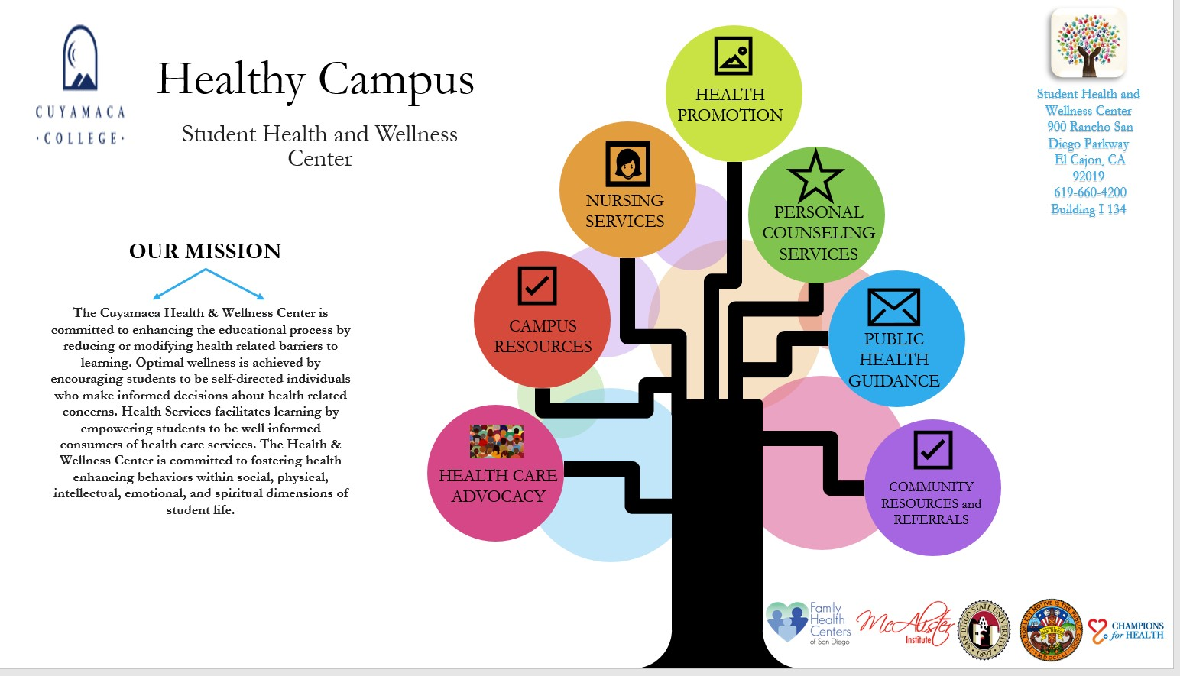

The Healthy Campus Framework incorporates six areas of focus to include: Nursing Services, Personal Counseling Services, Campus Resources, Public Health Guidance, Health Care Advocacy and Community Resources and Referrals in meeting the overall goal of Health Promotion. Promoting the overall well-being of our students physically, emotionally, and socially is very important and is directly tied to meeting academic achievements. When a student feels well, thinks well, and is supported they are more likely to reach their academic goals.

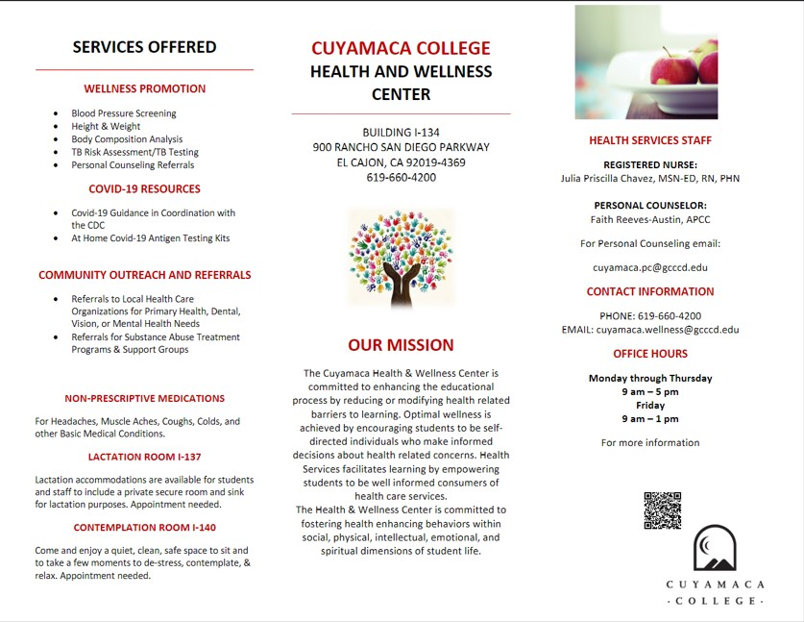

Student and Instructional Service Area Assessment & Data Analysis
Please refer to your service area comparison reports and other data provided by the Institutional Effectiveness, Success, and Equity Office or from within your program to address the following questions. If your service area does not yet have student service access/utilization and demographic data, please contact Brianna.Hays@gcccd.edu.

Student Access, Learning, and Achievement

Student Access:
Data are required to answer these questions. If no data are available, please describe the plan to gather, discuss, and use these data in the future.

9. Student Services areas collect data in many different ways. This may include the number of students, employees, or community members served, survey results, or other reports prepared by the department and external organizations. Which data was used for your service area?
A variety of collected data will be provided in supporting Health and Wellness Services to include the following:
      - Service Utilization Data from SARS: Unduplicated Student Count for Drop In’s. Code Reason Summary Report.
      - Covid 19-Data: Positive Cases, Potential Exposures, Covid 19 Antigen Testing Kits Released to Students versus Employees, Vaccine Participant Data
      - Tabling Event Numbers with Family Health Centers of San Diego
      - Health and Wellness Center Survey Results

Data:
Service Utilization Data SARS
- Unduplicated Count of Students Report SARS from 7.1.22 through 6.30.23
Appointment Status | Individual Count
Drop In’s | 1330

Drop In Students | 640
Appointments Only | 0
Total Unduplicated Contacts Health Services | 640

- Code Reason Summary Report SARS from 7.1.22 through 6.30.23
Reason Code | Description | Number of Student Contacts
Covid 19 | Covid 19 Guidance | 821
Follow Up | Follow up by RN | 162
TB Risk Assessment | TB Risk Assessment | 105
ILL/Assess | Illness and or Assessment by RN | 93
Other | Other | 27
Injury First Aid, ER | Injury, First Aid, Emergency Response | 22
Consult | Consultation with RN | 20
Mental Health | Mental Health Need | 17
OTC Meds | Administration Over the Counter Meds Ordered by MD | 16
B/P | Blood Pressure Monitoring | 14
Referral COMM | Referral Community | 9
Referral CAM | Referral Campus | 7
E.R. | Emergency Response by RN | 5
Misc. | Miscellaneous | 5
Anxiety | MH Anxiety | 2
Ins Claim | Insurance Claim Assistance | 2
Staff Assistance | Staff Assistance | 2
Accident Report | Accident Reporting | 1
Crisis Intervention | Crisis Intervention | 1
Advise | E Advising by RN | 1
Female | Gender Female | 1
Supplies | General Supplies | 1
Total Student Contacts |  | 1,134

Covid-19 Data and Vaccine Participant Data
- Covid 19 Table Data from 7.1.2022 through 6.30.2023
Description | Summer 2022 | Fall 2022 | Spring 2023
Total Number of Positive Covid 19 Cases Reported to Health Services Cuyamaca College | 5 | 48 | 17
Total Number of Illness Rule Outs to Include Flu Reported to Health Services Cuyamaca College | 0 | 15 | 12
Total Number of Covid 19 Exposures on Campus | 64 | 943 | 352
Total Number of Covid 19 At Home Antigen Kits Distributed to Students | 786 | 700 | 817
Total Number of Covid 19 At Home Antigen Kits Distributed to Employees at CC | 301 | 179 | 137

- Vaccine Data Covid 19 and Influenza Participant Count Champions for Health
Vaccine Event Date | Participant Count | Vaccines Offered
8.8.2022 | 0 | Moderna, Pfizer
9.12.22 | 11 | Moderna, Pfizer Bivalent
10.10.22 | 10 | Moderna, Pfizer Bivalent, Influenza
11.14.22 | 10 | Moderna, Pfizer Bivalent, Influenza
1.30.23 | 1 | Moderna, Pfizer Bivalent, Influenza
2.27.23 | 0 | Moderna, Pfizer Bivalent, Influenza
3.20.23 | 3 | Moderna, Pfizer Bivalent, Influenza
4.24.23 | 1 | Bivalent Covid 19
5.22.23 | 1 | Bivalent Covid 19
6.12.23 | 1 | Bivalent Covid 19
Total Participants | 38

Participant Data Tabling Events

- Participant Data for Family Health Centers of San Diego Tabling Events
Date | Number of Participants
10.10.22 | 2
10.11.22 | 25
10.25.22 | 31
11.8.22 | 12
11.14.22 | 2
1.31.23 | 25
2.28.23 | 12
3.21.23 | 12
4.25.23 | 6
5.23.23 | 8
6.13.23 | 6
Total Participants | 141

- Heart Event: Importance of Knowing your Heart Numbers Tabling with Registered Nursing
Fifteen students participated in the “Importance of Knowing your Heart Numbers” tabling event with Registered Nursing. Approximately 53% of these students identified as Hispanic/Latino, 20% White, 13% Middle Eastern, 7% African-American or Black, and 7% identify with another race or ethnicity. Two in three participants identified as male (66%), and one in three identified as female (33%). The majority of participants were age 24 or younger, with 28% under 20 years old and 50% age 20-24 years old. Approximately 27% indicated they are an athlete.
The body mass index (BMI) of participants ranged from 16.6 to 31, and participants’ body fat percentage ranged from 10.9% to 43.9%.

Student Characteristics | Count | Percent of Total
African-American/Black | 1 | 7%
American Indian/Alaskan Native | 0 | 0%
Asian | 0 | 0%
Hispanic/Latino | 8 | 53%
Middle Eastern | 2 | 13%
Pacific Islander | 0 | 0%
White | 3 | 20%
Other race or ethnicity | 1 | 7%
Female | 5 | 33%
Male | 10 | 67%
Unknown gender | 0 | 0%
<20 years | 5 | 28%
20-24 years | 8 | 50%
25-39 years | 1 | 7%
40+ years | 1 | 15%
Athlete | 4 | 27%
Not an athlete | 6 | 40%
Unknown athlete status | 5 | 33%
Total | 15 | 100%

- Health and Wellness Student Survey Demographics

- MEDICAT EHR DATA:
Diagnosis Group | Diagnosis Code | Quantity
Nursing Diagnosis | Nurse Recommendations | 75
Nursing Diagnosis | ILI (Influenza Like Illness) | 32
Nursing Diagnosis | Cough | 17
Nursing Diagnosis | Headache | 15
Nursing Diagnosis | Blood Pressure | 15
Nursing Diagnosis | Medical Advice | 13
Nursing Diagnosis | Abdominal Pain | 12
Nursing Diagnosis | Head Injury | 12
Nursing Diagnosis | Finger Laceration | 11
Nursing Diagnosis | Finger Pain | 11
Nursing Diagnosis | Dizziness | 10
Nursing Diagnosis | Back Pain | 9
Nursing Diagnosis | Boil | 7
Nursing Diagnosis | TB Assessment | 6
Nursing Diagnosis | Insurance | 5
Nursing Diagnosis | Knee Pain | 5
Nursing Diagnosis | Menstrual Cramps | 5
Nursing Diagnosis | Concussion | 4
Nursing Diagnosis | Diarrhea | 4
Nursing Diagnosis | Eye Pain | 4
Nursing Diagnosis | Lab Test | 4
Nursing Diagnosis | General Pain | 3
Nursing Diagnosis | TB Questionnaire | 1
Nursing Diagnosis | Allergic Reaction | 1
Nursing Diagnosis | Burn | 1
Nursing Diagnosis | Ear Pain | 1
Nursing Diagnosis | Arm Pain | 1
Nursing Diagnosis | Nausea | 1
Total Nursing Diagnoses |  | 285

10. How do the students served by the service area differ from the College's overall student population, if at all?

Demographic Data from the Health and Wellness Student Survey 2022-2023, provided the following analysis:
The Health & Wellness Center’s in-reach and outreach efforts to serve Latino/a/x students made a positive impact: Approximately 44% of the students who received these services identify as Latino/a/x, compared to 34% of our college population. Similarly, efforts to serve students with at least one disability made a positive impact: Approximately 12% of the students who received these services have at least one disability, compared to 7% of our college population.

11. Please discuss any equity gaps in access or success.
Additional analysis through the Office of IESE via the Health and Wellness Center Survey demonstrated the following:
Compared to our student population in 2022-2023, the following groups are slightly underrepresented in the Health Services data:

• Female students (female students comprise 53% of students who used Health Services, compared to 55% of our student population)
• Black students (Black students comprise 5% of students who used Health Services, compared to 6% of our student population); please note that your in-reach and outreach efforts to serve Black students made a positive impact—in 2021-2022, only 3% of students who used Health Services identified as Black, and this increased to 5% in 2022-2023.
• Native American students (no Native American students used Health Services in this time frame, even though they comprise 1% of our student population)
• Students who identify with two or more races or ethnicities (these students comprise 4% of students who used Health Services, compared to 5% of our student population)
• Students who are less than 20 years old (students <20 years old comprise 22% of students who used Health Services, compared to 27% of our student population)
• Students who are 25+ years old (these students comprise 32% of students who used Health Services, compared to 41% of our student population)
• Students who are first-generation college students (these students comprise 31% of students who used Health Services, compared to 34% of our student population)

12. What action will the service area take to address these equity gaps? If equity gaps have been reduced or eliminated, please share what your area did to achieve this. If equity gaps still exist, consider the specific steps your service area will take to address equity gaps.
Additional in-reach and out-reach efforts are needed with the above identified groups to include females, African Americans, Native Americans, to include targeted age ranges of students younger than 20-years of age, and students who are greater than 25 years of age. In addition, efforts to reach first generation college students has also been identified. In-reach and Outreach efforts consist of tabling events, workshops promoting health and wellness, and bringing local health care resources to campus supporting health care that is available locally. The Health and Wellness Services Center supports access to care, and providing venues to bring these resources to students on campus will be adopted. According to the National Institute of Health, health care disparities are rising especially in the African American and Native American population. Health care topics of Interest include:
Health-Care Disparities among African Americans and Native Americans and the Importance of Accessing Health Care in Bridging the Gap
Heart Health: As cardiovascular disease is a major source of concern in all minority groups
Brain Health: Cerebrovascular health is also a major concern as the risk of stroke rises in those that are not treated with cardiovascular disease
Reproductive Health: An important topic for the age range of 18-45, to include preventative care and management of diseases associated with this age group.
13. How has this data impacted the goals set in your previous comprehensive program review (link)?
Compared to the spring 2020 Comprehensive Program Review, robust data to include both qualitative and quantitative is available, as a result of a newly developed Health and Wellness Center Survey, and an Electronic Medical Health Record (MediCat) where data can be further accessed based on nursing diagnosis. Prior data was limited to Code Reasons accessed via SARS; however, this data is still vital in assessing overall student drop-ins to Health and Wellness Services.
14. Please describe the most significant or impactful ways your service area worked across the college to advance the college’s vision of equity, excellence and social justice through education over the past year.

Health and Wellness has established solid partnerships with the County of San Diego to include local health care organizations as Family Health Centers of San Diego, OPSAM Health, Champions for Health, Paws to Share, San Diego Blood Bank, and a contracted physician, Dr. Flora Danque, M.D. who oversees the Health and Wellness Registered Nursing Staff. Such partnerships only solidify further excellence and the vision of equity in providing health care resources on campus. Further, the partnership with Dr. Flora Danque, M.D. aligns with safe nursing practices and relevancy of care as it related to evidenced-based nursing protocols and processes.

15. What challenges is your service area still experiencing due to the disruption of operations caused by the pandemic and the need to offer services in various modalities?

Our service area is directly impacted by the Covid 19 pandemic in that an increase in use of services to include guidance for Covid 19 care, Covid 19 Testing Kit Access, and exposure notices to students with coordination of care in keeping professors aware of medical excuses can be a challenge with one RN currently practicing out of Health Services. Despite the limited number of current nurses, campus safety is of the utmost priority and safety measures have always been managed successfully.

Please upload any supporting documentation related to this section. You can upload PDF, Word, and image files

Student Learning Outcome and Service Area Outcome Assessment

- Please upload an updated, current version of your SLO/SAO assessment plan.
Ideally, the updated plan should specify assessment semesters for all outcomes over the next 4 years, between this comprehensive program review and the next. See a sample Assessment Plan Template.

Student Learning Outcome and Service Area Outcome Assessment (SLO/SAO Fall 2023)
Health and Wellness Services for Students

SAO#1: Employ effective referral practices that promote student follow through with local health service providers in meeting each students’ individualized health care needs.
SLO#1: Students will engage in wellness promotion practices available through the Health and Wellness Services Center, which will contribute to their overall well-being in alignment with a healthy campus framework further enhancing their academic journey at Cuyamaca College.

Please note SLO’s and SAO’s were updated to reflect the current needs of the Health and Wellness Service Department and student needs in the fall of 2022.

Here please upload your SAO/SLO Document

- What are your department’s key assessment findings over the past 4 years? Please include data and reflection pertaining to each of your current SLOs/SAOs in your response.
Please upload relevant assessment data, including reports, supporting documents, descriptions of methods of assessment, etc.

Upload all data tables here.

Key assessment findings over the past four years include Cuyamaca College students have readily utilized Health and Wellness Services as noted by the steady increase in numbers of students accessing various health services offered through our Health and Wellness Department. The primary accessed service is that of health care guidance as it relates to Covid-19 care, such guidance has been coordinated with our local public health department and totaled approximately 821 interactions.

A second key assessment finding, is that students have directly been impacted by the Covid-19 pandemic and have sought out additional resources to include assistance with primary care referrals, local health care referrals, and an increase in services as it relates to mental health needs. These needs have been met with outreach efforts to include the following organizations:

- Family Health Centers of San Diego: Both physical and mental health care need referrals.
- Champions for Health: Vaccination events to include both monovalent and bivalent Covid 19 vaccines, and annual influenza/flu vaccines on campus.
- Say San Diego: Education on smoking and vaping cessation during annual health fairs on campus
- Kickstart: Mental health resource referrals.
- Department of Public Health San Diego: All Covid 19 guidance for isolation and home care, to include exposure notifications
- OPSAM Health: Physical health referrals.
- YMCA McGrath Location: Local resources in promoting optimal health through exercise, socialization, and nutrition.
- San Diego Blood Bank: Blood donations via the bloodmobile parked on campus.
- Paws to Share: Emotional canines to support the student during crucial time periods on campus (midterms, finals.)
- McAlister Institute: Substance misuse referrals.

A third key finding is that of the need for mental health support through the use of supportive services offered through our Personal Counseling Department. With the Covid-19 pandemic and return to campus services, students have expressed the need for emotional, social, and mental support, in acclimating to new standards and navigating new processes that are required in both their academic and personal lives.

- Overall, what do your SLO/SAO data suggest about student experiences, successes, and challenges in your service area?

With SLO#1: Students will engage in wellness promotion practices available through the Health and Wellness Services Center, which will contribute to their overall well-being in alignment with a healthy campus framework further enhancing their academic journey at Cuyamaca College, supports that students are accessing wellness promotion resources available to include access to free Covid 19 at home testing antigen kits and vaccine participation for both Covid-19 and influenza vaccines. Although, the numbers early on in the pandemic with mandated vaccination efforts, reflect three times higher values with the total number of participants, students continue to have the opportunity to receive a vaccine for Covid 19 or influenza based on their personal choice.

In addition, with the data of Covid-19 antigen testing kits supplied to 786 students in the summer of 2022, 700 kits supplied in the fall of 2022, and lastly 817 kits supplied during the spring semester of 2023 to students, this suggests that students have utilized available resources on campus in promoting safe health care practices. Furthermore, with the data from the Reason Code Summary Report from SARS, of 821 students have been guided regarding Covid-19 care in accordance with our local public health department and the second highest value at 162 students have followed up for care with nursing for various health care concerns.

The third highest number of student contact was related to TB Risk Assessments in accordance to the California Department of Public of Health at 105 participants. Of special note, 93 students have been assessed by nursing for some form of illness or injury, and 22 have been seen for either a first aid injury or an emergency response need, where 911 services has been activated.

With SAO#1: Employ effective referral practices that promote student follow through with local health service providers in meeting each students’ individualized health care needs, such an objective has been met and reflective through the data with tabling events provided by Family Health Centers of San Diego, and referral processes documented through SARS, and data collected from Medicat EHR. Tabling events where Family Health Centers directly books appointments or assists with the referral process for enrollment for Medical and or Covered California has ranged from two to thirty one participants. Data from SARS reports that seven referrals have been made within the campus and nine referrals have been outsourced to local health care organizations. In addition, with the implementation of a new electronic health record, Medicat EHR, in March of 2023, 75 students have been provided with nurses recommendations as it relates to recommendations for health care.

With the initiation of both a paper survey and live link survey in March of 2023, titled “Health and Wellness Center Survey” a ten question survey was created with the assistance of the Offices of Institutional Effectiveness, Success, and Equity. This survey consisted of both demographic and Likert scales for the student to reflect on services received through the Health and Wellness offices. Of this data, 56% of the respondents accessed personal counseling services, with the second ranking of 15% of respondents accessing some form of wellness promotion to include blood pressure screening, height and weight measurements, body composition analysis and Tuberculosis Testing. Approximately 7% of respondents had accessed non-prescriptive medications for simple aches, pains, or minor illnesses. Positive feedback was received in areas of recommending the Health and Wellness Service Center to others at 82% and the comfort level of returning to Health and Wellness Services for additional services or care ranked at 82%. Approximately 79% of respondents felt welcomed at Health and Wellness Services with 73% of those respondents feeling their questions and or concerns were adequately addressed. Such data supports SLO#1 whereby students will engage in wellness promotion practices available through campus support services.

Challenges noted were related to the ease of finding information about Health and Wellness Services, which was ranked at 77% and the ease of scheduling an appointment was ranked at 72%. Such data demonstrates the need to utilize more in-reach efforts within various departments of Student Services at Cuyamaca College, and perhaps, updating the Health and Wellness Webpage with a more simplified version of what services are available, to include how to access these services. After analysis of the student feedback survey results from spring 2023, the Health Services RN Supervisor met with Research Analyst Katie Cabral from the Offices of IESE in the summer of 2023, to further modify the student survey to include additional data specific to student needs was identified; hence, three additional questions have since been added to the survey to capture specific data related to student needs and what was identified as the best experience to include areas needed for improvement:

            - What did you like the most about the services you received at Health and Wellness Center
            - What could the Health and Wellness Center do to improve your experience today
            - What educational topics related to health and wellness would you like to see provided. Please select all that apply:
Heart Health
Mental Health
Women’s Health
Men’s Health
Another Topic

In summary, all of the aforementioned data supports the objectives of student engagement in wellness promotion practices that are available through the Health and Wellness Services Department at Cuyamaca College to include access to referral practices that support individualized health care needs of our diverse student population.

- Share an example of meaningful, innovative, equitable, and/or student-centered SLO/SAO assessment happening in your program.

Without affecting HIPAA policies regarding student/patient medical confidentiality, students have been reporting that access to both physical and mental health resources on campus have positively impacted their college experience. Students are known to come to Health and Wellness Services as a safe zone simply to de-stress, re-align, and gain knowledge on better advocacy and coping skills in such demanding times. With housing, and food known as a basic right on campus, students are learning that health care access is also a basic right, and feel better equipped to utilize available resources. Granted, Health and Wellness Services is supportive in nature, students have identified that Health and Wellness Services is a location to access further guidance in health care access with confidentiality in mind.

- Discuss how your SLO/SAO data are being used for service area and/or course improvements to advance student retention, success, and/or goal achievement.

Without data to include the Student Health and Wellness Survey, SARS, Medicat EHR, and the data tracked via tabling and vaccine events, Health and Wellness would not be able to identify specific student needs and requests. One can’t improve, what is not measured, and data is central to our improvement of services to include the specific wants of our student population. As mentioned prior, the Student Health and Wellness Survey has since been modified in early summer 2023, to capture specific educational topics the student is interested in and what is and what is not currently working best in accessing care and services through Health Services.
Strengths, Challenges & External Influences

Consider your service area’s strengths, challenges, areas for improvement, and internal and external factors impacting services in your department.

21. Please describe your service area strengths.

With supportive data from the Cuyamaca Health and Wellness Center Survey from the spring of 2023, nearly 80% of our students utilizing services from Health and Wellness Services felt welcomed by staff, in addition, 73% percent of our students felt that questions and concerns were adequately addressed and 76% of students felt that resources and referrals provided from staff of the Health and Wellness Services Center were appropriate and useful. Hence, our service area strengths are that of a welcoming, trustworthy, and reliable health services department. In addition, approximately 82% of our students would strongly agree in recommending the Health and Wellness Services Center to others for their supportive health service’s needs.
Furthermore, the partnerships developed with Champions for Health and Family Health Centers for San Diego, further solidify the importance of establishing ties with the community in assisting our students in accessing further health care needs. Therefore, additional strengths lie in our community partnerships in assisting student’s access to further care. Overall, our strengths include reliability, trust, welcoming safe environment, and useful and appropriate available resources with growing partnerships in the community. An additional service area strength is the ease at which Registered Nursing staff have access to a contracted physician for further supervision and guidance in meeting evidenced-based safe nursing practices.

- Please describe your service area challenges.

Some of our service area challenges include the ease of accessing services to include student awareness of the services offered. This has been directly voiced by students with comments such as “I didn’t know a Health Services area existed” or “I tried to make an appointment via SARS and it would not allow me to book an appointment, so that is why I’m calling.”

In addition, limited resources with the personal counseling department in having the SDSU graduate interns available only available certain days of the week and hours can directly impact the student with limitations in accessing services for those who take evening or weekend classes.

Financial constraints also impact our service area in that we are budgeted for a ten-month RN and a twelve-month RN Supervisor, the reduced hours for the ten-month RN affects both in-reach and outreach efforts, as care for students must be prioritized and triaged; hence, outreach and in-reach efforts move to the lower priority level as students with illnesses, guidance needs, and or referrals must be seen first. Moreover, our department does not currently have a full-time licensed LMFT. Personal Counseling services are provided through student externs from SDSU, and supervised by a contracted LMFT with limited hours per week.

An additional external challenge has been the request from the California Department of Public Health for CLIA certification. CLIA stands for Clinical Laboratory Improvement Amendments which would allow Health and Wellness Registered Nursing staff to perform Point of Care Blood Glucose levels if needed when an individual presents with signs or symptoms of either hyperglycemia or hypoglycemia, Covid 19 Rapid Antigen Testing, and HCG Urine Pregnancy Testing. A new application with the license request was placed in November of 2022, and several changes have been made to the application as requested by CDPH; however, processes have been delayed due to requests for changes that need to be approved by the Contracts and Purchasing Department. Despite such, the application remains under review by CDPH and we remain hopeful that it is just a matter of time when the certificate will be approved.

- Please describe external influences that affect your service area (both positively and negatively).

External influences that directly affect our service area are that of community partnerships. Having a solid relationship with various constituents in health care locally is very important. Currently, our partnerships with Champions for Health, Family Health Centers of San Diego, McAlister Institute, Paws to Share, Kick Start, Say San Diego, San Diego Blood Bank and the Public Health Department of San Diego for Covid 19 Guidance are very important. However, further robust efforts are needed in the mental health arena and with efforts to bring services directly onto campus. More awareness is needed in the area of mental health wellness and to reduce the negative stigma associated with those with mental health needs. Goals for the future involve partnerships with outreach and in-reach in educating our community college population on the importance of well-being in the three dimensional realm, where physical, emotional, and social components are instrumental and directly play an important role in meeting academic objectives and achievements’.

24. Given these factors, what opportunities exist for the service area to advance the College’s goals in the next 4 years?

Opportunities lie both within our local community and our own respective student services departments. All available resources need to be advertised in a central hub, with ease in access for our students. In addition, in-reach efforts need to be tailored for the student who attends classes in the evening or weekend classes. Robust relationships with local health care organizations need further attention and access to local mental health resources are needed. Furthermore, an advanced health care model is needed in keeping with the overall mission of Health and Wellness Services.
The Education and Training Group, a non-profit organization referred to as ETR has established a Well-Being & Resilience Model, which strives in improving health outcomes for college campuses, and this model has excellent strategies that I recommend be adopted in keeping our campus community in alignment with practices of optimal wellness.

Previous Goals:
For each of your program’s goals (as noted in your Fall 2022 program review annual update), please provide a goal status update and, if applicable, the results of these actions. For a list of active goals as of Fall 2022, visit the program review website to access the Previously Submitted Program Reviews Fall 2022 Program Reviews page.
Previous Goal 1:

Cuyamaca College Health and Wellness Services; a supportive health center for students at Cuyamaca College, will collaborate with local health organizations in providing referrals based on individualized student needs to include medical care, mental health care, health insurance enrollment assistance, and wellness promotion resources.

Goal Status
X☐ In Progress
☐ Completed
☐ Not Started
☐ Deleted

If Deleted or Completed:

This goal is still In Progress.

Please describe the results or explain the reason for deletion/completion of the goal:

Neither deletion nor completion of this goal has been identified. Please see the area discussing a work in progress.

If it is Not Started, please share why including whether your program is experiencing barriers for starting this goal

N/A
If it is In Progress, what actions steps from the last report have been completed and which ones are you still working towards:
Although partnerships have been developed with two primary local health organizations to include Champions for Health and Family Health Centers for San Diego, other local health organizations to include mental health resources are needed. One access point is that of the San Diego Access Crisis Line and their Mobile Unit for Crisis Interventions. In addition, there are free access programs through the County of San Diego that may be accessed to include free vaccines for influenza that can be offered directly from our health services center. In essence, additional partnerships are needed with other local health care organizations and that of the Public Health Department of San Diego. The California Department of Public Health has been central in providing the Health and Wellness Center with thousands of free at home Covid 19 antigen testing kits, and we will continue to outreach bi-annually for this resource.

Link to College Strategic Goal (Which College Strategic Goal does this department goal most directly support? (Check only one)
☐ Increase equitable access (enrollment)
☐ Eliminate equity gaps in course success (passing grades) rates
X☐ Increase persistence (students re-enrolling semester after semester) and eliminate equity gaps
☐ Increase completion rate (graduation with a degree/certificate or transfer within 4-years) and eliminate equity gaps
☐ Increase hiring and retention of diverse employees

Action Steps for the Next Year: If you are requesting resources in order to achieve this goal, please list them below as action steps and specify the type of request (e.g., submit technology request for new laptop computers).

What resources, if any, are needed to achieve this goal? Please select all that apply. Note that links to request forms for each request are included below. All resource requests are due on the program review deadline.
☐ New faculty position [link to request form]
☐ New classified position [link to request form]
☐ Technology [link to request form]
☐ Facilities renovation [link to request form]
☐ Supplies, equipment, and/or furniture [link to request form]
☐ Other, please specify: ____________ [link to request form]

(Repeated as needed)
N/A

4-Year Goals

Please describe the department’s long-term, overarching goals for this comprehensive program review cycle (the next 4 years). Please state the new goal(s), summarize key action steps for the next academic year, and describe your plan to evaluate the outcomes/results of these actions. You may include previous goals that the program is continuing into this comprehensive program review cycle. PRSC recommends identifying a small number of (1 to 4) broad goals to address over the next four years so that they can help the program focus its efforts.

New Goal 1:

Cuyamaca College Health and Wellness Services; a supportive health center for students at Cuyamaca College, will collaborate with local health organizations in providing referrals based on individualized student needs to include medical care, mental health care, health insurance enrollment assistance, and wellness promotion resources.

New Goal 2:

Cuyamaca College Health and Wellness Services; a supportive health center for students at Cuyamaca College, will adopt a well-being and resilience model in alignment with best practices for self-care in the areas of physical self-care, psychological self-care, emotional self-care, spiritual self-care and professional self-care. These personal practices for self-care will provide a structural framework for students to refer to with education on specific practices in meeting individual goals in improving overall health and well-being.

Link to 2022-2028 College Strategic Goal: Which College Strategic Goal does this department goal most directly address? (Check only one)
☐ Increase equitable access (enrollment)
☐ Eliminate equity gaps in course success (passing grades) rates
X☐ Increase persistence (students re-enrolling semester after semester) and eliminate equity gaps
☐ Increase completion rate (graduation with a degree/certificate or transfer within 4-years) and eliminate equity gaps
☐ Increase hiring and retention of diverse employees

Please describe how this goal advances the college strategic goal identified above.

By assisting student’s access local health resources and promotion of best health care practices with education, Cuyamaca College students will be better equipped as health care consumers in addition to self-care practices that are critical for maintaining well-being in several domains to include physical, mental, social, and spiritual.

Please indicate how this goal was informed by SLO/SAO assessment results, PLO assessment results, student achievement data, or other data:

Our data indicates that students are willing to utilize available resources in alignment with best health care practices; however, further refinement of the Health Care Center Framework is needed in meeting the various demands of the community college student. An updated framework which will outline specific strategies related to self-care efforts in the following domains will be utilized in meeting the overall strategic goal:

- Physical
- Psychological
- Emotional
- Spiritual
- Professional

Personal practices for self-care in the five aforementioned areas will allow the student to learn coping strategies enhance social connections, and reaffirm the purpose of their overall intentions and goals in alignment with their academic journey at Cuyamaca College.

Action Steps for this Year:

What resources, if any, are needed to achieve this goal in the next 4 years? Please select all that apply. Note that links to request forms for each request are included below and due on the program review deadline.
☐ New faculty position [link to request form]
☐ New classified position [link to request form]
☐ Technology [link to request form]
☐ Facilities renovation [link to request form]
☐ Supplies, equipment, and/or furniture [link to request form]
☐ Other, please specify: ____________ [link to request form]

How will this goal be evaluated?
[Repeated as needed up to 4 goals]

The two goals will be evaluated via various instruments to include:
- Confidential Health and Wellness Student Service Surveys

- Data from Health and Wellness Promotion Events to include: Annual Health Fair, Heart Health Awareness Events, Breast Health Education Event, Vaccine Events, Mental Health Awareness Events, and other confidential data collected by the Personal Counseling Team.

RESOURCES NEEDED TO ACHIEVE PROGRAM GOALS
Faculty Resource Needs
Contact Person: TBD
Link to Faculty Staff Request Form- One form must be submitted for each request

Please submit an electronic Faculty Position Request Form for each position your department is requesting. A copy of the request form is posted to the Program Review webpage (under the Staffing Request Information menu) for planning purposes.
Classified Staff Resource Needs
Contact Person: Bri Hays (Brianna.hays@gcccd.edu)
Link to Classified Position Request Form- One form must be submitted for each request
Please submit an electronic Classified Position Request Form for each position your department is requesting. A copy of the request form is posted to the Program Review webpage (under the Staffing Request Information menu) for planning purposes.
Technology Resource Needs
Contact Person: Jessica Hurtado Soto (Jessica.hurtadosoto@gcccd.edu)
Link to Technology Request Form- One form must be submitted for each request

Supplies, Equipment & Other Resource Needs
Contact Person: Nicole Salgado (nicole.salgado@gcccd.edu)
Link to Supplies, Equipment & Other Resources Request Form-One form must be submitted for each request

Facilities Resource Needs
Contact Person: Francisco Gonzales (francisco.gonzalez@gcccd.edu)
Link to Facilities Request Form- One form must be submitted for each request

Have you completed all of the other sections of this program review?
☐ Yes ☐ No

