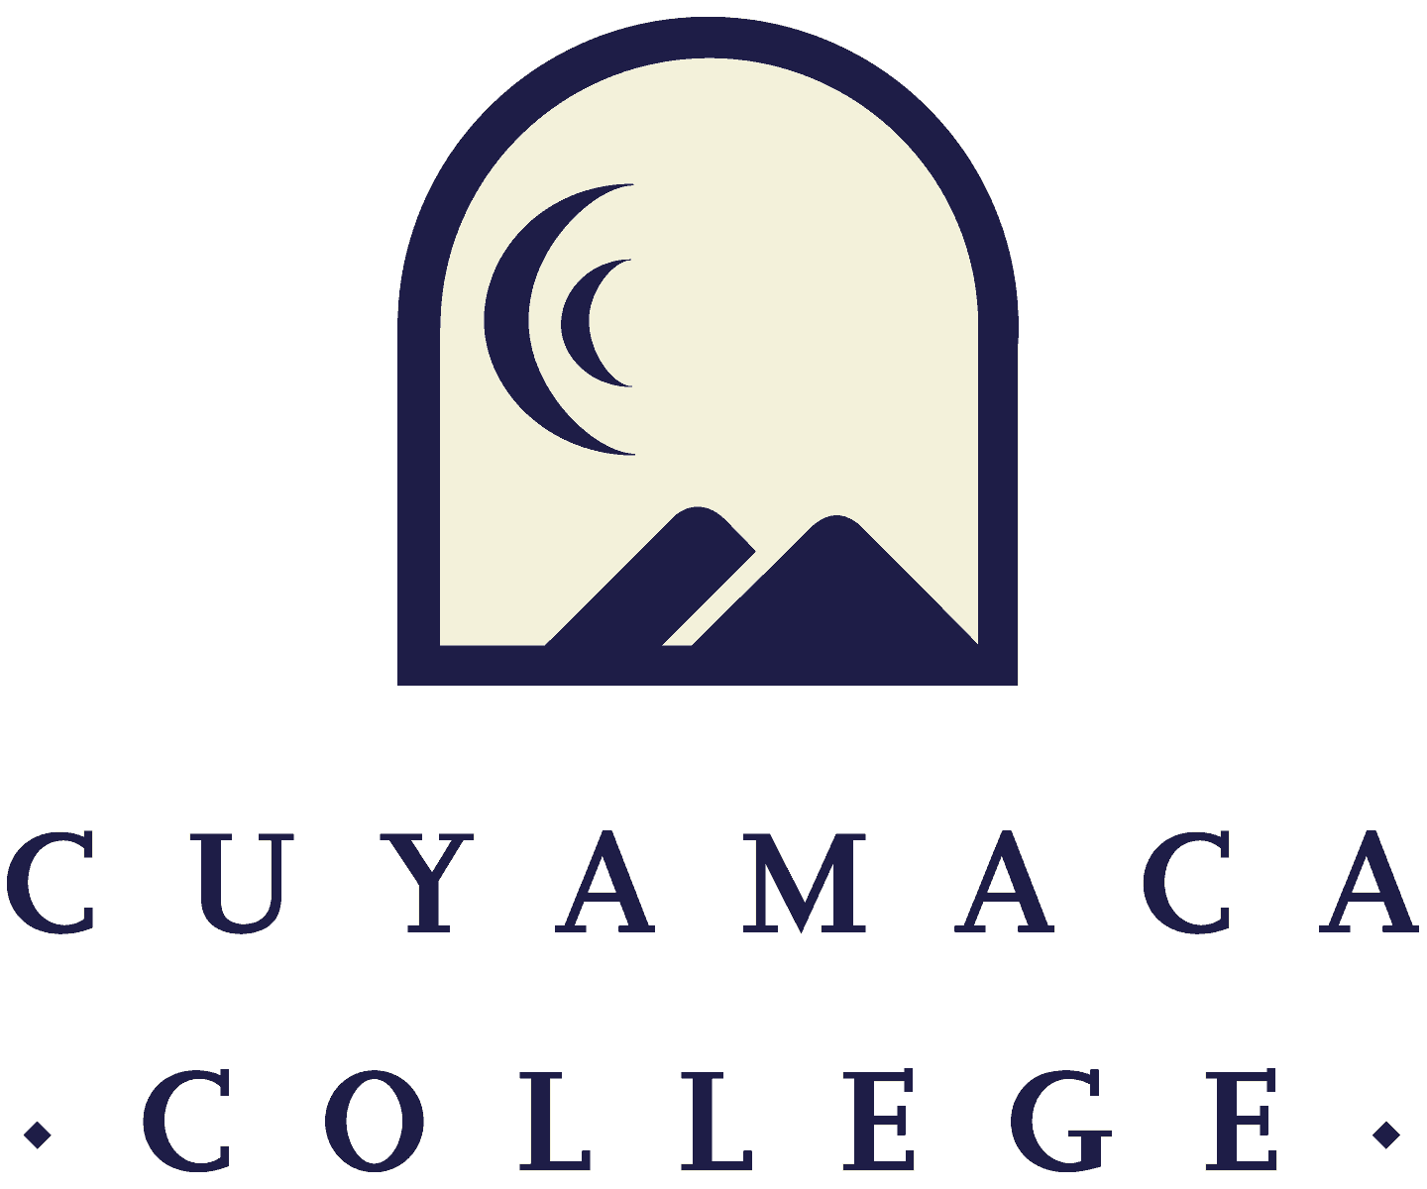

FALL 2021
Administrative Program Review
Annual Update Template
NOTE THAT ALL PROGRAM REVIEWS MUST BE SUBMITTED ONLINE VIA SURVEYMONKEY.
THIS FORM IS PROVIDED FOR RESPONSE DRAFTING AND PLANNING PURPOSES ONLY.
EMAILS WITH THE LINK TO EACH SERVICE AREA’S ONLINE MODULE WILL BE PROVIDED IN FALL 2021.
IF YOU HAVE QUESTIONS ABOUT THE SURVEYMONKEY PROGRAM REVIEW MODULE, PLEASE CONTACT THE INSTITUTIONAL EFFECTIVENESS, SUCCESS, AND EQUITY OFFICE AT (619) 660-4380 brianna.hays@gcccd.edu.
- Service Area Overview and Update

I.1. Service Area for Review:
I.2. Lead Author:
I.3 Collaborator(s):
I.3. Manager(s):
I.4 Please summarize the changes, additions, and achievements have occurred in your service area since the last program review. You can access 2021 program reviews on the program review webpage.

II. Student Learning Outcome/Service Area Outcome Assessment and Student Success
If your service area does not yet have data that informs your planning, please contact Brianna.Hays@gcccd.edu.

Data to Inform Service Area Annual Planning

II.1. Administrative service areas collect data in many different ways. Please discuss the access, success and/or other data that your service area is using to inform its plans for the year and/or to evaluate its progress. This may include the number of students, employees, or community members served, survey results, or other reports prepared by the department and external organizations.
II.2. How has this data impacted the goals set in your Spring 2020 comprehensive program review (link)?
Please upload any supporting documentation related to this section. You can upload PDF, Word, and image files.
II.3. Please describe the most significant or impactful ways your service area worked across the college to advance the college’s student success & equity goals and strategic priorities over the past year?

II.4 What did your service area learn from the transition to remote operations over the past year? How can this be used to improve the student experience and operational improvements in the future?

III. Previous Goals: Update
For the goals you set in your last Comprehensive Program Review, please provide a status update, a summary of key action steps for the next year, and the results of these actions (if applicable). List previous goals as needed.
Goal 1:
- Goal 1:
- Link to College Strategic Goal (Which College Strategic Goal does this department goal most directly support? (Check only one)
Basic Skills Acceleration

Guided Student Pathways

Student Validation and Engagement

Organizational Health

- Goal Status
In Progress - will carry this goal forward into next year

Completed

Not Started

Deleted

If Deleted or Completed:
- Please describe the results or explain the reason for deletion/completion of the goal:

If Continuing (Not Started or In Progress):
- Action Steps for the Next Year: If you are requesting resources in order to achieve this goal, please list them below as action steps and specific the type of request (e.g., submit technology request for new laptop computers).
(Repeated as needed)

- New Goals
If your program is proposing any new goals for the remainder of your program review cycle (up to your next Comprehensive Program Review), please state the new goal(s), summarize key action steps for the next year, and describe your plan to evaluate the outcomes/results of these actions.

New Goal 1:
- New Goal 1:
- Link to College Strategic Goal (Which College Strategic Goal does this department goal most directly support? (Check only one)
Basic Skills Acceleration

Guided Student Pathways

Student Validation and Engagement

Organizational Health

- Please describe how this goal advances the college strategic goal identified above.
- Please indicate how this goal was informed by SLO assessment results, PLO assessment results, student achievement data, or other data:
- Action Steps for the Next Year: If you are requesting resources in order to achieve this goal, please list them below as action steps and specific the type of request (e.g., submit technology request for new laptop computers).
- How will this goal be evaluated?
[Repeated as needed up to 4 goals]

RESOURCES NEEDED TO ACHIEVE PROGRAM GOALS
Administrator Resource Needs
Contact Person: Brianna Hays (brianna.hays@gcccd.edu)
Link to Administrative Position Request Form- “under construction”

- Administrator Position Request 1:
  - Description
  - This position is being requested to advance the following Program Goal(s):

- Administrator Position Request 2:
  - Description
  - This position is being requested to advance the following Program Goal(s):

Classified Staff Resource Needs
Contact Person: Jessica Robinson (jessica.robinson@gcccd.edu)
Link to Classified Position Request Form- One form must be submitted for each request

Please submit an electronic Classified Position Request Form for each position your department is requesting. A copy of the request form is posted to the Program Review webpage (under the Staffing Request Information menu) for planning purposes.

Technology Resource Needs
Contact Person: Jodi Reed (jodi.reed@gcccd.edu)
Link to Technology Request Form- One form must be submitted for each request

Supplies, Equipment & Other Resource Needs
Contact Person: Nicole Salgado (nicole.salgado@gcccd.edu)
Link to Supplies, Equipment & Other Resources Request Form-One form must be submitted for each request

Facilities Resource Needs
Contact Person: Francisco Gonzales (francisco.gonzalez@gcccd.edu)
Link to Facilities Request Form- one form must be submitted for each request

Have you completed all of the other sections of this program review?
☐ Yes ☐ No

