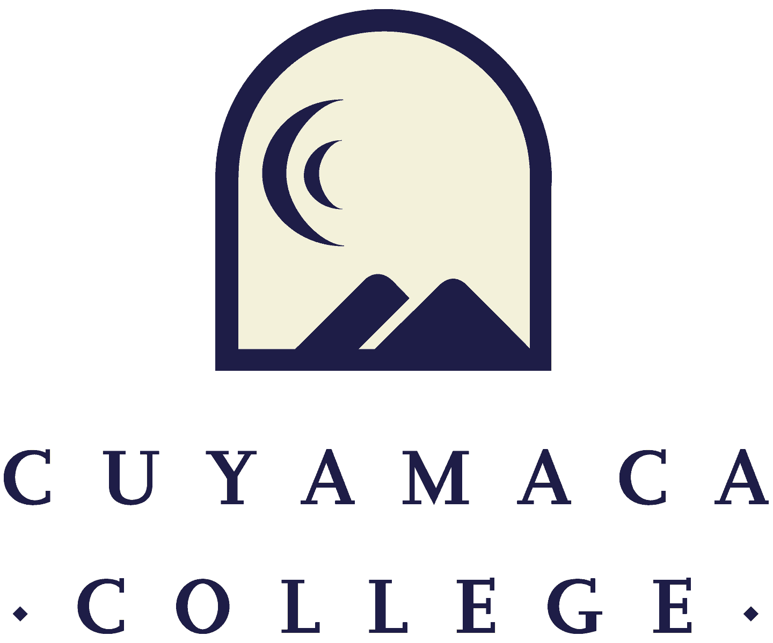

FALL 2021
Instructional Program Review
Comprehensive Template
NOTE THAT ALL PROGRAM REVIEWS MUST BE SUBMITTED ONLINE VIA SURVEYMONKEY.
THIS FORM IS PROVIDED FOR RESPONSE DRAFTING AND PLANNING PURPOSES ONLY.
EMAILS WITH THE LINK TO EACH PROGRAM’S ONLINE MODULE WILL BE PROVIDED IN FALL 2021.
IF YOU HAVE QUESTIONS ABOUT THE SURVEYMONKEY PROGRAM REVIEW MODULE, PLEASE CONTACT THE INSTITUTIONAL EFFECTIVENESS, SUCCESS, AND EQUITY OFFICE AT (619) 660-4380 brianna.hays@gcccd.edu.

- Program Overview and Update

I.1. Department(s) Reviewed:
I.2. Lead Author:
I.3 Collaborator(s) {list any person that participated in the preparation of this report}:
I.4. Dean/Manager(s):
Initial Collaboration Date with Dean:
- Program Reflection and Description

II.1. Provide your program’s mission statement.
II.2. How is the program advancing the college mission, vision and values?
II.3. How does your program support the college’s strategic goal of implementing guided pathways?
II.4. Is the program description in the current college catalog up to date and accurate?
☐ Yes ☐ No
If no, what steps will you take to revise the college catalog description?

III. Course Curriculum, Assessment and Student Success

Curriculum Review and Assessment

Provide an overview of your program’s Curriculum Review and Development status.
III.1. Access the Five Year Curriculum Review Cycle. Have all of your active course outlines been reviewed within the last five years?
☐ Yes ☐No (if no, please explain in Section III.3 below)

III.2. Please list any planned changes from the current semester forward for curriculum (courses, degrees, and/or certificates) and the rationale for those changes (e.g., labor market data, advisory committee recommendations, transfer institution changes, industry trends, statewide transfer model curriculum).

III.3 How is your program meeting the needs of students, and/or articulation with four year institutions?

Please provide an overview of your Student Learning Outcomes (SLO) Assessments
For assistance with SLOs, please contact SLO Coordinator Tania Jabour at tania.jabour@gcccd.edu. For assistance with TracDat, please contact Madison Harding at madison.harding@gcccd.edu.
Additional resources are provided on the Learning Outcomes and Assessment webpage

III.4. Please upload the most recent version of your program’s course SLO assessment plan. Click here for Assessment Plan Template.

III.5. Please provide a high-level analysis of your SLO findings over the past year and discuss what changes, if any, were made as a result. Include any student learning-related successes and challenges SLO results have revealed for your department.

DEGREE/CERTIFICATE PROGRAMS
- Degree and Certificate Programs

IV.1. Does your program offer any degree/certificate programs?
☐ Yes ☐ No, and it does not have Program-Level Outcomes (PLOs) ☐ No, but it does have PLOs
(If Yes, complete Sections IV. Below)
(If No and it does not have PLOs, GO TO Section IV.10)
(If No but it does have PLOs, GO TO IV.7)
IV.2. For each degree and certificate indicate how many awards were conferred in the past five years {upload excel spreadsheet}
IV.3. Please indicate when each degree and certificate was last reviewed and updated (semester):
IV.4. Can students complete the degree/certificate requirements within a two-year period?*
☐ Yes ☐ No, Please explain
*requirement of Title 5, California Code of Regulations and Accreditation Standard II.A.
Note: The college requires assessment of PLOs within a 4-year cycle
IV.5. How are you currently assessing your PLOs?

IV.6. Are the PLOs in the catalog an accurate reflection of the department or discipline’s current learning objectives?
☐ Yes ☐ No {if no, briefly explain the plan to revise}
IV.7. Are the PLOs mapped to the course SLOs?
☐ Yes ☐ No
Student Achievement

Student characteristics and achievement data (both college-wide and by discipline) can be located on the program review data webpage.

IV.8. The College has set a 2024 goal of reaching a 77% course success rate (students passing with a grade of A, B, C, or P out of those enrolled at census) for the College as a whole. What is your department or discipline's four-year (2024-25) goal for success rate across all courses in the department or discipline and how has the department or discipline’s success rate across all courses changed within the past 4 years?
IV.9. What other qualitative or quantitative data (from any source) is the program using to inform its planning for this comprehensive program review? Please reference additional internal or external data, such as retention and enrollment, student survey results, focus groups, student throughput, or other data, if there are any notable trends.
IV.10. Please review the college-wide and program data sets, which have identified equity gaps based on the following criteria: 3% n=10 students/enrollments. Which groups are experiencing equity gaps in your program? Please discuss all equity gaps identified in the data.
IV.11. What department/discipline (or institutional) factors may be contributing to these lower rates of success for these groups of students?
IV.12. What action will the department or discipline take to address these equity gaps in the short-term (next year) and long term (next four years)? Consider the specific steps your department will take to address equity gaps and discuss any plans for diversifying department faculty in alignment with the GCCCD Board Resolution 20-015. For examples of action steps your department can take to increase the diversity of faculty, see this resource.
IV.13 What did your program learn from the transition to remote teaching and operations over the past year? How can this be used to improve the student experience in the future?
Distance Education Course Success (If Applicable)

Does your program offer courses via distance education excluding emergency remote teaching in 2020-21 (classes that would have been taught in person, if not for the pandemic)
☐ Yes (proceed to III.13) ☐ No (proceed to III.15)

For distance education teaching and learning resources, please visit the Cuyamaca Teaching Online webpage.

IV.14. Are there differences in success rates for distance education (online) versus in-person sections?
☐ Yes ☐ No (proceed to III.15)
IV.15. If there are differences in success rates for distance education (online) versus in-person classes, what will the program do to address these disparities?
IV.16. What mechanisms are in place to ensure regular and effective contact {Guided to Best Practices in Online Teaching (link)} within online courses across the discipline or department?
IV.17. What innovative tools and strategies are you using in your online courses to engage students and support student success?

Career Exploration and Program Demand

IV.18 Is your program a career education program (e.g., does it prepare students to directly enter the workforce)?
☐ Yes [Go to IV.11] ☐ No [Go to IV.14]

IV.19 Please share your observations about the employment rate for your program over the past several years.

IV.20 What is the institution-set standard for your program’s employment rate? The institution set standard is what you would consider the lowest acceptable employment rate for your program (or “floor”).

IV.21 What would you like your program’s employment rate to be, ideally (stretch goal)?

IV.22 What is your program doing to prepare students for successful transition (e.g. transfer and career readiness)? Please include information on how your program is helping students explore careers in your program area.

IV.23 What do the latest labor market data reveal about the careers (including those for transfer students) for which your program prepares students? Consider what career information you would share with students on a career or transfer pathway in your area. Labor market data may be sourced from the California Employment Development Department. You can also contact the Institutional Effectiveness, Success, and Equity Office to access additional labor market information related to your program.

OPTIONAL If your program has labor market data to include in your program review, please use the upload button below to attach the file.

Strengths, Challenges & External Influences

Consider your program’s strengths, challenges, areas for improvement, and internal and external factors impacting your program.

IV.24. Please describe your program’s strengths.
IV.25. Please describe your program’s challenges.
IV.26. Please describe external influences that affect your program (both positively and negatively).
IV.27. Given these factors, what opportunities exist for the program to advance student success and equity in the next 4 years?

Previous Goals:

For each of your program’s goals (as noted in your Spring 2021 program review annual update), please provide a goal status update and, if applicable, the results of these actions. For a list of active goals as of Spring 2021, visit the program review website to access the Program Review Goals Annual Report.
Previous Goal 1:
- Goal 1:
- Link to College Strategic Goal (Which College Strategic Goal does this department goal most directly support? (Check only one)
{ } Basic Skills Acceleration
{ } Guided Student Pathways
{ } Student Validation & Engagement
{ } Organizational Health
- Goal Status
{ } Completed
{ } Deleted
{ } In Progress - please describe the goal and action steps in the 4-Year Goals section (Section VI)
{ } Not Started - please describe the goal and action steps in the 4-Year Goals section (Section VI)
If Deleted or Completed:
- Please describe the results or explain the reason for deletion/completion of the goal:

(Repeated as needed)

4-Year Goals

Please describe the department’s long-term goals for this comprehensive program review cycle (the next 4 years), please state the new goal(s), summarize key action steps for the next academic year, and describe your plan to evaluate the outcomes/results of these actions. You may include previous goals that the program is continuing into this comprehensive program review cycle.
Goal 1:
- Goal 1:
- Link to College Strategic Goal (Which College Strategic Goal does this department goal most directly support? (Check only one)
{ } Basic Skills Acceleration
{ } Guided Student Pathways
{ } Student Validation & Engagement
{ } Organizational Health
- Please describe how this goal advances the college strategic goal(s) identified above.

- Please indicate how this goal was informed by SLO assessment results, PLO assessment results, student achievement data, or other qualitative or quantitative data (from any source):

- Action Steps for the Next Year: If you are requesting resources in order to achieve this goal, please list them below as action steps and specific the type of request (e.g., submit technology request for new laptop computers).

- How will this goal be evaluated?

(Repeat as needed up to 4 goals)

RESOURCES NEEDED TO ACHIEVE PROGRAM GOALS
Faculty Resource Needs
Contact Person: Alicia Munoz (alicia.munoz@gcccd.edu)
Link to Faculty Staff Request Form- One form must be submitted for each request

Please submit an electronic Faculty Position Request Form for each position your department is requesting. A copy of the request form is posted to the Program Review webpage (under the Staffing Request Information menu) for planning purposes.

Classified Staff Resource Needs
Contact Person: Jessica Robinson jessica.robinson@gcccd.edu
Link to Classified Position Request Form- One form must be submitted for each request
Please submit an electronic Classified Position Request Form for each position your department is requesting. A copy of the request form is posted to the Program Review webpage (under the Staffing Request Information menu) for planning purposes.

Technology Resource Needs
Contact Person: Jodi Reed (jodi.reed@gcccd.edu)
Link to Technology Request Form- One form must be submitted for each request

Supplies, Equipment & Other Resource Needs
Contact Person: Nicole Salgado (nicole.salgado@gcccd.edu)
Link to Supplies, Equipment & Other Resources Request Form-One form must be submitted for each request

Facilities Resource Needs
Contact Person: Francisco Gonzales (francisco.gonzalez@gcccd.edu)
Link to Facilities Request Form- One form must be submitted for each request

Have you completed all of the other sections of this program review?
☐ Yes ☐ No

