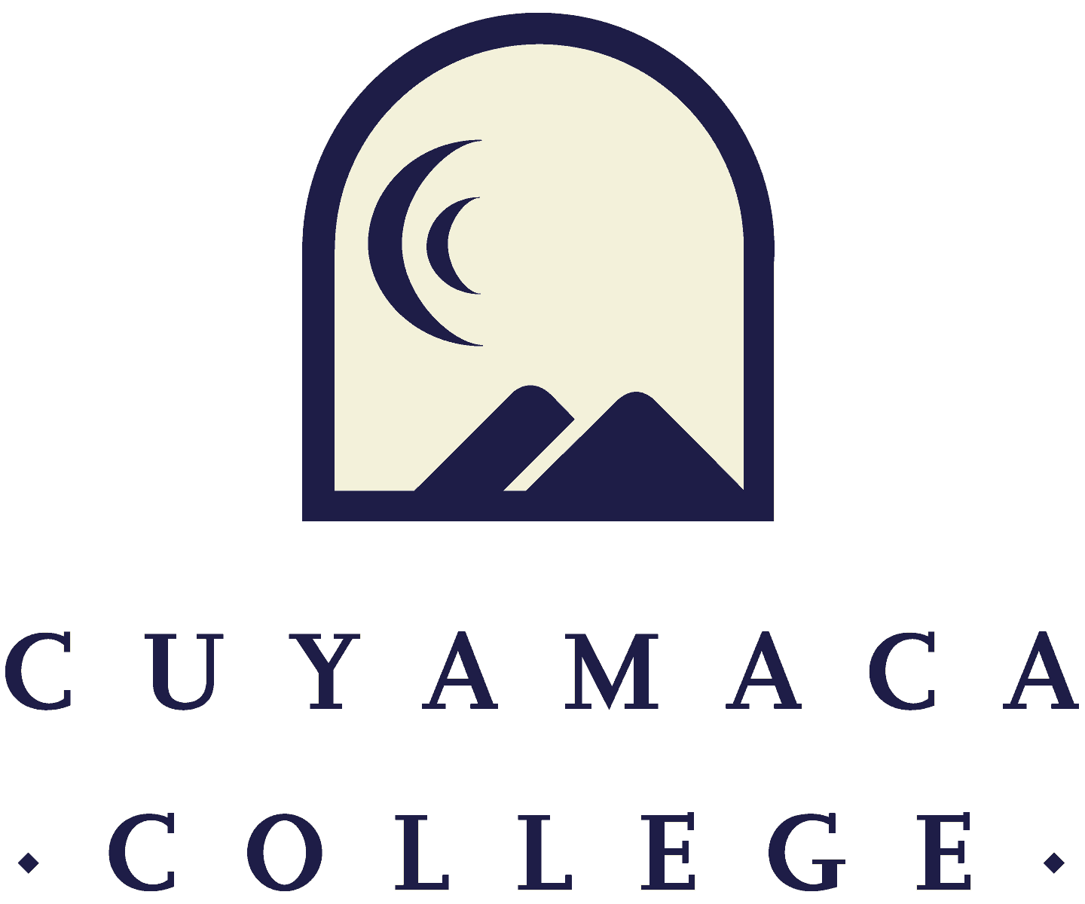

FALL 2021
Student Services Program Review
Annual Update Template
NOTE THAT ALL PROGRAM REVIEWS MUST BE SUBMITTED ONLINE VIA SURVEYMONKEY.
THIS FORM IS PROVIDED FOR RESPONSE DRAFTING AND PLANNING PURPOSES ONLY.
EMAILS WITH THE LINK TO EACH SERVICE AREA’S ONLINE MODULE WILL BE PROVIDED IN FALL 2021.
IF YOU HAVE QUESTIONS ABOUT THE SURVEYMONKEY PROGRAM REVIEW MODULE, PLEASE CONTACT THE INSTITUTIONAL EFFECTIVENESS, SUCCESS, AND EQUITY OFFICE AT (619) 660-4380 brianna.hays@gcccd.edu.

- Service Area Overview and Update

I.1. Department(s) Reviewed:
I.2. Lead Author:
I.3. Collaborator(s):
I.3. Dean/Manager(s):
I.4 Please summarize the changes, additions, and achievements have occurred in your service area since the last program review. You can access 2021 program reviews on the program review webpage.

II. Student Learning Outcome/Service Area Outcome Assessment and Student Success
Please refer to your service area comparison or survey reports provided by the Institutional Effectiveness and Student Equity Office as well as any internal data your service area collects to address the following questions. If your service area does not yet have student service access/utilization and demographic data, please contact Brianna.Hays@gcccd.edu.

Student Access, Learning, and Achievement

II.1. Student services and administrative areas collect data in many different ways. Please discuss the access, success and/or other data that your service area is using to inform its plans for the year and/or to evaluate its progress. This may include student achievement data from comparison reports, service utilization data from SARS or another database, demographic information on the students your area serves, student or employee survey results, reports prepared by external organizations, or other data collected by your service area. Please include information on the implications for practice (e.g., on how your service area used the data for improvement).
II.2 What did your service area learn from the transition to remote operations over the past year? How can this be used to improve the student experience in the future?
II.3 In light of the goals set in your program review, what are your plans to improve equitable student access and outcomes (enrollment, matriculation, success, retention, persistence, graduation, etc.) in the coming year?
Please upload any supporting documentation related to this section. You can upload PDF, Word, and image files.
Service Area Assessment

For assistance with SLOs/SAOs, please contact SLO Coordinator Tania Jabour at tania.jabour@gcccd.edu. For assistance with TracDat, please contact Madison Harding at madison.harding@gcccd.edu.
Additional resources are provided on the Learning Outcomes and Assessment webpage
II.3. Are the SLOs and/or SAOs an accurate reflection of the department’s major priorities?
☐ Yes ☐ No, please describe the department’s plan to update them

II.4. Does your service area have a SLO/SAO assessment plan on file with the SLO Coordinator (or the Outcome Assessment Committee)?
☐ Yes ☐ No, please describe your plan
II.5. What are the key assessment findings over the past year and what have you changed (or will you change over the next year) as a result?
- Previous Goals: Update
For each of your program’s goals (as noted in your Spring 2021 program review annual update), please provide a goal status update and, if applicable, the results of these actions. For a list of active goals as of Spring 2021, visit the program review website to access the Program Review Goals Annual Report.

Goal 1:
- Goal 1:
- Link to College Strategic Goal (Which College Strategic Goal does this department goal most directly support?
(Check only one)
Basic Skills Acceleration

Guided Student Pathways

Student Validation and Engagement

Organizational Health

- Goal Status
In Progress - will carry this goal forward into next year

Completed

Not Started

Deleted

If Deleted or Completed:
- Please describe the results or explain the reason for deletion/completion of the goal:

If Continuing (Not Started or In Progress):
- Action Steps for the Next Year: If you are requesting resources in order to achieve this goal, please list them below as action steps and specify the type of request (e.g., submit technology request for new laptop computers).

(Repeated as needed)

- New Goals
If your program is proposing any new goals for the remainder of your program review cycle (up to your next Comprehensive Program Review), please state the new goal(s), summarize key action steps for the next year, and describe your plan to evaluate the outcomes/results of these actions.

New Goal 1:
- New Goal 1:
- Link to College Strategic Goal (Which College Strategic Goal does this department goal most directly support? (Check only one)
Basic Skills Acceleration

Guided Student Pathways

Student Validation and Engagement

Organizational Health

- Please describe how this goal advances the college strategic goal identified above.

- Please indicate how this goal was informed by SLO assessment results, PLO assessment results, student achievement data, or other data:

- Action Steps for this Year: If you are requesting resources in order to achieve this goal, please list them below as action steps and specify the type of request (e.g., submit technology request for new computer hardware).

- How will this goal be evaluated?
[Repeated as needed up to 4 goals]

RESOURCES NEEDED TO ACHIEVE PROGRAM GOALS
Faculty Resource Needs
Contact Person: Alicia Munoz (alicia.munoz@gcccd.edu)
Link to Faculty Position Request Form- One form must be submitted for each request

Please submit an electronic Faculty Position Request Form for each position your department is requesting. A copy of the request form is posted to the Program Review webpage (under the Staffing Request Information menu) for planning purposes.

Classified Staff Resource Needs
Contact Person: Jessica Robinson (jessica.robinson@gcccd.edu)
Link to Classified Position Request Form- One form must be submitted for each request

Please submit an electronic Classified Position Request Form for each position your department is requesting. A copy of the request form is posted to the Program Review webpage (under the Staffing Request Information menu) for planning purposes.

Technology Resource Needs
Contact Person: Jodi Reed (jodi.reed@gcccd.edu)
Link to Technology Request Form- One form must be submitted for each request

Supplies, Equipment & Other Resource Needs
Contact Person: Nicole Salgado (nicole.salgado@gcccd.edu)
Link to Supplies, Equipment & Other Resources Request Form-One form must be submitted for each request

Facilities Resource Needs
Contact Person: Francisco Gonzales (francisco.gonzalez@gcccd.edu)
Link to Facilities Request Form- one form must be submitted for each request

Have you completed all of the other sections of this program review?
☐ Yes ☐ No

