Instructional Cycle

This chart depicts the instructional cycle of the reading and writing processes I use in my accelerated classes. It is based on the assumption that the reading and writing processes are integrated, that students use both reading and writing to make and create meaning from written language.

NOTE: Both the reading and writing processes are recursive, and the arrows below do not always represent the process in which students engage. It can be much messier than the image below implies, with students circling back to any stage during the process of completing a writing assignment.

Before Reading activity to preview topic and teach summary and annotation skills:

**Activity 2 – Annotation**

1] As a class, discuss the title of the piece and what they think it could mean.

*'Blink': Hunch Power*

**By**[**DAVID BROOKS**](https://www.nytimes.com/by/david-brooks)

2] Put students into 6 groups – 3 A groups, 3 B groups.

Students in their groups read the article section and do the following: Underline or highlight important ideas, make a short note of important facts on the left, write questions on the right. Then fill out the S and A Log.  
3] Merge each A group with a B group and have them work together to fill in the second S & A log. The groups then create a poster and put up their answers for both S & A logs and class discussion on the posters and the information.  
4] Discuss that this is how to do S and A logs  
5] Go to Canvas and show S and A Log example log and blank log and where to submit.  
6] As time remains discuss the importance of bids, our responses to bids, and what do students think they’ll be learning in this book?

**Part One for Group A**

Gladwell opens "Blink: The Power of Thinking Without Thinking" with the story of a kouros, an ancient Greek statue of a youth that came on the art market and was about to be purchased by the Getty Museum in California. It was a magnificently preserved work, close to seven feet tall, and the asking price was just under $10 million.

The Getty did all the normal background checks to establish the authenticity of the piece. A geologist determined that the marble came from the ancient Cape Vathy quarry on the island of Thasos. It was covered with a thin layer of calcite, a substance that accumulates on statues over hundreds or perhaps thousands of years. After 14 months of investigation, the Getty staff concluded the thing was genuine, and went ahead with the purchase.

But an art historian named Federico Zeri was taken to see the statue, and in an instant he decided it was fake. Another art historian took a glimpse and sensed that while it had the form of a proper classical statue, it somehow lacked the spirit. A third felt a wave of "intuitive repulsion" when he first laid eyes on it.

Further investigations were made, and finally the whole scheme unraveled. It transpired that the statue had been sculptured by forgers in Rome in the early 1980's. The teams of analysts who did 14 months of research turned out to be wrong. The historians who relied on their initial hunches were right.

THERE is in all of our brains, Gladwell argues, a mighty backstage process, which works its will subconsciously. Through this process we have the capacity to sift huge amounts of information, blend data, isolate telling details and come to astonishingly rapid conclusions, even in the first two seconds of seeing something. " 'Blink' is a book about those first two seconds," Gladwell writes.

S and A Log Group A

|  |  |  |
| --- | --- | --- |
| Notes  1.  2.  3.  4. | Main Ideas  1.  2.  3.  4. | Questions/Observations  1.  2.  3.  4. |

**Part Two for Group B**

"Blink" moves quickly through a series of delightful stories, all about the backstage mental process we call intuition. There is the story of the psychologist John Gottman, who since the 1980's has worked with more than 3,000 married couples in a small room, his "love lab," near the University of Washington. He videotapes them having a conversation. Reviewing just an hour's worth of each tape, Gottman has been able to predict with 95 percent accuracy whether that couple will be married 15 years later. If he watches only 15 minutes of tape, his success rate is about 90 percent. Scientists in his lab have determined they can usually predict whether a marriage will work after watching just three minutes of newlywed conversation.

Gottman believes that each relationship has a DNA, or an essential nature. It's possible to take a very thin slice of that relationship, grasp its fundamental pattern and make a decent prediction of its destiny.

Gladwell says we are thin-slicing all the time -- when we go on a date, meet a prospective employee, judge any situation. We take a small portion of a person or problem and extrapolate amazingly well about the whole. A psychologist named Nalini Ambady gave students three 10-second soundless videotapes of a teacher lecturing. Then she asked the students to rate the teacher. Their ratings matched the ratings from students who had taken the teacher's course for an entire semester. Then she cut the videotape back to two seconds and showed it to a new group. The ratings still matched those of the students who'd sat through the entire term.

"We are innately suspicious of this kind of rapid cognition," Gladwell observes. We assume that long, methodical investigation yields more reliable conclusions than a snap judgment. But in fact, "decisions made very quickly can be every bit as good as decisions made cautiously and deliberately."

S and A Log Group B

|  |  |  |
| --- | --- | --- |
| Notes  1.  2.  3.  4. | Main Ideas  1.  2.  3.  4. | Questions/Observations  1.  2.  3.  4. |

**TEACHER – look ahead to assign the next exercise as homework at the end of week 1.**

EXAMPLE OF COMPLETED S AND A LOG FOR ANOTHER CHAPTER

Summary and Annotation Log # _4___

Chapter #__72___98_________ Chapter Title The Warren Harding Error: Why We Fall For Tall, Dark, and Handsome Men

|  |  |  |
| --- | --- | --- |
| Facts | Summary | Opinions/Questions |
| 1] After the IAT test turned out to be racist and biased towards whites over blacks.  2] The IAT test is a powerful indicator of how to behave in some spontaneous situation.  3] Golomb has been successful in his work and proof of it is the letters of satisfied customers. | In chapter 3, Gladwell speaks of people who take their unconscious decisions and judge people from their outward appearance. The best example is that American voters assumed Harding would be a good president, but their quick decision was wrong because Harding was the worst president in American history. Needs intensive study before taking. | 1] Did most scientists believe that Harding was the worst president in American history?  2] Why scientists used the IAT test and what is the benefit?  3] What is the reason why IAT enjoys a great popularity as a research tool? |

**Activity 3 Introduction – Thinking it through vs. snap decisions**  (During reading and after reading)

Homework to prepare for Activity 3.

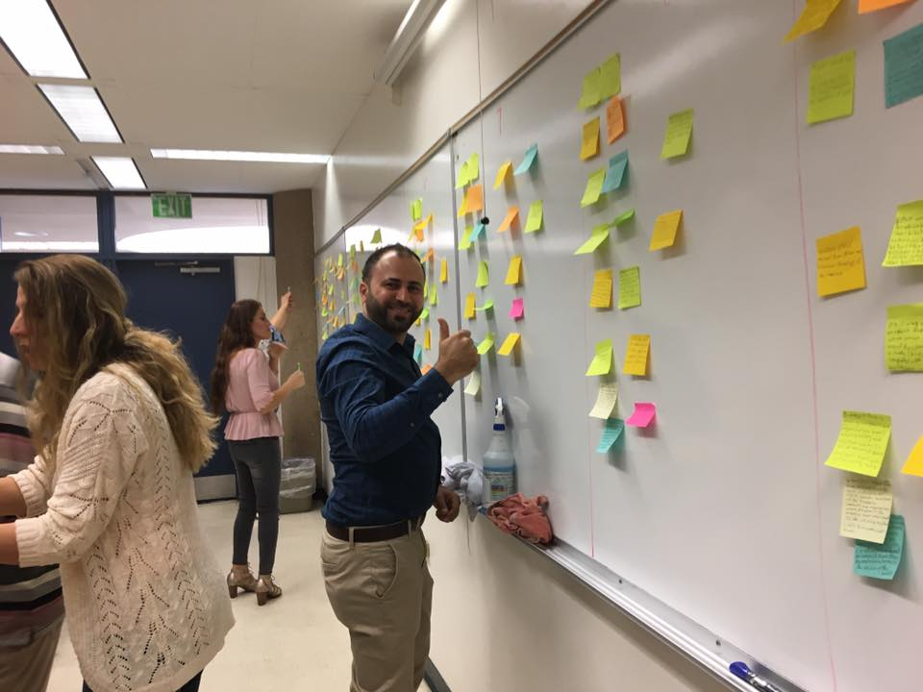Write a two-sentence summary of each section on a post-it note. Use your own words, and do not copy sentences from the text. Bring to class.

Section 1 pg. 3-5

Section 2 pg. 6-8

Section 3 pg. 8-11

Section 4 pg. 11-16

Section 5 pg. 16-17

In class: Put your post-it on the poster that matches each section (1-5).

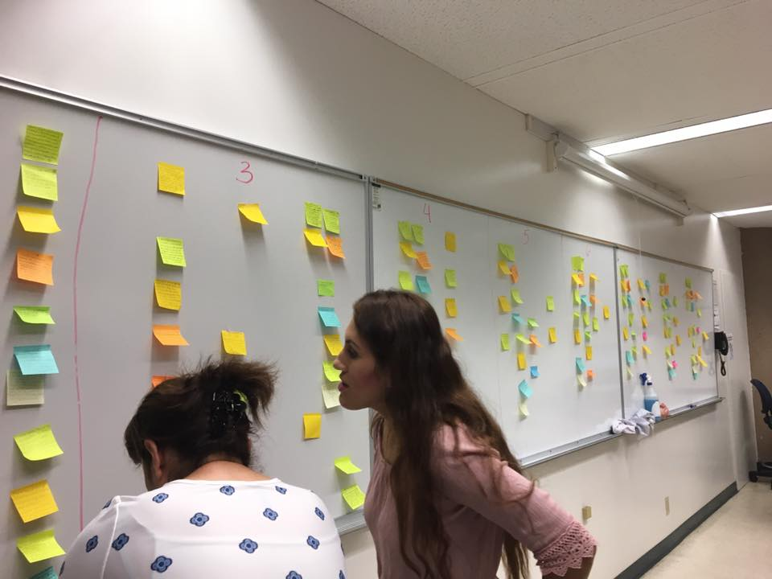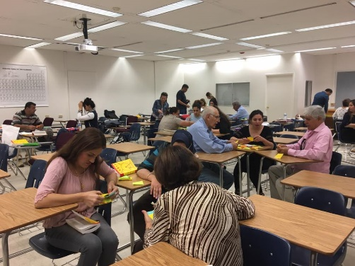Get into 5 groups. Each group creates a new two sentence summary of the post-its on their poster by choosing the best sentence[s] or combining ideas into a new sentence that best represents the section. Write your new sentences on the poster.

Then, students use all of the sentences to write a summary paragraph. Starting with a topic sentence, using transitions, and combining ideas using compound and complex sentences (using just-in -time remediation).

**Activity 4: Vocabulary 1**

VOCABULARY DIRECTIONS:

For each vocabulary word assigned on the left, write the part of speech of the word, synonym & antonym, and an original sentence using the word on the right.

Write an original sentence for each assigned word. The sentences in your textbook are models. Do not copy them. Do not copy sentences from a dictionary.

You will need to write these sentences for the class when we check it next period. Your sentences need to clearly reflect the meaning of the word.

Worksheet 1

|  |  |  |  |
| --- | --- | --- | --- |
| Word | Part of Speech | Synonym & Antonym | Original Sentence |
| Research | Noun |  |  |
| Instinctive |  |  |  |
| Conscious |  |  |  |
| Deliberating |  |  |  |
| Fallible |  |  |  |

**Activity 5 Introduction– Snap Judgments or Deliberations?**  (After reading analysis)

**Speed Dating**: students face one another and answer the following questions during 2 The instructor will have you stand and face a partner while the whole class is forming two lines. Questions will come on the overhead. You are to answer those questions with your partner until the instructor tells you to change partners. A new question will come up and you will repeat the process.

1] What is a kourous? Why did the Getty wish to purchase this statue? What process did they use to decide if it was real or fake?

2] What evidence did the Getty rely upon to make their decision?  Once they bought the kourous, what did they decide about its authenticity? Why?

3] In the university of Iowa experiment regarding gambling, people chose cards from different decks – which decks were bad, red or blue and why? In the experiment, did people figure out consciously which decks were bad first or unconsciously? How do you know?

4] What is adaptive unconscious? How does it work? When Ambady compared student decisions on teacher effectiveness, did students need a lot of time to judge? Why/why not?

5] Why are many people comfortable with conscious decision making? When or how can this type of decision making be wrong? Are people very comfortable with adaptive unconscious decision making? Why? When might this type of decision making be good?

**World Cafe – Decision Making** (After reading analysis)

At certain tables around the room will be posters with the following subjects on them:

**Getty Kourous Purchase**

**Iowa Gambling**

**Ambady Study Teacher Effectiveness**

Follow the instructor’s directions as you figure out what conscious and unconscious decisions were made in those three cases. You are to think which of those decisions were better ones.

Put a group at each table. Time it for about 10-15 minutes. Tell each group to look up the incident on their poster and fill in **the Conscious Decision Making** that went on. After the time, groups move tables to a poster NOT the same as the one they had. Now they spend 10-15 minutes filling in **the Unconscious Decision Making** that went on. Then they switch to a third table that they have not seen. In the 10-15 minutes for this round the group fills in any missing info on the charts and decides the following-- Ultimately, which kind of decision making proved to be better? Or did they prove to be equally good or bad? The groups write their judgment on the bottom.

**Gallery Walk**

You will put up the posters the groups make and discuss how accurate they are and what they say about “snap” decisions versus deliberated decisions. 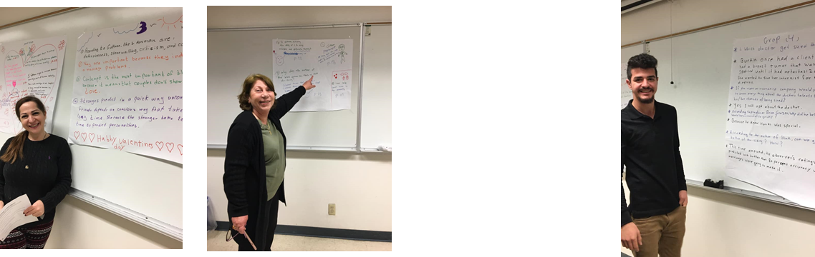

**Activity 7 chapt 1 – Conscious Decision Making Body 1**

In pairs, discuss the following questions.

What is conscious decision making? Why do people often prefer conscious decision making? Are there any issues that might make conscious decision making problematic?

Group work: Work on worksheet below, completing part A in your groups

Part A

Making conscious decisions – write down 6 reasons a person might want to engage in conscious decision making

1] 4]

2] 5]

3] 6]

Problems making conscious decisions – write down 6 reasons a person might make an error or have a problem with conscious decision making

1] 4]

2] 5]

3] 6]

Part B: Circle one idea from the top group and 2 ideas from the bottom group to write about.

Create your topic sentence to include a reason why people prefer conscious decision making but that there are 2 reasons why this type of decision making is problematic.

_______________________________________________________________________________

_______________________________________________________________________________

_______________________________________________________________________________

Now complete the following for your three ideas

idea #1: ____Why people like conscious decision making___________________________________  
  
_________________________________________________________________________________

Quote from text supporting the above idea:___________________________________________

___________________________________________________________________________

____________________________________________________________________________

Explanation of how quote supports your idea: ____________________________________

___________________________________________________________________________

____________________________________________________________________________

idea #2: ____idea why conscious decision making may be faulty______________________________

________________________________________________________________________________

Quote from text supporting the idea:__________________________________________________

___________________________________________________________________________

____________________________________________________________________________

Explanation of how quote supports your idea: ____________________________________

___________________________________________________________________________

____________________________________________________________________________

idea #3: ____idea why conscious decision making may be faulty______________________________

Quote from text supporting the idea:__________________________________________________

___________________________________________________________________________

____________________________________________________________________________

Explanation of how quote supports your idea: ____________________________________

___________________________________________________________________________

____________________________________________________________________________

Single-Source Essay #1:

Conscious and Unconscious Decision Making

**Purpose:**

By writing this assignment, students will write a well-developed five-paragraph essay. To complete the assignment, they will learn essential writing strategies: using a text to support assertions, creating a solid introduction and conclusion. In doing so, they will practice the skills of incorporating and documenting quotes to support a main idea, choosing precise words, including vivid details, and creating smooth transitions. In addition to essential writing skills, this assignment helps students practice effective reading strategies through annotating.

**Description of the Assignment:**

For this assignment, you will turn in a five-paragraph essay. In the introduction present the topic—how people use conscious and unconscious decision making, using Malcolm Gladwell’s *Blink: The Power of Thinking Without Thinking*. In the body paragraphs, describe what each kind of decision making it, how it can be faulty, how it can be reliable, and provide a personal narrative to agree/disagree with the author. In the conclusion, make a suggestion or prediction of how unconscious decision making can be useful.

**Requirements:**

Turn in a five-paragraph essay about Malcolm Gladwell’s *Blink: The Power of Thinking Without Thinking* using MLA format and following the outline provided.

**Directions:**

Read and annotate Malcolm Gladwell’s *Blink: The Power of Thinking Without Thinking* In the introduction of the essay, provide a hook (using our guide), a *brief* description of the ideas in the text, the title underlined, the author’s name, and the thesis:

**I agree/disagree with Malcolm Gladwell’s *Blink: The Power of Thinking Without Thinking,* that unconscious decision making is valuable even for important decisions.**

In the **introduction**, guide your readers from point to point, utilizing transitional words, phrases, and sentences.

In the **first body paragraph**, write a clear topic sentence and use the paragraph to describe conscious decision making according to Malcolm Gladwell’s *Blink: The Power of Thinking Without Thinking,* and why people like to use it. Then provide 2 examples of how conscious decision making can be faulty.

In the **second body paragraph**, write a clear topic sentence and use the paragraph to explain unconscious decision making according to Malcolm Gladwell’s *Blink: The Power of Thinking Without Thinking,* and why people are often uncomfortable with it.

The provide 2 examples of how this type of decision making can be reliable.

In the **third body paragraph**, write a clear topic sentence agreeing OR disagreeing that Malcolm Gladwell’spremise that unconscious decision making is valuable. Provide support for this with a personal narrative.

**Conclude** your paper by restating the thesis in other words, summarizing the main points of the body, and finishing with an additional ending strategy such as a prediction, suggestion, observation, or moral relating to the ideas presented in your body paragraphs.

**Basic Essay Outline:**

Introduction –

* Hook
* Background information
* Thesis statement

Body Paragraphs (repeat 3 or more times as per terms of the assignment) –

* Topic Sentence
* 1st Quote sandwich (idea, quote, explain)
* Transition
* 2nd Quote Sandwich (idea, quote, explain)
* Transition
* 3rd Quote Sandwich (idea, quote, explain)
* Transition sentence to next paragraph

Conclusion –

* Restate thesis
* Summarize main ideas
* End on a strong note!