Cuyamaca College

Civic and Voter Empowerment Action Plan 2020
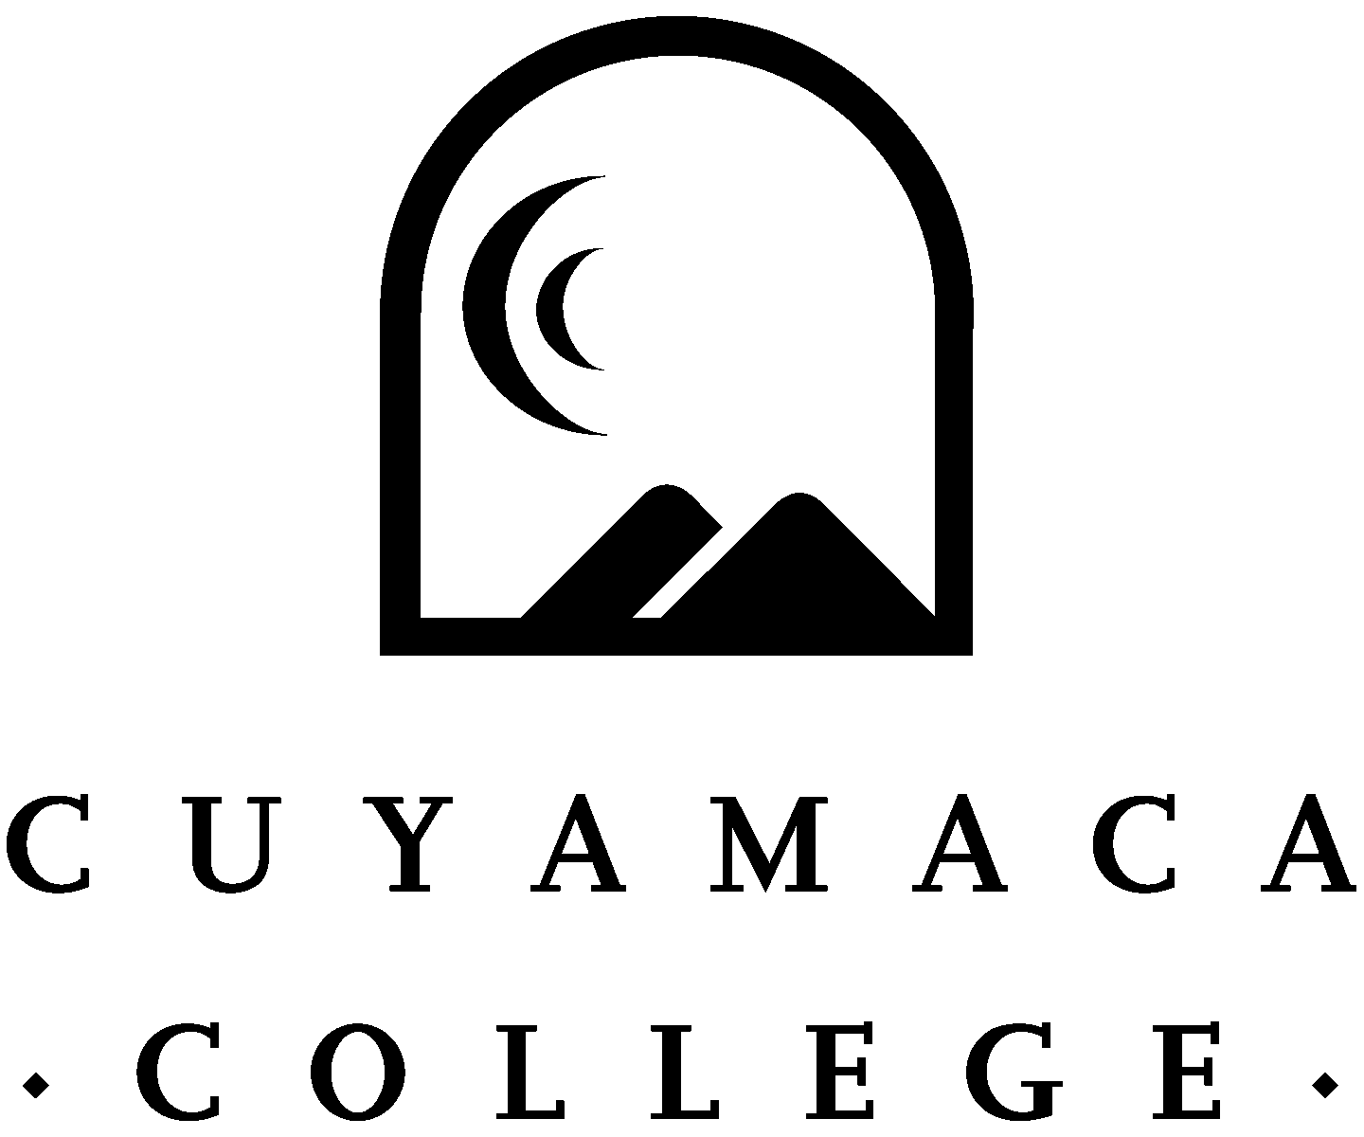

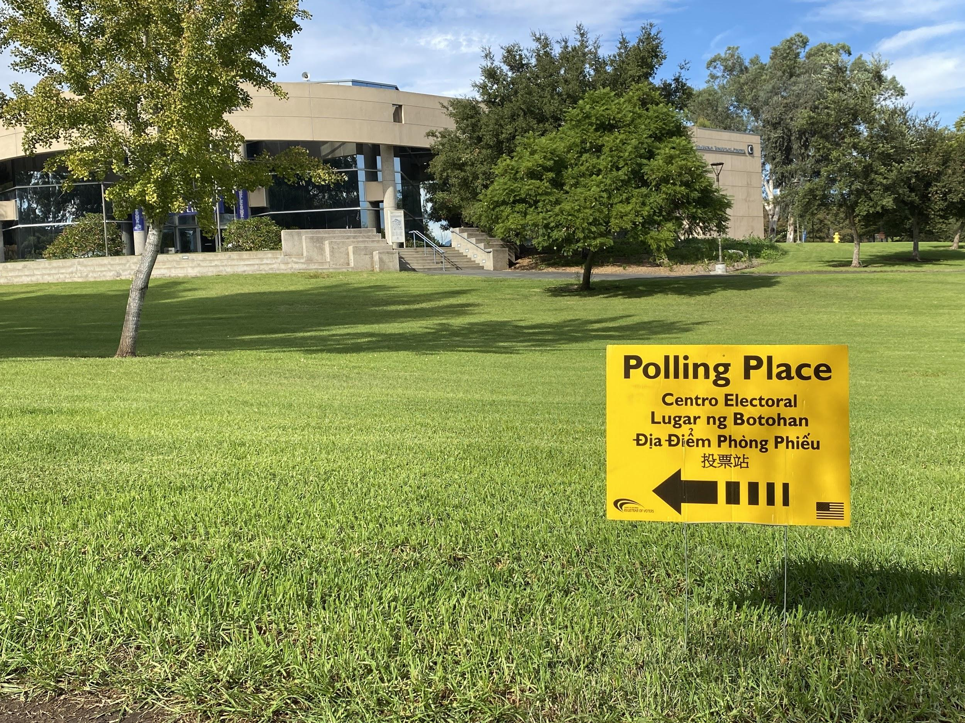

Introduction
AB 963 established the Student Civic and Voter Empowerment Program to be conducted by the Secretary of State, in partnership with the California Community Colleges, the California State University, and the University of California. The bill requires each campus of the California Community Colleges and the California State University and requests each campus of the University of California.

In response to the creation of AB 963, Cuyamaca College developed a collaborative partnership with faculty, staff, and students to comply with the requirements and create a robust civic engagement plan for our campus community. At the beginning of Fall Semester 2020, student leaders from the Associated Student Government and the Political Science Club worked closely with faculty and staff to develop campus events focusing on voter registration and civic engagement. These events included a voter registration session for National Voter Registration Day, Constitution Day program, student podcasts, educational workshops, and a Town Hall event. In addition, the Director of Community College Relations developed marketing for all electronic communication and social media. The social media toolkit from the California Student Vote project was utilized to develop marketing messages. Students, faculty, and staff received email messages on an ongoing basis with information regarding the election and reminders of deadlines. Social media messages were posted to remind the campus community about the upcoming election. The Disabled Students Programs & Services Counselors worked with their students during counseling sessions to assist with voter registration questions. The Disabled Students Programs & Services Media Access Specialist created a website with links to Voter Registration on the main Disabled Students Programs & Services Website. In addition, a link was created for a fillable form for students with disabilities who need assistance to fill out voter registration forms.

This is an exciting time at Cuyamaca College to engage our students with Civic Learning and engagement opportunities. Students will have the opportunity to participate in Civic Learning and Democratic Participation programs both inside and outside the classroom with the Introduction to the Politics of Race and Gender, POSC 165/ENTH 165 course. Programs such as the Mock Election will not only promote civic learning, but institutionalize campus voter registration programs. Students will be recognized for their participation in civic engagement programs during the Spring Semester recognition ceremony. In addition to receiving certificates for civic engagement work, students can apply for the Civic Leader of the Year award.

Student leaders are developing additional opportunities to integrate civic engagement work as a focus for their clubs. The Associated Student government leaders created a requirement for all officers to develop or partner on a civic engagement program. The Phi Theta Kappa honor society leaders are developing civic engagement programs within their chapter excellence programs.

The Civic Engagement & Voter Empowerment advisory group was established during the Fall Semester 2020 to develop Civic Learning & Voter Registration programs at Cuyamaca College. The members are excited to move this initiative forward and continue to build on the excitement and momentum from Fall Semester 2020. Cuyamaca College is committed to engaging our campus community in Civic learning and Voter Registration programs.

Leadership Point of Contact for Report
Lauren Vaknin, Ed.D.
Dean, Student Affairs
Lauren.Vaknin@gcccd.edu
(619) 660-4295

Civic Engagement & Voter Empowerment Advisory Group

Participants
- Dr. Josh Franco, Political Science Faculty
- Dr. Lauren Vaknin, Dean, Student Affairs
- Dr. Jessica Robinson, Vice President, Student Services
- Agustin Orozco, Associate Dean of Student Services, Special Programs
- Christianne Penunuri, Director, Community College Relations
- Cindy Morrin, Counseling Faculty
- Martin Campos, Associated Student Government & Political Science Club
- Maryam Rammahi, Associated Student Government & Political Science Club
- Darlene Farnes, Phi Theta Kappa Club

Meetings
- October 12, 2020: Dr. Lauren Vaknin and Dr. Josh Franco met to discuss the Act
- October 29, 2020: Student Civic & Voter Empowerment kick-off Meeting
- November 12, 2020: Student Civic & Voter Empowerment Meeting
- November 16, 2020: Dr. Lauren Vaknin and Dr. Josh Franco met to review the draft report

- Meetings will continue to be held on a monthly basis

Civic Learning
- Attend and participate in iPoliSci Workshop on “Holding Government Accountable”
- Enroll and Successfully complete a Political Science course

Democratic Participation
- Registering to Vote
- Voting Early
- Election Day Voting
- Attending or participating in local government meeting
- Attending or participating in state board or commission meeting (for now, these are accessible because they are on Zoom)

Civic Engagement Programs: Voter Registration Campus Efforts

College Printed Communication & Websites
- Academic Calendar- Dates were added to the online academic calendar.
- Class Schedule- Addendum to the Fall 2020 catalogue was published on September 8, 2020 to include the link for voter registration and deadlines (p.12, Addendum).
- Class Schedule- Voter registration information was included in the Spring Semester 2020 schedule.
- Student Voter Coalition- Cuyamaca College participated in the Student Voter Coalition- Ballot Bowl program. Information provided by the Student Voter Coalition was posted on the Student Affairs website.
- Student Vote Coalition messages were included with all Cuyamaca College voter registration information.
- Voter Registration flyers were distributed in all food bags during the food pantry event on September 17, 2020 and October 9, 2020.
- Voter Registration information posted on the Student Affairs website.
- DSPS High Tech Center Alternate Media Access Specialist created a website with links to Voter Registration on the main DSPS Website. In addition, a link was created for a fillable form for students with disabilities who need assistance to fill out voter registration forms.
- Website developed to detail voter registration and civic engagement efforts (https://cuyamaca.edu/scvea/).

Voter Information- Electronic Communication sent to all students
(The information from the California Vote Project toolkit was used in the electronic communication messages)
- September 16, 2020- Voter information was sent to all students in the VP Student Services newsletter.
- September 22, 2020- National Voter Registration email was sent to all students.
- September 22, 2020- Election information shared with employees.
- October 1, 2020- Voter registration reminders were included in the Student Connection newsletter.
- October 5, 2020- Election information reminders sent to employees.
- October 12, 2020- Voter registration reminders were included in the Student Connection newsletter.
- October 16, 2020- DSPS sent an outreach email to students with a link to Register to Vote.
- October 19, 2020- DSPS sent an outreach email to current students with disabilities in the Fall Semester 2020 Newsletter with the link to vote.
- October 19, 2020- Election information reminders were sent to employees.
- October 20, 2020- Student voter email was sent to students.
- October 22, 2020- Campus newsletter was sent and included information about elections and the Political Science club election event.
- October 26- The Student Connection newsletter will be completely focused on election information.
- October 22, 2020- Ballot information was sent to students.
- November 2, 2020- Election information email sent to students
- November 3, 2020- Election information email sent to students and employees
- Student Vote Coalition social media toolkit will be used for posts leading to the election.

Social media reminders to students of specified voter-related dates and information

- Weekly Instagram, Facebook, and Twitter posts were scheduled from September 21 – November 3

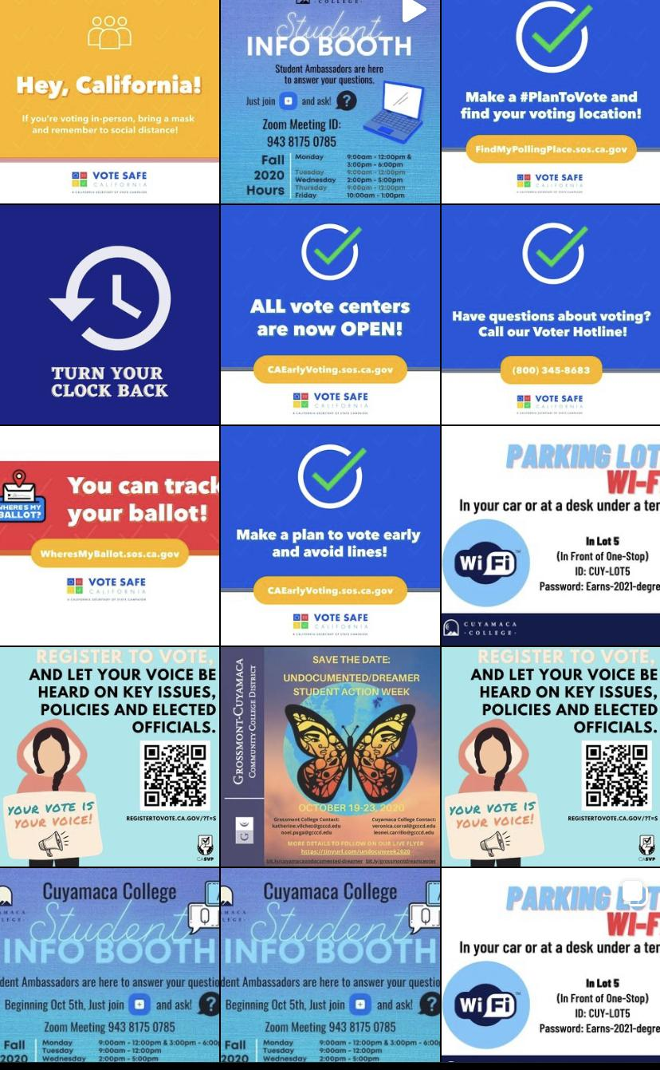
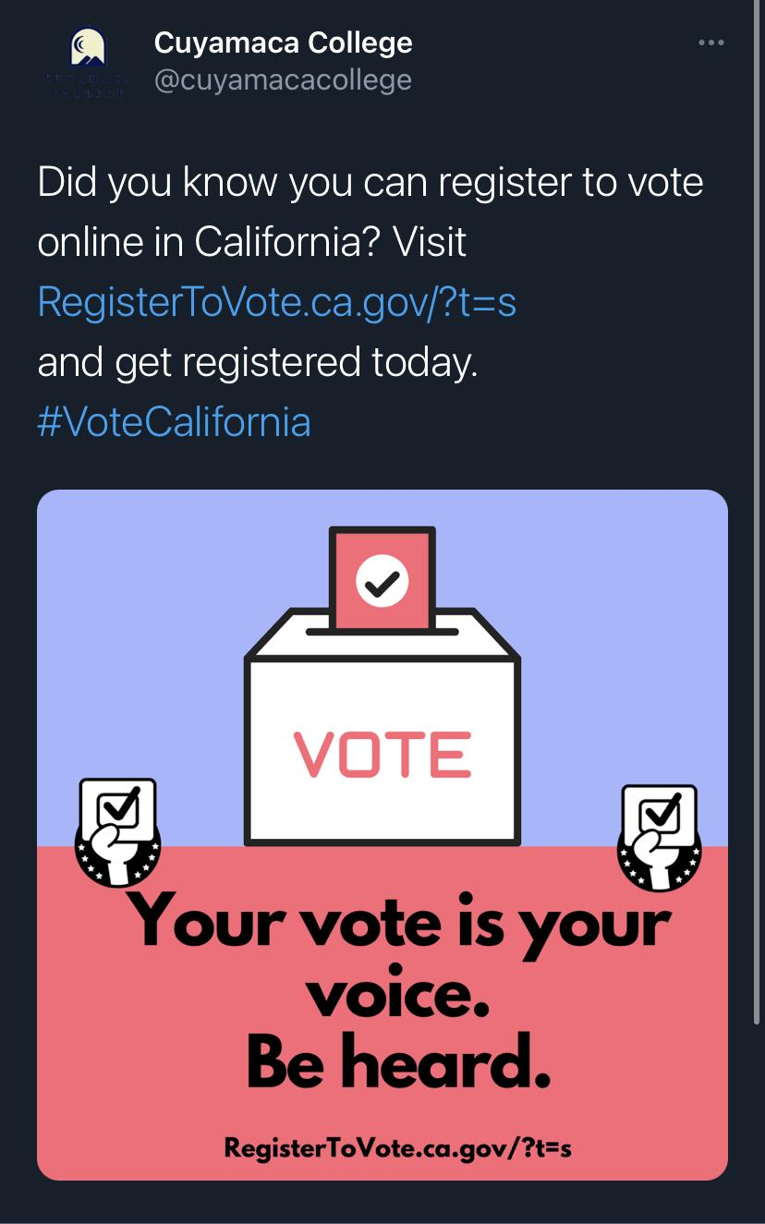
Sample Twitter Post Instagram Feed

Community Building: Voter Education & Civic Engagement (Fall Semester 2020)
September 17, 2020- Constitution Day & Voter Registration podcast
The Associated Student Government leaders and the Political Science Club presented a Constitution Day podcast and included Register to Vote information.

September 22, 2020- National Voter Registration Day
The Student Affairs Department and members of the Political Science Club sponsored a zoom session workshop for students to answer questions and provide informational resources to register to vote.

September 30, 2020- Voter Education Workshop
The Pillars of the Community presented the “Importance of Local Politics” workshop for students in conjunction with the Community & Culture workshop series. Various faculty members brought the classes to attend the workshop series. In addition, students were provided with voter registration information during the workshop.

October 15, 2020- National Voter Registration Act Compliance by Cuyamaca DSPS Office
The National Voter Registration Act (NVRA) requires states to designate state government agencies and offices that provide public assistance or services to people with disabilities as NVRA Voter Registration Agencies (VRAs), as well as other offices each state deems appropriate. The Cuyamaca College Disabled Students Programs and Services Office (DSPS) is considered a VRA. As such, DSPS has been tasked with ensuring compliance of the NVRA as part of the services we offer. This includes ordering/tracking of voter registration cards, annual training of staff, and coordination of NVRA responsibilities with our local county elections official. As part of our compliance, we have done the following to comply with the NVRA:

- 10/19- Outreach email to current students with disabilities in Fall 2020 Newsletter with a link to vote.
- 10/16 - Outreach email to students with a link to Register to Vote.
- 10/15 - DSPS Counselors and Specialists met with students as they completed a form that gets sent directly to the state with our unique URL for Cuyamaca College.
- 10/13 - Email: focused on Arabic Language inquiry to NVRA due to demographics of the Cuyamaca College.
- 10/8 - Coordinator and High Tech Center Alternate Media Access Specialist went to NVRA Training done by NVRA.
- 9-11-10-1 - High Tech Center Alternate Media Access Specialist created a website with links to Voter Registration on the Main DSPS Website. In addition, he created a link for a fillable form for students with disabilities who need assistance to fill out voter registration forms.

October 16, 2020- Know your Rights Workshop
The Know your Rights workshop was presented by the Alliance San Diego & The LGBT Center of San Diego. During the workshops, voter registration information was provided.

October 17, 2020 - 53rd Congressional District Town Hall Program
The Cuyamaca College Political Science Club hosted its first Congressional District Town hall via Zoom. 53rd Congressional District Candidates Georgette Gomez, City of the San Diego Council President, and Sara Jacobs, Founder and Chair of San Diego for Every Child, attended the hour-long event and answered questions submitted by students and community members.

October 21, 2020- Black Consciousness Conference
Purpose: Presented by the Umoja Scholars, the Black Consciousness Conference was established to address prevalent issues of the Black Community. The presenters discussed the importance of voting.

November 3, 2020- Campus Polling Location
Purpose: Cuyamaca College was a polling site for the November 3, 2020 election.

November 17, 2020 & November 18, 2020- Social Justice conference: Resistance through Solidarity
Purpose: Cuyamaca’s Annual Social Justice Conference highlights issues of social in/justice, showcases the work of local activists, and connected students to local activist organizations.

Civic Engagement Plan
Goals & Action Steps

Associated Student Government Programs (Democratic Participation)
- Strategies: Integrate voter registration and civic engagement efforts into the Associated Student Government of Cuyamaca College events and activities. The outreach programs will include tabling activities during orientation activities, Welcome Week, and engagement events. The Associated Student Government will develop the voter registration and civic engagement programs on an annual basis during the Associated Student Government leadership retreat.
- Timeline: Project will start during Spring Semester 2021 & Fall Semester 2021

Associated Student Government Leader Requirement (Democratic Participation & Civic Learning)
- Strategies: The Associated Student Government Emerging Leaders and Senators will be required to develop or collaborate with a student club to develop a voter registration or civic engagement program as part of their Associated Student Government requirements.
- Timeline: Project will start during Fall Semester 2021

Student Clubs & Voter Registration (Democratic Participation)
- Strategies: In collaboration with the student club leaders on campus, coordinate an annual planning meeting to develop voter registration and civic engagement programs and activities. In addition, the Phi Theta Kappa leaders will be actively involved in voter registration programming to link with the club’s chapter project requirement for five star chapters.
- Timeline: Project will start during Spring Semester 2021 & Fall Semester 2021

Civic Engagement Recognition Ceremony (Civic Learning)
- Strategies: Students will be recognized with certificates at the annual Associated Student Government/Magnum Opus awards series. All students who participated in voter registration and civic engagement programs will be recognized with a certificate. In addition, students will have the opportunity to apply and be selected for the prestigious “Civic Empowerment Leaders” awards. These students will receive a graduation sash in recognition of their outstanding work with voter empowerment and civic engagement efforts.
- Timeline: Project will start during Spring Semester 2022 (This project could start during Spring Semester 2021 if the campus opens earlier and allows events to be held on campus.)

Civic Engagement Experiential Learning Opportunities (Democratic Participation & Civic Learning)
- Strategies: POSC 165/ENTH 165, Introduction to the Politics of Race and Gender, this course is an introduction to the politics of race and gender. The course offers an overview of the identity, status, and power of Women, Native Americans, African Americans, Latina/o Americans, and Asian Americans from an intersectionality perspective. Also listed as ES 165. Not open to students with credit in ES 165. One of the Student Learning Outcomes is: Assemble a civic engagement project that focuses on local, state, and federal public policies which promote diversity, inclusion, and equity. The course will be offered every semester starting Fall Semester 2021.
- Timeline: Project will start during Fall Semester 2021

Student Engagement Ambassador (Democratic Participation & Civic Learning)
- Strategies: Student position hired through Student Affairs to develop student-initiated civic engagement programs. Student Engagement Ambassador will be trained to make class and student presentations on registering to vote and other civic engagement topics. The Student Engagement Ambassador will work closely with student leaders and programs on campus to make presentations during outreach and orientation sessions.
- Timeline: Project will start during the Spring Semester 2021

Culture & Community Circle: Workshop Series
- Strategies: The Culture & Community Circle workshop series will include sessions focusing on civic engagement and voter empowerment topics. Possible workshop topics include: Federal, State, Local Officials, Measures and Propositions. A representative from the Civic Engagement/Voter Empowerment advisory group will serve on the planning group for the Culture & Community Circle program.
- Timeline: Project will start during Spring Semester 2021 & Fall Semester 2021

Leadership Academy (Democratic Participation & Civic Learning)
- Strategies: In collaboration with the GCCCD Foundation, develop a student Leadership Academy. Students will gain leadership development and civic engagement experience as a result of attending the Leadership Academy. There is a planning meeting tentatively scheduled for December.
- Timeline: Project will start in Fall Semester 2021

Mock Election (Democratic Participation & Civic Learning)
- Strategies: Every even-year, Californians have the opportunity to vote for local, state, and federal candidates. Interestingly, unless there is a special election, odd-years in California are relatively quiet times electorally. Mock Elections are one way to build a habit of voting during odd-years. The Political Science Program will facilitate a mock election in conjunction with Associated Student Government elections in the spring of every odd-year.
- Timeline: Every odd-year Spring, a Mock Election will be held.

National Voter Registration Programs- 4th Tuesday of September) (Democratic Participation)
- Strategies: The Civic Engagement/Voter Empowerment advisory group will develop programming for the National Voter Registration events. The advisory group will meet during the prior Spring Semester to finalize the events for National Voter Registration Day.
- Timeline: Project will start in Fall Semester 2021.

Constitution Day Programs- September 17 (Civic Learning)
- Strategies: The annual Constitution Day program will be developed by the Civic Engagement/Voter Empowerment advisory group to incorporate civic engagement and vote empowerment efforts.
- Timeline: Project will start in Fall Semester 2021.

Civic Engagement/Voter Empowerment Advisory Group (Democratic Participation & Civic Learning)
- Strategies: There will be an advisory board established with faculty, staff, and students to develop and provide ongoing guidance for the campus Civic Engagement and Voter Empowerment efforts. The advisory committee will meet on a monthly basis during the academic year and schedule a planning prior to Memorial Day every year to assess previous efforts and plan for the upcoming year.
- Timeline: Project will start in Fall Semester 2021.

Welcome Week (Democratic Participation)
- Strategies: Voter registration programs will be developed for Welcome Week events every semester. These events include student activities, student involvement tables, and outreach programs.
- Timeline: Project will start in Fall Semester 2021.

“Ask me about Voter Registration” Buttons (Democratic Participation)
- Strategies: The Student Affairs Department staff and the Associated Student Government leaders will create buttons to wear during Welcome Week and other activities on campus to encourage voter registration.
- Timeline: Project will start in Fall Semester 2021.

Marketing Effort (Democratic Participation)
- Strategies: The Civic Engagement/Voter Empowerment advisory group will continue to develop annual marketing plans to promote voter registration and civic engagement participation. To improve visibility, the voter registration link will be embedded in high traffic areas on the website. Cuyamaca College will use the California Student Vote.Org site to facilitate student voter registration. The marketing team will continue to utilize the California Student Vote Project toolkit for all marketing efforts. In addition, when the campus fully reopens for in person classes and services, we will develop additional voter registration campaigns and programs on campus.
- The advisory group will utilize the social media resources from the Student Vote Project and participate in the Student Vote Programs, such as the Ballot Bowl.
- Timeline: Project will start in Fall Semester 2021.

Disabled Students Programs & Services
Voter Registration (Democratic Participation)
- Strategies: The Disabled Students Programs & Services Counselors and Specialists will continue to work with DSPS students to order and track voter registration cards, provide annual training for staff, and ensure compliance with NVRA guidelines.
- Timeline: Project will start in Fall Semester 2021.

Phi Theta Kappa (PTK) Programs & Honors Program (Democratic Participation)
- Strategies: The PTK Officers and Members will send a representative to all future meetings to assist with the mission of the Civic Engagement/Voter Registration Empowerment Action Plan. The club will continue to encourage PTK activism, involvement and volunteerism by updating members of all activities and opportunities. Ideas of involvement will be to wear buttons, participate in campus and Zoom events, promote the cause, volunteer at voter registration outreach events and always being a part of the student representation.
- Timeline: Fall Semester 2021 and ongoing

Community Partners
The Civic Engagement/Voter Empowerment advisory group members will work closely to identify community partners and local resources to promote civic engagement and voter registration efforts on campus. We will utilize resources from the American Political Science Association, National Study of Learning and Voter Engagement, League of Women Voters, Student Vote Project, and the California Community College Student Senate Association. In addition, the Student Affairs Department and the Associated Student Government members will work closely with existing community agencies through the Cuyamaca Cares programs to promote voter registration and civic engagement efforts during Cuyamaca Cares and Health & Wellness programs. These partners include Feeding San Diego, San Diego Food Bank, and local housing and community agencies.

Evaluation & Reporting
The Civic Engagement program will be assessed on an annual basis through the Student Affairs program review process. We will work closely with the Institutional Effectiveness Office to develop multiple methods of assessment including surveys and focus groups. The members of the Civic Engagement advisory board will utilize the results from the various assessment methods to inform program improvement for the Civic Engagement plan. The Dean of Student Affairs will oversee the plan and submit annual updates to the Secretary of State’s Office.

Appendix
Crosswalk List Above with Chapter 10.5 of Title 3, Division 5, Part 40 of California Education Code
Student Civic and Voter Empowerment Act
- EDUCATION CODE - EDC
- TITLE 3. POSTSECONDARY EDUCATION [66000 - 101060]
  - DIVISION 5. GENERAL PROVISIONS [66000 - 70115.2]
    - PART 40. DONAHOE HIGHER EDUCATION ACT [66000 - 67400] ( Part 40
      - CHAPTER 10.5. Student Civic and Voter Empowerment Act [66850 - 66852]

Item # | Section | Description | Cuyamaca College
1 | 66852(a)(1) | Campuswide emails to all students with (A) through (F) during 1st month of fall semester | Link to Email #1  Link to Email #2
2 | 66852(a)(2) | Campuswide email to all students with 66852(a)(1)(A)-(F) & SOS URL one month before statewide election (primary) | N/A in Fall 2020, since Primary Election was March 2020
3 | 66852(a)(2) | Campuswide email to all students with 66852(a)(1)(A)-(F) & SOS URL one month before statewide election (general) | Link to Email #1  Register to Vote flyer
4 | 66852(a)(3) | Academic calendars have dates from 66852(a)(1)(A)-(F) | Link to Academic Calendar
5 | 66852(b)(1) | Social media post of (A) regarding early voting | Refer to Civic Engagement report for Social Media Posts  Student Email
6 | 66852(b)(1) | Social media post of (B) regarding election day - before election day | Social Media- Refer to Civic Engagement report for Social Media Posts  Campus Email
7 | 66852(b)(1) | Social media post of (B) regarding election day - day of election | Social Media-Refer to Civic Engagement report for Social Media Posts  Campus Email-Students  Campus Email- Employees  Campus Email- Employee (Polling Locations)
8 | 66852(b)(1) | Social media post of (C) regarding voter information guide and county sample ballot 30 days before PRIMARY statewide | Information will be included prior to the next primary.
9 | 66852(b)(1) | Social media post of (C) regarding voter information guide and county sample ballot 30 days before GENERAL statewide | Link to Email #1  Link to Email#2  Link to Email#3
10 | 66852(c)(1) | Designate Civic and Voter Empowerment Coordinator | Completed  Lauren Vaknin, Ed.D.  Dean, Student Affairs  Civic and Voter Empowerment Coordinator
11 | 66852(c)(1)(B) | Election Outreach Event ⅓ during academic year | Link to Event Page on college website  Political Science Club Election Events  Constitution Day Event  National Voter Registration Day  Post Election Series Reflection
12 | 66852(c)(1)(B) | Election Outreach Event ⅔ during academic year | Link to Event Flyer- Importance of Local Politics  Link to Flyer- October Workshops (Social Justice)  Link to Flyer- November workshops (Social Justice)  National Voter Registration  Constitution Day  Political Science Club events
13 | 66852(c)(1)(B)(i) | During even-year (2020, 2022, 2024, etc.) Election Outreach Event 30 days before PRIMARY election | NA
14 | 66852(c)(1)(B)(i) | During even-year (2020, 2022, 2024, etc.) Election Outreach Event 30 days before GENERAL election | N/A in Fall 2020, since Primary Election was March 2020
15 | 66852(c)(1)(B)(ii) | Invitation to Students to Participate in coordination of and attendance | Link to Invitation Email
16 | 66852(c)(1)(C) | Development Civic and Voter Empowerment Action Plan | Please refer to Action Plan
17 | 66852(c)(1)(D) | Submit Action Plan to Secretary of State’s Office by December 1, 2020 | Please refer to Action Plan

