CAREER CENTER GUIDE

COVER LETTERS
Cover Letter Guide
Cover Letter Example
Cover Letter Rubric

PROFESSIONAL COMMUNICATIONS
Develop Your Elevator Pitch
Networking Emails/Messages
Thank You Notes
Job or Internship Inquiry Emails

RESUME
Resume Guide
Resume Building Worksheet
Resume Example: Student With Work Experience
Resume Example: Student With Little to No Work Experience
Resume Action Words
Resume Rubric

JOB SEARCH
Cuyamaca’s College Central Network Job Board
Other Job Search Sites
Organize Your Job Search

COVER LETTER GUIDE
The point of a cover letter is to introduce yourself, show interest, enthusiasm, and write one so fantastic that it screams “Read my resume!” Like a resume, it needs to be tailored for each job. When emailing a cover letter, it should be included as a PDF attachment.

Your cover letter should be one page written in professional, business letter format with three to four paragraphs.

Salutation and First paragraph:
- Whenever possible, address it to the person responsible for the hiring process or for making the hiring decision. Calling the HR department to ask for the name of the hiring manager for the purpose of addressing your cover letter is acceptable. If you are unable to get a name, address it to “Dear Recruiting Manager.”
- List the position you are applying for and where you found this position
- Also, mention a mutual contact or if you have met someone/know someone within the company
- Why this field/industry? (For example: I am passionate about nursing because…)
- Why this company? Stroke their ego! Do your research! (For example: I would be honored to work at Disney because…) Bonus: Reference their slogan, mission statement, awards, etc. found on their website.

Second & third paragraphs:
- Why they should hire YOU/showcase what skills you have to offer
- How specifically your education, work experience, leadership and background match the qualifications they are seeking. You are giving more detail behind your resume.

Final paragraph:
- Restate your interest, confidence and enthusiasm in this position and company
- Thank the employer for considering and taking the time to read your letter

COVER LETTER EXAMPLE
[YOUR RESUME HEADER]

[Today’s Date]
[Hiring Manager’s Name]
[Company Name]
[341 Company Address]
[Company City, State XXXXX]

Dear Mr./Ms. Hiring Manager’s Last Name OR Dear Recruiting Manager,

I wish to submit my application for the Office Manager job opening, which I saw on (Website Name). I believe that my experience, education, and skill set place me to meet the challenges described in your job posting. Over my five years working in administrative positions, I accumulated extensive experience and skills in office management. I am excited about this opportunity at [company name], as this position aligns with my goal to utilize my unique skills in a respected multi-national company.

With three years of experience in document scanning, data entry, payroll activities, and answering telephones, I have proven to be reliable and organized. I was recognized at Gamma Corporations for my work ethic, where I have been employed as an Office Clerk Intern since August 2015. My key skills include IT skills for data entry, high attention to detail, the ability to run a payroll, and an excellent telephone manner. I am also adept with MS Word and Excel.

Additionally, I have worked with Sema Copies as a Junior Assistant Payroll Clerk and also in Customer Service, where I strived to maintain high standards for effectiveness, precision, dependability, and attendance. I am a flexible team player and can adapt to various situations that may occur and handle any additional assigned duties. In summary, I am an extremely friendly and organized professional with proven administrational skills.

I am enthusiastic about working with [company name] and am confident that my skills, experience, and education have prepared me to meet your expectations. If you would like to discuss my qualifications further or schedule an interview, please do not hesitate to contact me. Thank you for your time and consideration. I look forward to hearing from you.

Sincerely,
[First Name Last Name]

COVER LETTER RUBRIC
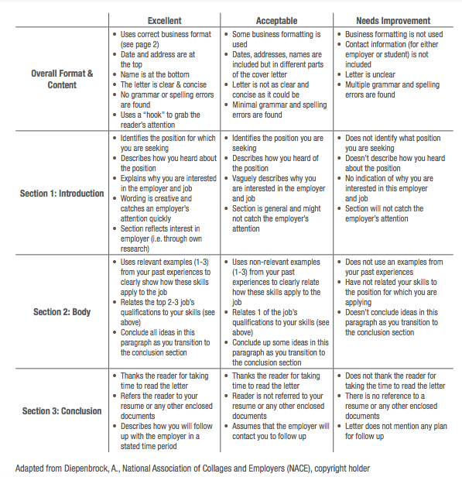

DEVELOP YOUR ELEVATOR PITCH
An Elevator Pitch is a brief overview of your professional experience, skills, strengths, accomplishments, and goals. It is essentially your 30 to 60-second commercial used to network at a job fair or say, if an employer stepped into an elevator with you. You have limited amount of time with this person, so be sure to cover these three main items: 1. Who you are and what you do, 2. Your relevant experience, skills, strengths, abilities, and 3. What you want from this interaction. Your Elevator Pitch should be tailored based on your purpose. For example, if you are interested in a career as a mobile application developer, only discuss what is relevant to that field or profession.

Developing and practicing your Elevator Pitch beforehand is key to making a meaningful introduction. You will use this throughout your professional life such as in a cover letter, at a career fair, in networking emails, and during an interview where they will inevitably ask you to tell them a bit about yourself. Craft yours by using the guide below. Read it aloud, make it sound natural to you, and practice, practice, practice!

EXAMPLE: My name is Michelle. I’m currently studying Computer & Information Science at Cuyamaca College. I love learning about technology. I’d like to start a career as a mobile application developer, so I spend my free time learning about mobile programming languages on the internet. I’m proud to be the first person in my family to graduate from college—it means I’ve worked extra hard to learn new things on my own when my parents weren’t able to help. I’d love to use my ability to learn new things quickly as a part of your team at Cubic Corporation San Diego.

Start by writing something you love to do or learn about. In our example, that’s where Michelle wrote “I love learning about technology.” Write yours below.
“I love __________________________.”

Now, tell us your career goal or a specific desired result. In our example, Michelle wrote “I’d like to start a career as a mobile application developer”. Write yours below.
“I’d like to _______________________.”

Next, tell us what you’re doing to help you get there. For this, Michelle wrote “so I spend my free time learning about mobile programming languages on the internet.” Write yours below.
“So I ____________________________.”

Next, tell us something you are proud of. Michelle wrote “I’m proud to be the first person in my family to graduate from college.” Write yours below.
“I’m proud of/to __________________.”

Now, tell us why you’re proud of that, or what it means to you. Michelle wrote “it means I’ve worked extra hard to learn new things on my own when my parents weren’t able to help.” Write yours below.
“Because ________________________.”

Finally, connect everything for us by telling us how your story can help us as your future employer. Michelle wrote “I’d love to use my ability to learn new things quickly as a part of your team at Cubic Corporation San Diego.” Write yours below—practice by using your dream employer as an example!
“I’d love to ______________________.”

NETWORKING EMAILS/MESSAGES
A Networking Email is sent to someone whom you wish to connect up with to get a bit of information about the field in which they work. Attach your updated resume in PDF format or refer them to your LinkedIn profile. Example #1 is to a Cuyamaca College alumnus. Example #2 is to a connection on LinkedIn.

EXAMPLE #1:

Subject: Hello from a Cuyamaca College Student!

Dear Mr./Ms. ______,

I came across your contact information through (insert source). I am currently a student at Cuyamaca College, and I thought that I would reach out to discuss your career path. I am majoring in (insert major), and I have a strong interest in (insert interest). I would love to schedule a phone chat with you to discuss your career path and learn more about your transition from Cuyamaca College to your current position at Company X.

I am attaching my resume for your reference. Thank you very much for your time, and I look forward to hearing back from you soon!

Sincerely,
Catherine Coyote
Associate of (Arts or Sciences) in (Major Name) anticipated (Month Year)
Cuyamaca College
Email
Phone number

EXAMPLE #2:
Dear Mr./Ms. _____,
I am a current student at Cuyamaca College pursuing my degree in (insert major) and I have a background in ______. I came across your LinkedIn profile while researching (job title) in the El Cajon area. I see that you have worked in this field for several years and would love to ask you a few questions about your career path and how you got to where you are today. Would you have time for a quick 20-minute informational interview via phone or Zoom in the next few weeks? Thank you for considering my request. I look forward to hearing from you.
Sincerely,
Catherine Coyote

THANK YOU NOTES
After an interview, within 24 hours, it is advised that you send a thank you note to each interviewer with whom you met. You may send the note as an email. Additionally, you may also send a small handwritten notecard. Your note should be brief, reiterate your interest in the position, and reference specific qualifications (or topics of conversation during the interview) that you want the interviewer to remember.

EXAMPLE:

Subject: Thank You!

Dear Mr./Ms. ______,

Thank you for taking the time out of your busy schedule to discuss the (position title) position with me. I enjoyed our conversation, especially talking about (insert most memorable part of the conversation). Company X is truly an exceptional place to start my career because (insert a few notes on why Company X). I hope to hear back from you soon regarding my next steps. Have a great day, and once again, thank you very much for taking the time to meet with me!

Sincerely,
Catherine Coyote
Associate of (Arts or Sciences) in (Major Name) anticipated (Month Year)
Cuyamaca College
Email
Phone number

JOB OR INTERNSHIP INQUIRY EMAILS
A Job or Internship Inquiry Email is sent to any organization or person you wish to gain employment with. This email is appropriate if you want to learn more about a current or prospective opening from a connection you’ve made by networking in person, via LinkedIn, etc.. Please note that some employers do not post internships online and the only way to find out about internships is by directly contacting them. The email below is to an employer.

EXAMPLE:

Subject: Insert the job title or type of internship that you are inquiring about

Dear Mr./Ms. ______,

I am writing to you because I am very interested in (working or interning) with (company name). I am currently a student at Cuyamaca College majoring in (major) with a (GPA if above 3.0). I believe that my current coursework in (series of relevant course work) would make me a great asset to your team. I am diligent, trustworthy, motivated, and I never stray from a challenge (or any other skills). For example, (discuss an experience that demonstrates these skills).

By (interning or working) with you, I hope to learn more about the field of (insert field name) and fully develop my professional skills. I hope that you please consider my resume.

Thank you,
Catherine Coyote
Associate of (Arts or Sciences) in (Major Name) anticipated (Month Year)
Cuyamaca College
Email
Phone number

RESUME GUIDE
WHAT IS A RESUME?

A resume is a summary of your professional and personal qualifications for a job or internship. The reader will view your education, skills, work experience (paid and unpaid), activities, and achievements. It highlights how you qualify for the particular position for which you are applying. It should demonstrate how you have used relevant and transferable skills to produce results.

This is your time to shine! Remember, you’re not bragging or boasting: employers want to know why YOU are the best person for this position and the only way to do that is to advocate for yourself and be confident in your skills and accomplishments!

- There is no perfect resume. While you should follow basic resume guidelines as outlined below, remember that everyone’s career path is different and every hiring manager is different. 20 different people will give you 20 different suggestions on how they think your resume should look. Therefore, focus on writing what makes you stand out as a strong candidate for this position while keeping the document visually appealing.

- Look at the resume examples we provide here and elsewhere, but remember to stylize your own based on your unique experience and the type of job you’re applying for.

- Employers spend an average of 30 seconds initially reviewing a resume, so first impressions count! It’s your job to make related skills stand out.

- Resumes are typically 1 page and cover the last 5-10 years of experience. Seasoned job seekers may have 2 pages. Avoid using templates!

- For each job you apply for, your resume must be tailored to their job description. Include related skills and keywords from their description in your resume.

- Emphasize results, skills, and accomplishments rather than listing duties and tasks.

- Demonstrate that you have direct or transferable skills

- Many companies use Applicant Tracking Systems (ATS) to scan resumes for keywords. This system is a way for companies to weed through the large quantity of applicants by triggering certain keywords or traits they're looking for in their next hire. Tip: use a word cloud app to paste the job description in and identify the keywords such as www.tagcrowd.com

- The purpose of your resume and cover letter is to convince the employer to offer you an interview. A resume alone will almost never land you the job. The Career Center conducts practice interviews/mock interviews to help you ace the interview and get a job offer!

GRAMMAR & SPELLING
• You should have no spelling or grammatical errors on your resume! Be aware that spell check does not catch all spelling and grammatical errors, especially if you’re word is spelled right but used incorrectly (see what we did there?)
• Avoid abbreviations and inside jargon as much as possible; you may use abbreviations as long as you spell out the abbreviated phrase initially and then show the abbreviation you will subsequently use in parentheses. For example: Career Technical Education (CTE)
• Use present or past verb tense consistent with the time of your experience.

MARGINS & LENGTH
• Margins between .5”–1” for both left-right and top-bottom work best for a resume. You don’t want your resume to have too much white space or seem too crowded into the margins.
• Resumes should only be one page long unless you have a significant amount of relevant work experience or an advanced degree.
• Keeping your resume to one page demonstrates to the reader that you can express yourself concisely and effectively.

FONT
• Use relatively plain, easy-to-read fonts; you want your font to be clean in case your resume is photocopied, scanned, or faxed one or more times.
• Times New Roman, Arial, Garamond, Helvetica, Calibri, Palatino are appropriate resume fonts.
• Font sizes 10.5–12 are best for resumes. However, it is advised that you use at least size 18 font for your name at the top of your resume.

TEXT EFFECTS, INDENTATION, LINE SPACING
• Keep it simple; too many different effects (bold, italics, underlining, all-caps) and indents will make your resume look cluttered and busy
• Keep it consistent; if you use all caps for the name of one resume section, do it for all the section names; if you have one line space between your sections, be sure you do that between each section; be sure bullet points are aligned and sized the same; be sure your fonts are the same size and style
• Use text effects strategically to emphasize things that you want to stand out (like school names or employer names) and to help create visual breaks between different experiences within the sections of your resume

SECTIONS
• Common resume sections include EDUCATION, WORK EXPERIENCE or EXPERIENCE, VOLUNTEER EXPERIENCE, SKILLS or SKILLS & LANGUAGES.
• Some resumes have tailored section titles or other sections such as: OBJECTIVE or SUMMARY, RELAVENT EXPERIENCE, RELAVENT COURSEWORK, LEADERSHIP, HONORS AND AWARDS.
• Do not include references or write “references available upon request” on your resume. References should be placed on a separate document. Unless the job posting explicitly states that you must list references on your resume, do not list them.

BULLET POINTS
• Each position under EXPERIENCE typically has 3-5 bullet points describing your tasks. If you need help developing bullet points, search for similar job descriptions of your position online to use as a guide. Tip: Visit www.onetonline.org and search for your job title.
• Do not simply list out tasks and responsibilities. Use the STAR Method and start each bullet point with an action verb. If possible, quantify your accomplishments and achievements to put your experience in context.
• Write about the skills and abilities you used to complete those tasks and emphasize your accomplishments and achievements.
• They do not need to be written with complete sentence structures (though they should be grammatically correct).
• Since they are not complete sentences, you DO NOT need to use periods at the end of your bullets (remember to be consistent; don’t end some bullets with periods and other without periods).
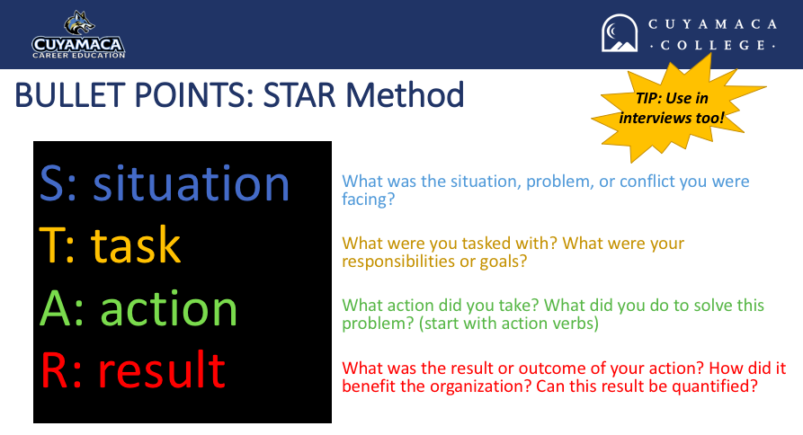
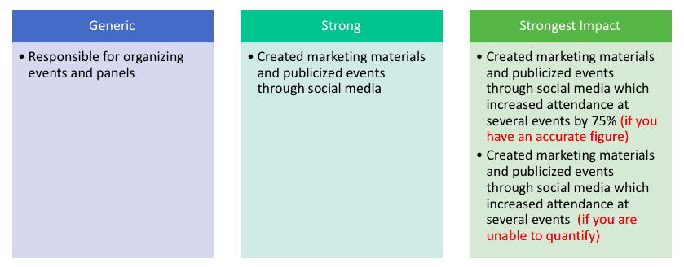

RESUME BUILDING WORKSHEET
Use this form to brainstorm ideas for your resume and then place the information in your preferred resume format.

Contact Information: Name____________________________________________________________________
Mailing Address____________________________________________________________
Email Address_____________________________________________________________
Phone Number____________________________________________________________

Education: Institution ________________________________________________________________
Degree seeking____________________________________________________________
Major/Minor/Certificate _____________________________________________________
Cumulative and/or Major GPA (if above 3.0)_____________________________________
Anticipated Graduation Date (Month/Year)_____________________________________
Relevant
Coursework: _____________________________ _____________________________
(*Optional) _____________________________ _____________________________

Work Experience: Title_____________________________________________________________________
*Include jobs or internships Company/Location_________________________________________________________
*Use bullet points & start Duties____________________________________________________________________
with a power verb _________________________________________________________________________
Skills Used________________________________________________________________ Projects/Promotions________________________________________________________
Dates Employed (Month/Year to Month/Year)____________________________________

Title_____________________________________________________________________
Company/Location_________________________________________________________
Duties____________________________________________________________________
_________________________________________________________________________
Skills Used________________________________________________________________
Projects/Promotions________________________________________________________
Dates Employed (Month/Year to Month/Year)____________________________________

Leadership Experience: Position__________________________________________________________________
*Include organizations, Organization______________________________________________________________
teams & volunteer activities Dates Involved_____________________________________________________________
where you contributed
significantly Position__________________________________________________________________
Organization______________________________________________________________
Dates Involved_____________________________________________________________

Activities/Volunteer: Organization______________________________________________________________
*Include organizations/ Dates Involved_____________________________________________________________
volunteer work
Organization______________________________________________________________
Dates Involved_____________________________________________________________
Language/Computer __________________, __________________, __________________,
Skills:
Awards/Honors: __________________, __________________, __________________,

You do not need to state “References available upon request.” References should be placed on a separate document.
NAME
RESUME EXAMPLE #1: Student With Work Experience
City, State Zip | Professional email | Phone number with professional message | LinkedIn

EDUCATION
Cuyamaca College El Cajon, CA anticipated May 2021
A.A. Business with an emphasis in Accounting
Overall GPA: 3.5
Dean’s List: Spring 2019

Santana High School Santee, CA June 2018
High School Diploma

WORK EXPERIENCE
Office Assistant December 2018-present
Coyote Accounting Group El Cajon, CA
- Assist with audits, fact checks, and resolving discrepancies while utilizing MS Excel and Quickbooks
- Process transactions, issue checks, and update ledgers
- Maintain the accounting filing system both digitally and in hard copy
- Handle communications with clients and vendors via phone, email, and in-person
- Develop a marketing plan, create flyers and distribute them to sixty local businesses

Department Supervisor March 2017-November 2018
Maci’s Market La Mesa, CA
- Supported human resources objectives by training and evaluating twelve new employees
- Communicated sales expectations by planning, monitoring, and evaluating department events
- Coordinated and established connection between local farms and the market
- Marketed services to prospective customers by following up on customer inquiries

Child Care Provider June 2017-December 2017
Ruiz Residence San Diego, CA
- Assisted in the cognitive development of two children, ages two and four, by reading to them and facilitating educational activities
- Planned and implemented play time while maintaining a clean, safe, nurturing, creative environment
- Provided emotional, social, and academic support to the children
- Communicated with parents about children’s behavior, activities, and concerns

Tutor February 2015-January 2016
Dowden Charter School San Diego, CA
- Tutored five students in subjects ranging from biology to literature
- Identified the needs of learners and if necessary adapted delivery style to meet their needs
- Developed academic strategies to improve student’s self-sufficiency
- Succeeded in assisting the students to improve failing test grades to solid B’s and A’s.

VOLUNTEER/LEADERSHIP EXPERIENCE
Volunteer, Mountain Animal Shelter, San Diego, CA Spring 2019
Vice President, World Cultures Club at Cuyamaca College, El Cajon, CA Fall 2017-Spring 2018

SKILLS & LANGUAGES
- Fluent in Spanish, Conversational in French
- Proficient with Microsoft Office (Word, Excel, PowerPoint)
- Knowledgeable of social media outlets (Twitter, Facebook, Instagram, Snapchat, LinkedIn)
- Experience maintaining web and print resources using Adobe Illustrator
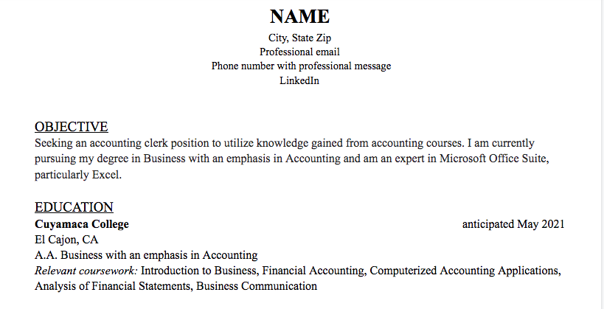
RESUME EXAMPLE #2: Student With Little to No Work Experience
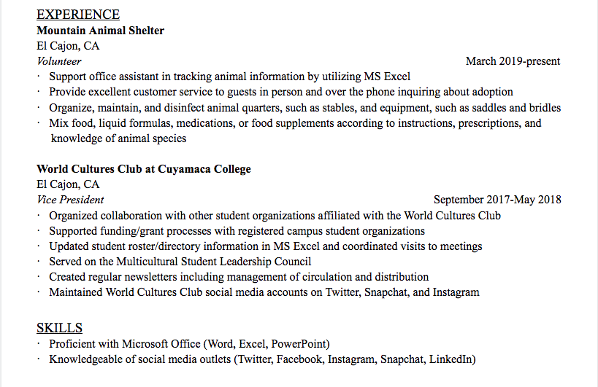

RESUME ACTION WORDS
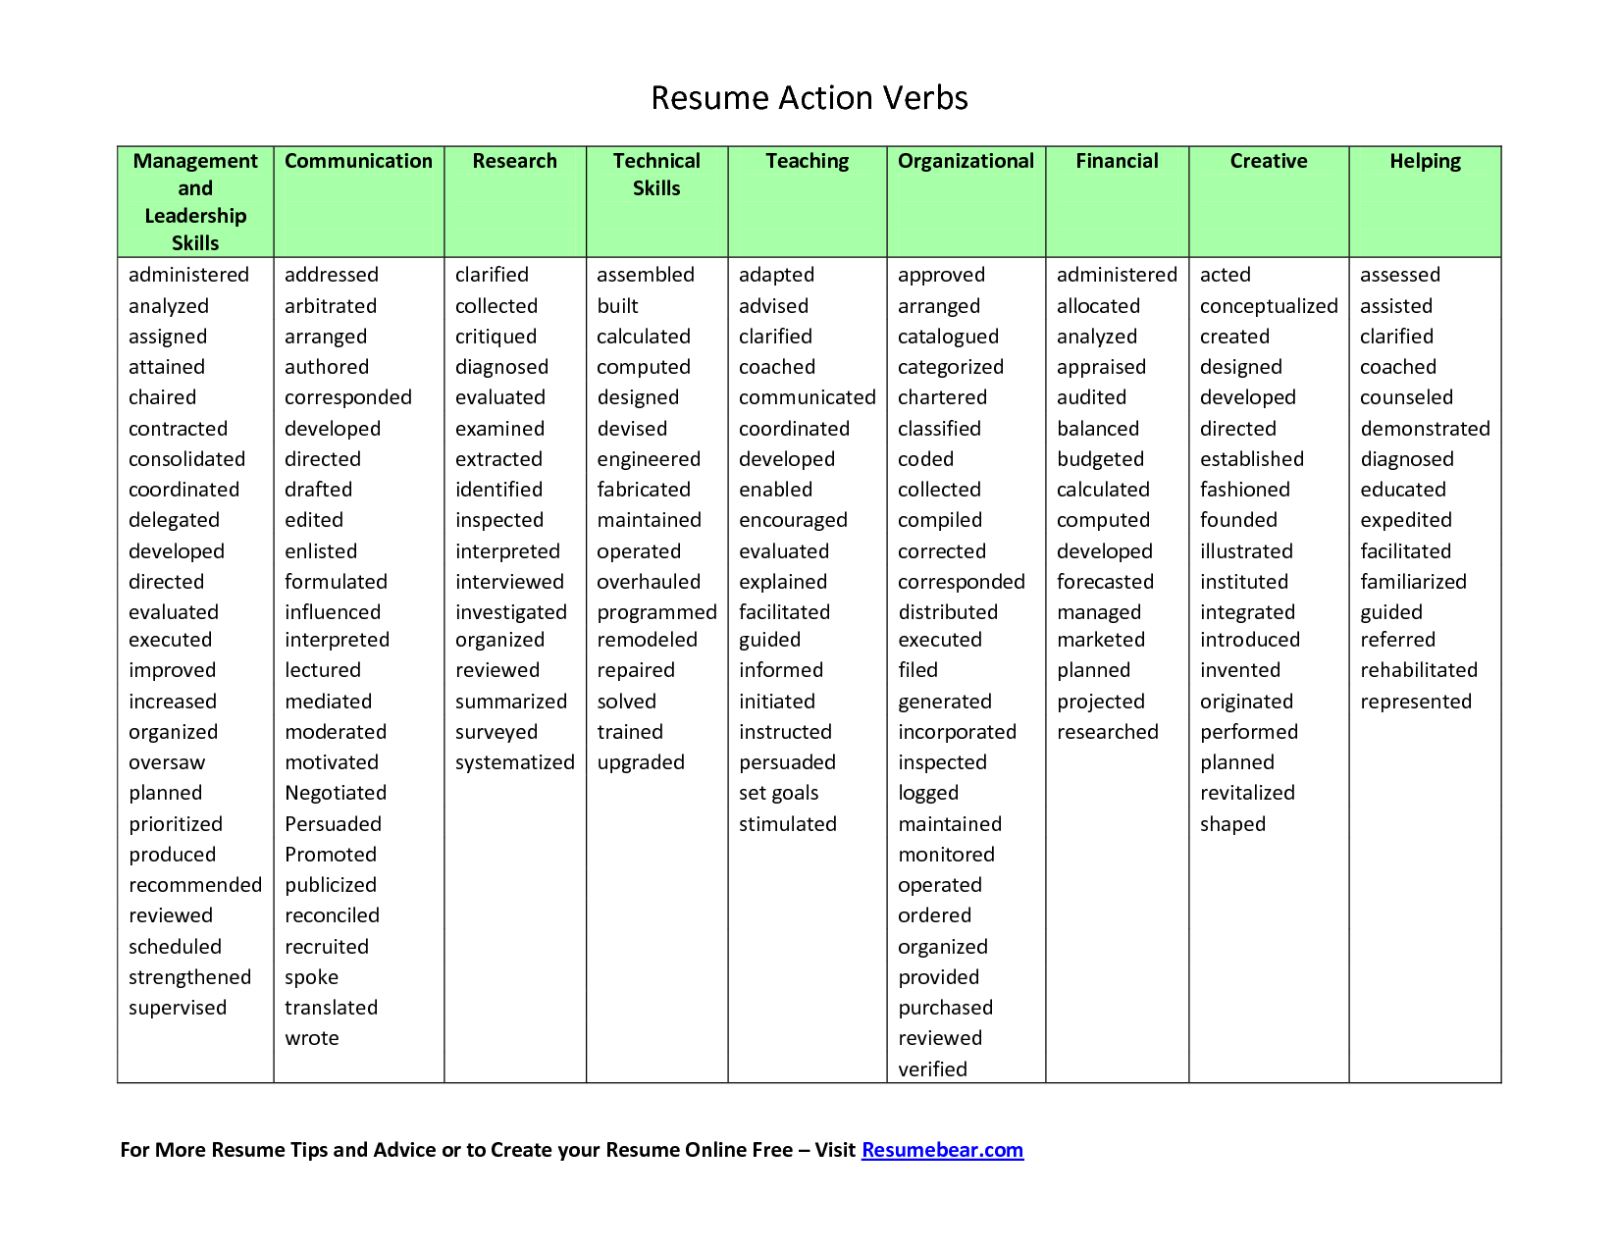

RESUME RUBRIC
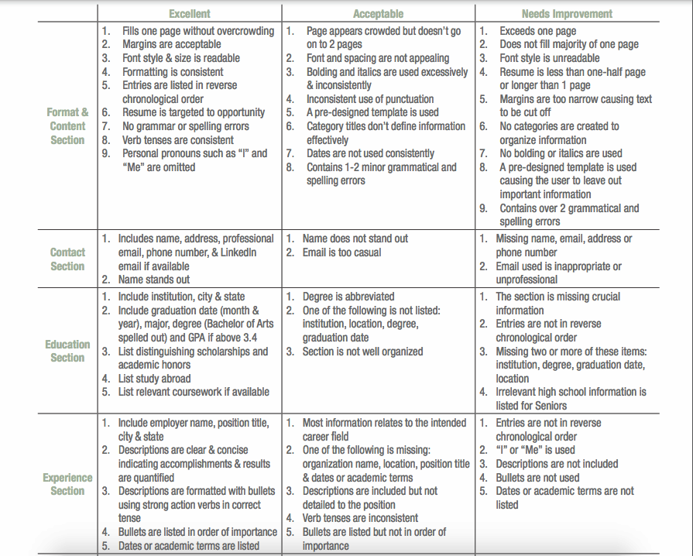
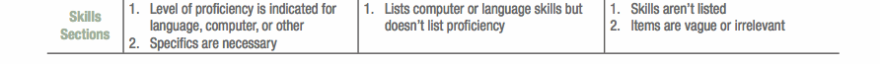
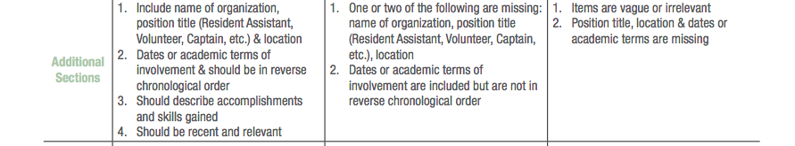
Adapted from Amherst Career Center Resume Rubric

JOB SEARCH

Free Job Board for Cuyamaca Students and alumni
https://www.cuyamaca.edu/student-support/career-center/job-board-for-students.php

College Central Network Job Board
Both on-campus and off campus jobs can be viewed for free at College Central Job Board. Cuyamaca, Grossmont College, enrolled high school students and alumni may use this service.
Access job opportunities 24 hours a day, 7 days a week. To look at the job list you may use a Career Center computer or use your own.
Post a resume to the Online Job Board. This will prompt our resume tutors at the Career Center to review and take a look at your resume. You may be called in to bring your resume with you for an additional appointment and assistance to work on it.

You will need your Student ID
You can log into the job board using your student ID. If you forgot your student ID, contact us.

E-Mail Account Required
Students will need an e-mail account to register for the Cuyamaca Online Job Board. You may use your own email account, but if you need a new e-mail account go to http://students.gcccd.edu . You will be asked to supply your student user name and password.
Register for your free College Central Job Board account:
Log in If you already have a College Central Job Board account.

Disclaimer: Cuyamaca College makes no representations nor guarantees about positions listed with the Student Employment Office. Cuyamaca is not responsible for safety, wages, working conditions, nor other aspects of off-campus employment. It is the responsibility of students and alumni to research the integrity of the organization to which they are applying. Students and alumni are advised to use caution and common sense when applying for any position with an organization or private party."
Cuyamaca College uses selected criteria to determine which job openings may or may not be posted on the JobLink.

OTHER JOB SEARCH SITES

Specialty or Niche Job Boards
Often, companies will post job opportunities on specialty or niche job boards in order to reach candidates with an industry, occupational or geographic specialty. It is worth searching for a site that caters to your area of interest. Some examples include:

• Dice, for technical jobs.
• eFinancialCareers, for finance jobs.
• Higheredjobs.com, for jobs from colleges and universities.
• Idealist, for nonprofit work openings.
• USAJobs.gov, for government jobs.

ORGANIZE YOUR JOB SEARCH
The job search can be challenging in today’s job market. Apply for several jobs and don’t forget to tailor your resume and cover letter for each! That involves lots of time, and lots to keep track of.
Creating a spreadsheet to keep track of your job applications will help you stay on top of the job search process. It doesn't have to be fancy, and it's up to you how detailed you want to get. But, here are the key columns to include:
- Company Name - The name of the organization you're applying to.

- Contact - Your point of contact at the company; probably who you addressed your cover letter to, such as a Director of Human Resources or Office Manager.

- Email - The email of your point of contact, or, if preferred, a phone number.

- Date Applied - When you submitted your application.

- Application Summary - What you submitted: a cover letter, resume, and any additional materials, like a portfolio or reference list.

- Interview - When your interview is scheduled.

- Follow-Up - Did you send a thank you email or letter? If so, indicate here.

- Status - If you were rejected, offered the job, asked in for a second interview, etc.

