**Contacts**

**Human Resources Coordinator x7039**

**Grossmont College Health Services Nurse x7194**

**Cuyamaca College Health Services Nurse x4200**

**Director of Public SAfety x7627**

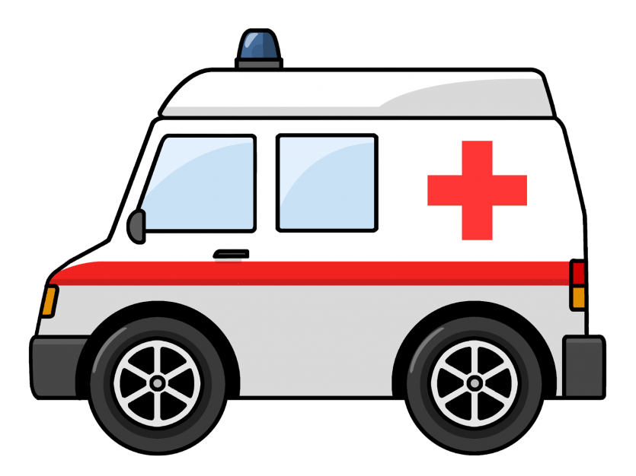

Medical Emergencies

**What** **do I do?**

Most employees have not been on campus for the past two years. Below is a refresher for procedures regarding on campus medical emergencies.

**Step 1:** Can the person walk and communicate? If yes, you may walk them to health services for evaluation. Never place a person who has lost their motor functions in a golf cart. If someone is unconscious, implied consent gives you the right to call 911 on their behalf. **Next:** If they cannot walk or communicate…

**Step 2: Call 911 for the patient immediately.**

**Step 3:** Stay on the phone with 911 and do not hang up. 911 operators are equipped to walk you through a medical emergency and give you updates on first responder’s status.

**Step 4:** If the person is refusing treatment, remind them that as an employee or student, their ambulance ride and treatment are covered. Many students are worried about the cost. Students can refuse EMT services after the medics have arrived. It is District policy to call 911 in all medical emergencies.

**Step 5:** Employees: A supervisor will fill out the [attached incident form](https://www.gcccd.edu/_resources/docs/human-resources/hr-misc/district-injury-illness-rpt-2008.pdf).

Students: Assistance is available from Health Services or Public Safety.

**Mental Health Emergencies?**

Call 911 - Our Sheriff’s team can deploy a [PERT](https://www.google.com/search?q=sheriff+department+pert&rlz=1C1GCEB_enUS982US982&oq=sheriff+department+pert&aqs=chrome..69i57j0i512j0i22i30l5j0i390l2.4317j0j7&sourceid=chrome&ie=UTF-8) (Psychiatric Emergency Response Team) member to assist. Threats of suicide, self-harm or harm to others should be taken seriously and PERT clinicians are trained to handle these situations delicately.

**Employee Company Nurse Hotline for Injury Triage**

**1-888-770-0929**

**Search Code: GCCCD**

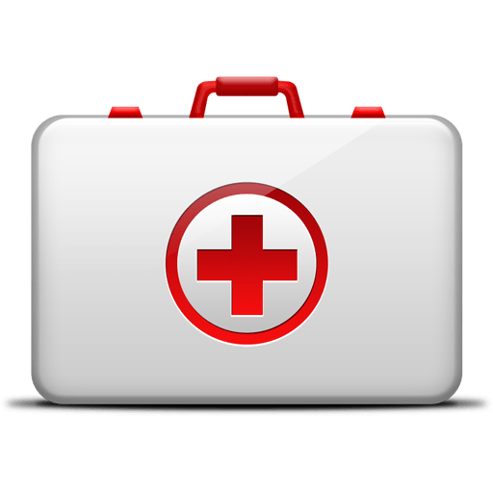

**Quick Facts**

* On average, it takes medical responders approximately 6-8 minutes to arrive at a scene.
* Not calling 911 immediately delays precious minutes for first responders.
* Campus and Parking Services personnel will often meet responders at the entrances of campus to lead them to a location quickly.
* Our DACA & immigrant students should never refuse assistance out of fear. Assure them that their status is not being evaluated receiving medical care. Their health and safety is our top priority and they need to receive proper medical care.
* You can dial 911 from any campus phone to receive services. You do not have to dial an extra 9 to get an outside line.