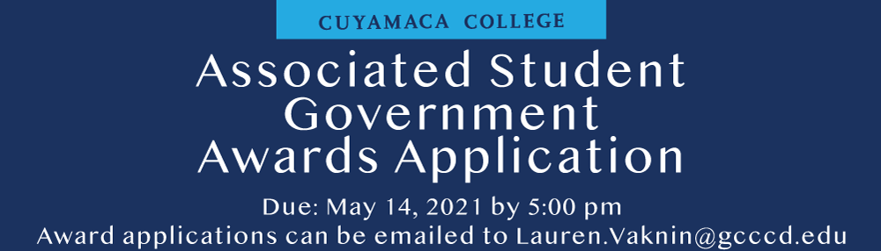

Name:

Student ID Number:

Contact Information:

Which award are you applying for on this application?

Please list your campus involvement:

Please list your leadership involvement (example: leadership positions with clubs)

Please list your campus committee involvement:

Please list your community service involvement?

Please list the campus workshops and events that you attended during the 2020-2021 academic year:

Why are you deserving of this award?

Please describe one event or program that you coordinated and explain your role in developing the program. What were your accomplishments with this event or program?

Please submit a statement describing why you are deserving of this award. (One-page max)

